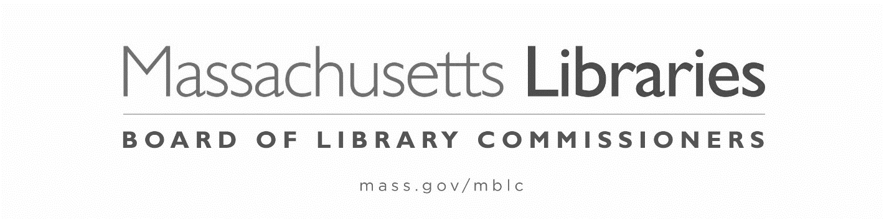

FY2025 STATE AID TO PUBLIC LIBRARIES
NOTIFICATION of NON-PARTICIPATION

The municipality of ___________________is not applying for the FY2025 State Aid to Public Libraries program.

Library Director’s Signature____________________________________________Date__________

Trustee Chair’s Signature_____________________________________________Date___________

THIS NOTIFICATION MUST BE
POSTMARKED BY OCTOBER 4, 2024

