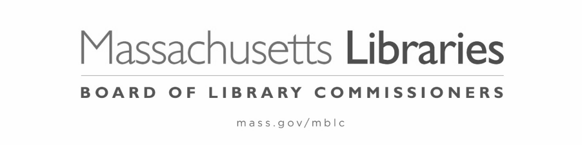

FY2025 STATE AID TO PUBLIC LIBRARIES
NOTIFICATION of REQUEST for HEARING
Pursuant to 801 C.M.R. 1.02, Informal Fair Hearing Rules

- This completed notification must be received in the Board of Library Commissioners Office within seven business days of the Board action being appealed.
- The hearing of the appeal will be placed on the agenda of the next regularly scheduled meeting of the Board of Library Commissioners.
- The Board will act on the appeal at the next Board meeting following the appeal hearing.

The municipality of Choose an item. is formally requesting a hearing to appeal one of the following:

☐ Denial of waiver of FY2025 Municipal Appropriation Requirement on February 6, 2025—appeal due February 21, 2025.
☐ Board action of Click here to enter a date. (date) regarding: ________________________________

Signature, Library Director: _______________________________________ Date: ___________

Signature, Library Trustee Chair: __________________________________ Date: ___________

