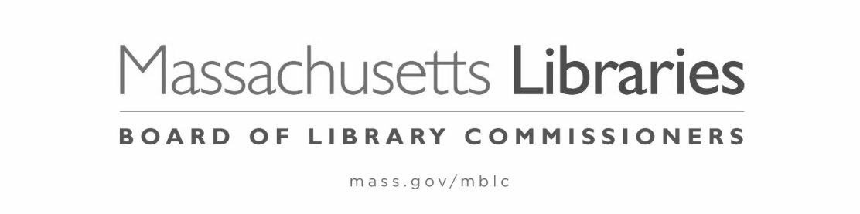

PETITION FOR WAIVER OF THE FY2025 MUNICIPAL APPROPRIATION REQUIREMENT

The municipality of Choose an item. hereby petitions the Massachusetts Board of Library Commissioners for a waiver of the Municipal Appropriation Requirement (MAR) for Fiscal Year 2025.

Signature, Library Director: ____________________________________ Date:__________

Signature, Library Trustee Chair:________________________________ Date:__________

PLEASE NOTE: The 5 year waiver plan is in effect.
This petition is due postmarked by October 4, 2024 and the following four (4) items** must be postmarked by November 8, 2024 (**additional items may be required if you are applying for a waiver in consecutive years):

- Signed, completed FY2024/FY2025 Total Municipal Operating Budget/Disproportionate Cut Worksheet
  - usually filled out by the municipality’s financial officer (i.e. town accountant)

- Supporting municipal budget document(s), summarizing the final FY2024 and proposed FY2025 total operating and departmental budgets for the municipality

- One letter from a municipal official:
  - citing the fiscal hardship surrounding the municipality’s inability to meet the FY2025 MAR
  - explaining the municipality's FY2025 budget process regarding the library
  - providing evidence that any reduction to the library budget is not disproportionate relative to changes in other municipal departments and the overall municipal budget

- One letter from the library director and trustee chair:
  - explaining the library's FY2025 budget process and reasons why the municipality did not comply with the FY2025 MAR
- ** If your library/municipality is applying for a consecutive year in a row, you must also submit the applicable Waiver Year Plan.

Please answer the following questions:

1.Has the municipality held an election to raise revenues beyond the limitations of Proposition 2½ for FY2025?
YES ☐ NO ☐ DATE OF ELECTION Click here to enter a date.
If YES, what was the result of the election? PASSED ☐ FAILED ☐

2.Is further budgetary action expected that might increase the municipality's FY2025 appropriation to the library?
YES ☐ NO ☐

If YES, what form of action is expected? a) Override referendum ☐ b) Capital exclusion ☐
c) Debt exclusion ☐ d) Budget revision ☐ e) Other (please specify)

Proposed Date(s) of above action(s) Click here to enter a date.

THIS PETITION MUST BE sent electronically to uechi.ng@mass.gov BY OCTOBER 4, 2024
THE ADDITIONAL 4 ITEMS** MUST BE SENT BY NOVEMBER 8, 2024.

