Cheat Sheet - Managing Your T-Mobile Hotspots

 | Contact: Paul Kissman  paul.kissman@mass.gov

Vendor Contact Information

T-Mobile
For reference, the MBLC Billing Account Number (BAN): 973977587
T-Mobile Portal Login:
https://statelocalgov.tmorders.com/portal
T-Mobile Portal Registration:
https://statelocalgov.tmorders.com/portal/register
Filtering Changes | Suspensions | Replace lost/stolen/broken equipment
423.604.3219 (Megan Stafford) or megan.stafford@t-mobilesupport.com
(8:00 AM to 4:50 PM EST Monday through Friday)
T-Mobile Device Troubleshooting (both staff and patrons):
844-341-4834
T-Mobile Portal Assistance (for when the portal itself is not working properly):
800-307-0340 or tmsupport@inseego.com

Pintrac MDM (Franklin wireless)
Pintrac MDM Portal Login:
https://mdm.pintracview.com/login
Pintrac MDM Portal Registration:
https://www.mobileedge.us/pintrac-mdm-ma
Support:
support@pintrac.com
https://www.franklinwireless.com/support
619-301-6365 Jennifer Schwartz (Jennifer is on Central Time)
Identifying Your Hotspot to Talk to T-Mobile or Franklin / Pintrac  Sometimes you need to talk to technical support. T-Mobile and Pintrac (Franklin Wireless) may use different numbers.  But both can use the hotspot phone number. | T-Mobile  T-Mobile uses the phone number and/or SIM card number to identify the correct line).  Check the label on the back of the hotspot.  T-Mobile may also need the MBLC BAN (Account # 973977587) and the library name if the SIM or phone numbers don’t match for some reason.  T-Mobile may also refer to the DAC, the library’s unique identifier under the MBLC account.  Example: PU-QUINCY-CRANE

Pintrac (Franklin Wireless)
Pintrac’s primary identifier: IMEI (hotspot serial number) and Phone number.
The IMEI is located inside the back cover
Pintrac calls the phone number the MSISDN, which is the 5th column when you look at the dashboard.
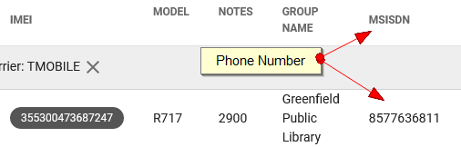
Pintrac uses “Organizations” (always MA Board Library) and “Groups”, (Your Library’s Name) to organize the devices.

Suspend / Restore Hotspot  Scenario: Patron does not return a hotspot. Library wishes to suspend service to make it non-functional.  Any of these three methods will work. | Option 1: T-Mobile Dashboard  (See: https://www.t-mobile.com/support/account/suspend-or-restore-your-line )  Login into the T-Mobile dashboard at: https://statelocalgov.tmorders.com/portal  Select Subscriber Management and find the line you want to suspend. You can use the search box and type in the phone number.  Select the checkbox next to that number and then click the Suspend / Restore button above.  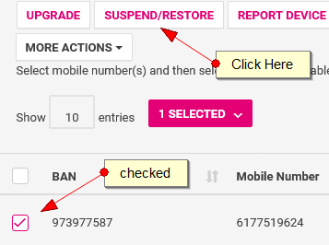  Select Add to Device to SUSPEND or Remove from Device to RESTORE service.  Leave today’s date for anticipated day of change.  Under Reason for Service Change, choose Temporary Suspend  Click Submit and follow the prompts to Complete the order.  Devices will remain suspended until you restore services or for 60 days, whichever comes first.  Suspensions/Restorations can be done on multiple lines at the same time.

Option 2: Pintrac Dashboard using Time of Day Access
Allows hotspot use only for one hour of the day in the early morning. Hotspot display shows RESTRICTED otherwise.
Log into the Pintrac Dashboard at: https://mdm.pintracview.com/login
Click on the phone number (MSISDN) you want to suspend.
Select Mobile SettingS
Change Time of Day Access to On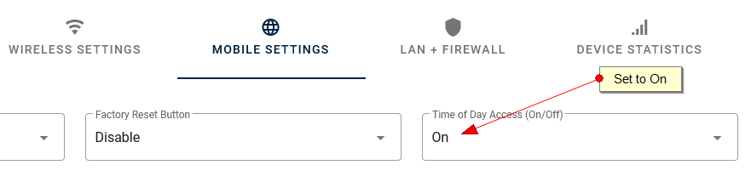

Scroll down to Manage Time of Day Access
In the leftmost column change Access Start Time to 03 (3:00AM) and Access End Time to 04
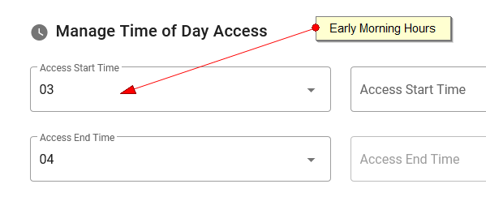
Save CONFIG and Publish
The hotspot will update next time it powers on or within 24 hours.
To RESTORE
Change Time of Day Access to OFF
Save CONFIG and Publish

Option 3: Pintrac Dashboard using SSID / Password Change
Blocks user from connecting devices to the hotspot by changing the SSID or Password and hiding display of that info on hotspot itself.
Log into the Pintrac Dashboard at: https://mdm.pintracview.com/login
Click on the phone number (MSISDN) you want to suspend.
Select Wireless Settings
Change the WiFi Name (and/or Password).
Change Display WiFi Name & Password to OFF
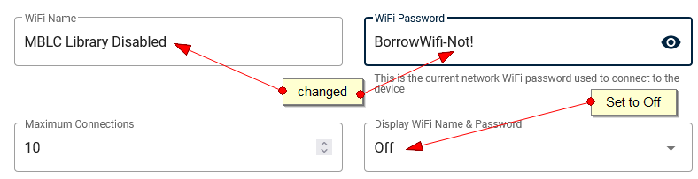
[Alternately, after changing the WiFi Name, set SSID Stealth Mode to On]
Save CONFIG and Publish
To RESTORE undo the changes made above, save config and publish.

Disable Filtering  Enabling and disabling filters can only be done through T-Mobile: via the dashboard, email or phone. | Option 1: T-Mobile Dashboard (single device)  Only one device at a time via the dashboard. Use phone or email for multiple hotspots.  Detailed instructions and video on MBLC website.  Login into the T-Mobile dashboard at: https://statelocalgov.tmorders.com/portal  Select Subscriber Management and find the line for which you want to change filtering. You can use the search box, above right, and type in the phone number.  Select the checkbox next to that number.  Under More Actions, select Feature Change.  Confirm the correct phone number and:  - Request Type: Select Remove  - Anticipated Date of Change: 08/13/2021 (usually today)  - CONTENT BLOCKING: $1.00 Magenta-Business EDU Filtering $1 Sub [no charge to library]  - Submit  Follow several screen prompts to place the change order (like a shopping cart).  To re-enable filtering, follow the same steps but select Add or Change for the Request Type.

Option 2: EMAIL
Send email to: megan.stafford@t-mobilesupport.com
Provide the MBLC BAN (973977587), the phone number(s) for the hotspots, and whether you are adding filtering back or removing filtering.
Suggested template:
****************************
Please remove EDU filtering on for My Town Public Library (BAN # 973977587) for the following lines:
• 857588####
• 857701####
• 857763####
Your name
Your title
Your email
****************************
Giselle will respond via email.

Option 3: T-Mobile PHONE
Phone calls may be fast, but since it involves reading out cellular numbers, email is probably the better way to go.
Call 423-497-1793 (Giselle Torres)
Provide the MBLC BAN (973977587), your name and contact info (email / phone)
Provide the same information as in Option 2, email, above.

Change SSID (Network Name) / Password | Changing the SSID or Password is done in the Pintrac MDM only.  Log into the Pintrac Dashboard at: https://mdm.pintracview.com/login  Click on the phone number (MSISDN) you want to change.  Select Wireless Settings  Change the WiFi Name (Minimum 6 chars) and/or Password (Minimum 8 chars).  Save CONFIG and Publish

This MBLC Public Library Hotspot Lending project is funded in part with funds from the Institute of Museum and Library Services, a federal agency that fosters innovation, leadership, and a lifetime of learning. 

