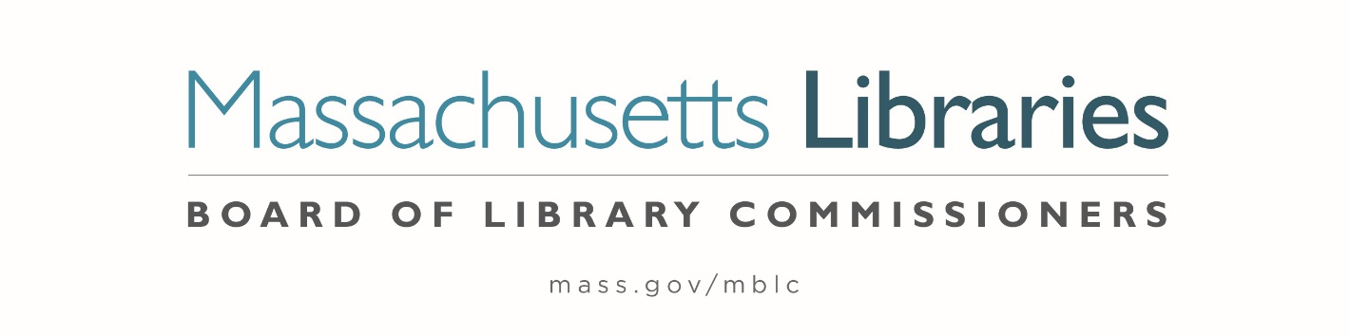

Welcome. Thank you for attending this meeting of the Massachusetts Board of Library Commissioners. Please remember that as part of the meeting agenda there is a time at the end of the meeting for public comment. Should you wish to address the Board during a particular item, please wait to be recognized by the chair.
Note: Agenda may include items not reasonably expected 48 hours before the meeting.
Massachusetts Board of Library Commissioners Monthly Board Meeting
Wednesday, December 3, 2025
HYBRID*
Massachusetts Board of Library Commissioners Offices
90 Canal Street, Suite 500, Boston, MA
Meeting to Start: 9:00 AM

*Pursuant to Chapter 2 of the Acts of 2025- An Act Extending Certain COVID-19 Measures Adopted During the State of Emergency, this meeting will be conducted in person and via remote means, in accordance with applicable law. This means that members of the public body as well as members of the public may access this meeting in person, or via virtual means. In person attendance will be at the Massachusetts Board of Library Commissioners Offices and it is possible that or all members of the public body may attend remotely, with in-person attendance consisting of members of the public. This meeting may be accessed remotely via:

Register in advance for this meeting:
https://us02web.zoom.us/meeting/register/KdvJnCcBT6-rREl4SX4F-g

When required by law or allowed by the Chair, persons wishing to provide public comment or otherwise participate in the meeting, may do so by in-person attendance, or by accessing the meeting remotely, as noted above.

- Call to order

- Welcome

- Roll Call of Commissioners

Speaker: Commissioner Linehan, Secretary

- Approval of Minutes- November 6, 2025 Minutes

Speaker: Vicky Biancolo, Chair

- Chair’s Report

Speaker: Vicky Biancolo, Chair

- Commissioner Reports

Speaker: Vicky Biancolo, Chair

- Director’s Report

Speaker: Maureen Amyot, Director

- Legislative Report

Speaker: Rob Favini, Government Liaison

- Consideration of approval for the 2023-2024 Grant Round, Construction Phase Provisional Grant Award for the Town of Blandford (ACTION)

Speaker: Andrea Bono-Bunker, Library Building Consultant

- Consideration of approval of municipalities meeting the requirements for the FY2026 State Aid to Public Libraries based on eligibility established in FY2026 for the Municipal Appropriation Requirement and in FY2025 for the minimum standards (ACTION)

Speakers: Cate Merlin, Head of State Programs
Jen Inglis, State Aid Specialist

- Consideration of appointment to the Statewide PR Committee (ACTION)

Speaker: Celeste Bruno, Communications Director

- Report from the Massachusetts Library System

Speaker: Sarah Sogigian, Executive Director
Massachusetts Library System (MLS)

- Report from the Library for the Commonwealth (LFC)

Speaker: Sarah Jackson, Network Administrator
Library for the Commonwealth/ Boston Public Library

- Quarterly Report from Perkins Braille and Talking Book Library

Speaker: Kim Charlson, Library Director

- Quarterly Report from Worcester Talking Book Library

Speaker: Lee Anne Hooley, Worcester Talking Book Library

- Reports from Library Partners

- Staff Years of Service Pins

- Amy Clayton- 25 years
- Rachel Masse- 25 years
- Aparna Ramachandran- 5 years
- Maureen Amyot- 1 year
- Heather Backman- 1 year
- Jessica Colati- 1 year
- Ally Dowds- 1 year
- Al Hayden- 1 year
- Cate Merlin- 1 year

- Unfinished Business and General Orders

- Public Comment

- Adjournment Vicky Biancolo, Chair

To review the Massachusetts Board of Library Commissioners current bylaws
(Organizations and Functions of the Board of Library Commissioners)
Visit https://mblc.state.ma.us/about-us/commissioners/index.php

