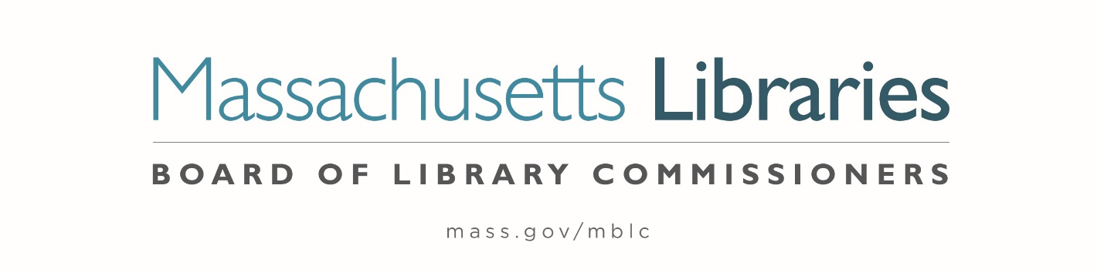

Welcome. Thank you for attending this meeting of the Massachusetts Board of Library Commissioners. Please remember that as part of the meeting agenda there is a time at the end of the meeting for public comment. Should you wish to address the Board during a particular item, please wait to be recognized by the chair.
Note: Agenda may include items not reasonably expected 48 hours before the meeting.
Massachusetts Board of Library Commissioners Monthly Board Meeting
Thursday, August 7, 2025
HYBRID*
Marlborough Public Library
35 W Main Street, Marlborough
10:00 AM (Refreshments 9:30 AM)

*Pursuant to Chapter 2 of the Acts of 2025- An Act Extending Certain COVID-19 Measures Adopted During the State of Emergency, this meeting will be conducted in person and via remote means, in accordance with applicable law. This means that members of the public body as well as members of the public may access this meeting in person, or via virtual means. In person attendance will be at Massachusetts Board of Library Commissioners Offices, Boston and it is possible that or all members of the public body may attend remotely, with in-person attendance consisting of members of the public. This meeting may be accessed remotely via:

Register in advance for this meeting:
https://us02web.zoom.us/meeting/register/wtPuWgKBQJ6B4ZuSfUN7lA

When required by law or allowed by the Chair, persons wishing to provide public comment or otherwise participate in the meeting, may do so by in-person attendance, or by accessing the meeting remotely, as noted above.

- Call to order

- Welcome

Speaker: Sara Belisle, Library Director

- Roll Call of Commissioners

Speaker: Commissioner Linehan, Secretary

- Approval of Minutes- July 10, 2025 Minutes

Speaker: Vicky Biancolo, Chair

- Chair’s Report

Speaker: Vicky Biancolo, Chair

- Commissioner Reports

Speaker: Vicky Biancolo, Chair

- Director’s Report

Speaker: Maureen Amyot, Director

- Legislative Report

Speaker: Rob Favini, Government Liaison

- Consideration of approval for a one-year extension of the current FY2021- FY2025 MBLC Strategic Plan (ACTION)

Speaker: Maureen Amyot, Director

- Consideration of approval for the Library eBooks and Audiobooks (LEA) Content Grants

- Consideration of approval of amended LEA Fact Sheet (ACTION)
- Consideration of approval of the LEA Content Grants (ACTION)

Speaker: Jaccavrie McNeely, Electronic Systems Specialist

- Preliminary discussion of the FY2027 Legislative Agenda

Speakers: Maureen Amyot, Director
Rob Favini, Government Liaison

Groups invited to speak:
Massachusetts Library System (MLS)
Library for the Commonwealth (LFC)
Library Networks
Perkins Library, Watertown
Worcester Talking Book Library
Western Mass Library Association (WMLA)
Central Mass Library Association (CMLA)
Massachusetts Center for the Book
Massachusetts Library Association (MLA)
School Library Association

- Report from the Massachusetts Library System (MLS)

Speaker: Sarah Sogigian, Executive Director
Massachusetts Library System (MLS)

- Report from the Library for the Commonwealth

- Unfinished Business and General Orders

- Public Comment

- Adjournment Vicky Biancolo, Chair

To review the Massachusetts Board of Library Commissioners current bylaws
(Organizations and Functions of the Board of Library Commissioners)
Visit https://mblc.state.ma.us/about-us/commissioners/index.php

