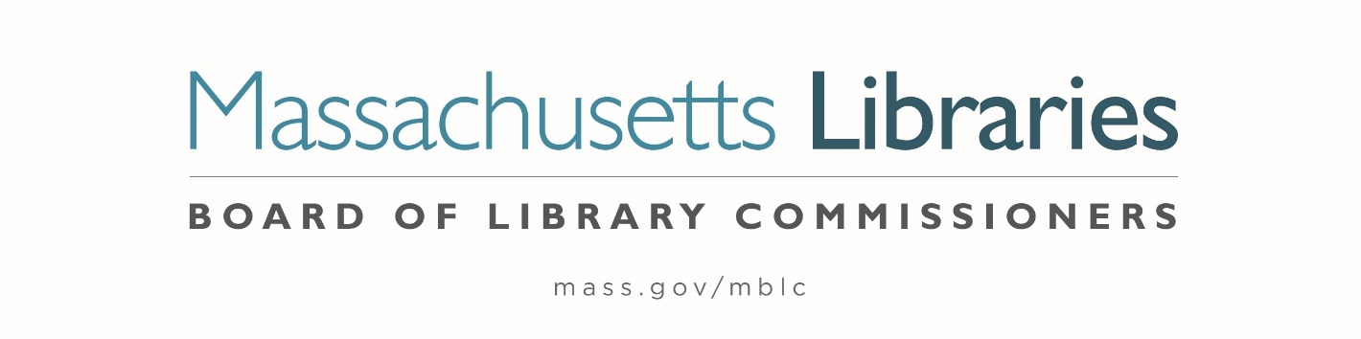

MINUTES OF THE BOARD OF LIBRARY COMMISSIONERS monthly regular meeting

Date : Thursday, August 7, 2025

Time : 10:00 A.M.

Place : Marlborough Public Library

Board
Present : Vicky Biancolo, Chair; Timothy Cherubini, Vice-Chair; Joyce Linehan, Secretary;
Kate Chang; George Comeau, Esq.; Debby Conrad; Kemarah Sika; Karen Traub;
Jessica Vilas Nova

Staff Present:
Maureen Amyot, Director; Heather Backman, Library Building Specialist; Andrea Bono-Bunker, Library Building Consultant; Jess Colati, Preservation Specialist; Terry D'Angelo, Administrative Assistant / Business Office; Tracey Dimant, Head of Operations & Budget / Business Office; Allyson Dowds, Consultant to Special Populations; Jen Inglis, State Aid Specialist; Rob Favini, Head of Library Advisory and Development; Al Hayden, Library Advisory Specialist; Rachel Masse, Assistant to the Director; Jaccavrie McNeely, Electronic Services Specialist; Cate Merlin, Head of State Programs; June Thammasnong, Communications Specialist

Observers Present:
Courtney Andree, Massachusetts Center for the Book; Laurie Lessner, SAILS Network; Nancy Milone Hill, Hopkinton; Sarah Saleh, Harvard/ trustee (ZOOM); Sarah Sogigian, Massachusetts Library System; Karen Urbec, East Bridgewater Public Library (ZOOM)

Meeting called to order by Chair Biancolo
Chair Biancolo called the meeting to order at 10:00 A.M.

Roll Call of Commissioners

Commissioner Linehan stated that she is required to take a roll call of Commissioners to comply with the Open Meeting Law for hybrid meetings.

Commissioner Biancolo - Present | Commissioner Comeau- Present | Commissioner Sika- Present
Commissioner Chang – Present Zoom | Commissioner Conrad- Present | Commissioner Traub- Present
Commissioner Cherubini- Present | Commissioner Linehan- Present | Commissioner Vilas Novas- Present Zoom

Chair Biancolo explained that she would be making a motion to comply with a consent agenda. A consent agenda is a board meeting practice that groups routine motions into the consent agenda. If there are no objections, the Chair can declare a motion passed, rather than counting votes for each motion separately.

Chair Biancolo moved to adopt a consent agenda for agenda items #7- Consideration of approval for a one-year extension of the current FY2021-FY2025 MBLC Strategic Plan; #8 Consideration of approval for the Library eBooks and Audiobooks (LEA) Content Grants- a.) Consideration of approval of amended LEA Fact Sheet; b.) Consideration of approval of the LEA Content Grants.

Commissioner Conrad seconded.

Chair Biancolo then requested a roll call vote for the consent agenda.

Commissioner Biancolo - Yes | Commissioner Comeau- Yes | Commissioner Sika- Yes
Commissioner Chang – Yes | Commissioner Conrad- Yes | Commissioner Traub- Yes
Commissioner Cherubini- Yes | Commissioner Linehan- Yes | Commissioner Vilas Novas- Yes

Approval of Minutes from the regular monthly meeting:

July 10, 2025

Chair Biancolo asked if there were any corrections to the July 10, 2025 minutes as presented.

There were no corrections.

Minutes were approved as presented.

Chair Report

Chair Biancolo provided the following report.

I’ve appointed Tim Cherubini to the strategic planning committee. His broad experience not only with this board, but as a librarian, a board member with the Center for the Book, and with the networks and state librarians, will serve the agency well.

We are starting a new year, so please let me know how you are feeling about your committee assignment/s. Also, to free up Commissioner Cherubini for his work on the strategic plan, he will not be attending the monthly meeting of the MLA legislative committee. Please let me know if you would be interested in joining me at these meetings.

I contributed written testimony to the Joint Committee on Tourism, Arts and Cultural Development, asking for their support for the Right to Read and eBook pricing bills.

- July 11: Zoom meeting with Electronic Services Specialist Jaccavrie McNeely to go over edits to the Commissioner Orientation LibGuide
- July 15: Met with Commissioners Cherubini & Sika in Wareham to start a dialogue and answer any of Commissioner Sika’s questions
- July 15: Attended the Summer Reading event with the Boston Bruins at Wareham Free Library
- July 16: Listened to the webinar A Library Is Not a Computer: Librarianing for Social Flourishing, presented by Margo Gustina and co-sponsored by Simmons University, Massachusetts Library System, and the Massachusetts Board of Library Commissioners
- July 18: Attended the monthly meeting of the Central Massachusetts Library Advocates
- July 29: Attended the monthly Zoom meeting of the eBoard

FYI, In order to accommodate all executive board members, we will be moving the executive board meeting, where we set the agenda for the monthly meeting, to Wednesdays at 10. This will give Rachel just enough time to post the agenda in accordance with the bylaws.

Commissioner Activities

Commissioner Cherubini
- July 14- Attended the monthly meeting of the Massachusetts Library System Executive Board (virtual)
- July 15- With Chair Biancolo, met with Commissioner Sika for welcome and orientation (Wareham, MA)
- July 29- Attended the monthly meeting of the MBLC Executive Board (virtual)
Commissioner Conrad
- July 15 – Summer Reading events at Osterville Library and Wareham Free Library
- July 22- Attended the Hearing on Right to Read and Ebook legislation (virtually) Submitted written testimony
- July 24 – Summer Reading Event at the Sherborn Public Library
- July 26 – Attended the virtual meeting of the Massachusetts Friends of Library (MFOL) as the group reorganizes. There will be a meeting on November 8 at the Worcester Public Library and they hope to have a more formal program in the spring
- July 28 – Attended the virtual meeting of the Massachusetts Library Association Legislative Committee working group planning the fall advocacy event. It will be held on October 7 at the Worcester Public Library
- July 30 – Joined the Southeast Library dinner with Director Amyot in Taunton
- August 6 – Attended the Massachusetts College of Art Aluminum Pour event at the Fall River Public Library

Commissioner Linehan
- July 22- Attended the MassArt Workshop in Lowell that was sustainable fashion
- August 6- Attended the MassArt Workshop in Fall River that was the aluminum pour

Commissioner Sika
- July 15- Attended Bruins Visit in Wareham
- July 18- Participated in Strategic Planning Meeting
- July 22- Submitted written testimony for the Freedom to Read legislation

Commissioner Traub
- July 18- Commissioner Awards Meeting
- July 22- Mass Library Trustee Association Meeting
- July 22- Summer Reading visit Hadley Library
- July 26- Mass Friends of Libraries Meeting
- July 29- United for Libraries webinar for Trustees
- July 30- Western Mass Library Advocates Coffee hour

Commissioner Vilas Novas
- July 1 - Woburn PL summer reading kickoff - speaker
- July 16 – Nevins Library, Methuen Summer reading
- July 16 - listened to recording of Maureen testifying before the House Committee on Federal Funding, Policy and Accountability

Director’s Report
Director Amyot provided the following report:

Business Office
The Business Office team continues to review and update multiple budget projections as we work to anticipate what the future of the Institute of Museum and Library Services (IMLS) and the Grants to States Program will look like in federal fiscal year 2026 and beyond.

Regarding IMLS funds, our FY2026 budget plan utilized only state funds to cover all our intended projects and support. However, while the current allotment from IMLS is still active, and IMLS is still functioning, we are submitting reimbursements for those invoices that would otherwise be paid by FY2026 state funds. We have asked for invoices for the full fiscal year whenever possible, so we can utilize federal funding to pay for the full year of such projects as the databases we were able to retain, eRate assistance, and the Commonwealth Catalog (ComCat).

Utilizing the current allotment of federal funding while IMLS is still functioning allows us to future-plan for the very real potential for 9C cuts from the state during this fiscal year. (See Rob Favini’s legislative report for a description of 9C cuts.) Our primary plan for FY2026 is based on the expectation that our IMLS funding will be cancelled. Under that plan, we moved projects, payments, and staff salaries from federal funding to state budget lines. All those shifts are in line with what the state budget lines are meant to support. While we have paid in advance everything we are able, we still have several items we’ll need to fund in Q2 through Q4 (including the ARIS software, the Communications plan, the completion of the Website Accessibility project, the network grants, staff salaries, and all the technological infrastructure that keeps the agency functioning). If 9C cuts do occur, we’ll have those funds from our federal reimbursements, which will allow our spending plan to remain whole.

If there are no 9C cuts, and/or the funding from IMLS continues with the new allotment beginning in October, we will work on our plan to utilize those funds for things like direct grants, increased funding to eContent, and other initiatives.

The BEST (Business Enterprise System Transformation) project (the modernization of the state finance and Human Resources systems) continues to move forward. The Business Office team received a “behind the scenes” look at the new system (called Mosaic) this month. Go-live for the state finance system takes place in January. Initial training for the Business Office team is expected to start in the coming weeks.

Communications
The Communications Team has been on the road in July with some of our high-visibility events: Bruins summer reading visits and MassArt at the Library. Bruins visits have been packed, and media coverage across the state has been outstanding. We made our first-ever Bruins visit to Russell, and it attracted the attention of the local police department! They stopped by to see what was going on at the library because there were so many cars that they weren’t used to seeing. Celeste Bruno shared news stories from Russell with Commissioners that week. We were also excited to visit Attleboro, Barnstable, Wareham, Hadley, and Sherborn.

Our first two MassArt workshops are done as well. Sustainable Fashion at the Pollard Memorial Library in Lowell featured an enthusiastic teen group who made tote bags from recycled sail material. Most had never used a sewing machine before. The two boys in the group, who only attended because their moms made them come with their sisters, ended up having a great time and were proud of their finished bags.

For the federal response, Celeste Bruno helped draft and edit weekly updates for July 11 and 18 and August 1 when there was news to share. We’re trying to get information out to the library community as soon as we have it, and her help has been invaluable. She also compiled talking points and coordinated scheduling for my radio interview with WBZ, helped me write testimony for the State House hearing with the cultural sector, and connected a western Massachusetts reporter with school librarians who could speak to the impact of database cuts on students.
Celeste also worked closely with the State Programs team to create a blog post that explains reporting changes in this year’s Annual Report of Information Statistics (ARIS) survey. A few librarians had reached out with the same questions, and a blog post allows the question to be answered easily if it should arise again.
Library Advisory and Development
July was full of webinars and events presented by the Library Advisory and Development unit.

Fortifying Your Library: Protecting Your Library and Staff Through Policy
On July 9, Al Hayden presented a webinar on the fundamentals of library policy for Niche Academy titled, Fortifying Your Library: Protecting Your Library and Staff Through Policy. The webinar had 563 live attendees from 44 states, plus Puerto Rico, 2 Canadian provinces, and Trinidad & Tobago. Registrations totaled 1676 individuals and included public and academic librarians. The recording is publicly available on Niche Academy's blog.

Census Data for Libraries: A Deeper Dive into Your Community encore presentation
On July 15th Al Hayden hosted an encore of this spring’s popular Census Data 101 and Census Data: A Deeper Dive. The session focused on discovering your community through Census Data. Nicole Esburnett McKenzie from the U.S. Census Bureau led a live demonstrations and taught participants to how to use data.census.gov to gain meaningful data and insights into a library's community. The data found can be used to inform advocacy, programming, services and more. The webinar had 39 registrants.

Introduction to Web Accessibility
Jaccavrie McNeeley presented Introduction to Web Accessibility, the first webinar in a new series discussing digital accessibility. Topics discussed included the Department of Justice ADA Title II ruling and how it affects libraries as well as some accessibility basics to get you started. The webinar had 75 registrants

New Blog Post
Immigration Enforcement and Library Spaces blog post by Ally Dowds: Libraries serve as vital community hubs and value their institutions as welcoming spaces that take proactive steps to protect patron rights and intellectual freedoms. Current federal immigration enforcement activities throughout Massachusetts and the broader United States have left library staff and stakeholders grappling with how best to support vulnerable community members and remain committed to missions rooted in diverse and inclusive practices. In the post Ally suggests pathways to support staff and sustain our place as trusted institutions for all patrons.

Upcoming Webinars and Events
Web Accessibility Office Hours announced
Jaccavrie McNeely and Kate Butler will host regular office hours to help libraries make their web content accessible. Office hours are scheduled monthly every first Friday at 11AM and third Wednesday at 3PM. For more information:
First Friday Session: Friday, September 5 at 11AM - No registration needed
Third Wednesday Session: Wednesday, September 17 at 3PM - No registration needed

Get to Know Your Local Trial Court Law Libraries
Ally Dowds invites the library community to join staff from the Massachusetts Trial Court Law Libraries to learn about legal resources available to the general public and library staff. Services like Ask a Law Librarian and Document Delivery Service and informational access to Massachusetts and Federal legal forms, treatises, and case law support legal research needs across the Commonwealth and may equip librarians with skills and tools to use during reference-based interactions. Registration is required. Tuesday, August 19 at 11AM - Registration & More Information

Environmental Monitoring: Identifying and Monitoring for Mold
Jess Colati will host a webinar featuring Conserv, MBLC's environmental monitoring program partner, who will offer a brief overview of mold risks and monitoring methods in library and archival collections. Registration required. Tuesday, August 12, 2025, at 2:00AM- Registration & More Information
State Programs

Construction
Most of the libraries that are in the Planning and Design phase have now executed contracts with architectural firms, and Andrea Bono-Bunker and Heather Backman are working closely with each one on building program reconciliations and initial designs.

The construction team visited Gloucester for a final walk-through before their soft opening, conducted a space planning visit in Wayland, attended the summer reading visit in Sherborn, and contributed to the internal working group on the agency's strategic plan.

Heather conducted a site visit at the Meekins Library in Williamsburg, updated resources on the construction webpages, and attended summer reading visits on the Cape and in western Massachusetts. Andrea sent out the Requests for Responses (RFRs) for independent reviewers for the Massachusetts Public Library Construction Program (MPLCP) Level of Design (huge thank you to Tanesha Deane in the Business Office) and met with the American Library Association/American Institute of Architects Library Architecture Awards jurors for a feedback session to suggest improvements to the award process.

State Aid
State Aid season continues! The Annual Report of Information Statistics (ARIS) closes at 5pm on Friday, August 15th. The Financial Report Survey opened this past Monday, August 4th, and closes at 5pm on Friday, October 4th.

Uechi Ng finalized the FY26 Financial Report, sent updates and edits to our vendor, Baker & Taylor; and scheduled six Financial Report workshops and three Waiver workshops beginning in late August.

Jen Inglis finished formal ARIS workshops, held two online ARIS Drop In Office Hours (with two more each week through August 15th), and answered hundreds of questions related to filling out the ARIS.

Cate Merlin continued her bi-monthly online State Aid Office Hours, which transition in August and September to weekly (Wed 9am) State Aid + Financial Report Drop In Office Hours. She began to work with libraries that will be applying for Waivers of the FY26 Municipal Appropriation Requirement (MAR) and also answered ARIS questions from libraries.

Director Activities
I am excited to report that the Strategic Plan is underway. Our internal steering committee met twice in August, and I worked with Commissioner Biancolo to get a commissioner liaison appointed. We are seeking representatives from the networks and affiliates, and will be looping the Statewide Advisory Council on Libraries (SACL) into the process shortly as well. I’ve already learned so much from this talented group.

I attended as many Bruins events as I was able, and actually had to miss a few due to events at the State House. I was happy to be able to meet State Representative James Arena-DeRosa and Governor’s Councilor Tamisha Civil at the Sherborn event and spent some time talking with both of them about all the ways libraries build community. Both stayed for the entire event, and Councilor Civil even participated in the tug-of-war with Bruins mascot Blades and the kids! I also got to attend the MassArt Sustainable Fashion program in Lowell, and plan to attend the Aluminum Pour this week.

I was invited to testify at a hearing of the House Committee on Federal Funding, Policy, and Accountability in their effort to understand the impact of federal cuts and policy changes on the cultural sector. David Leonard, President of the Boston Public Library; Maria McCauley, Director of the Cambridge Public Library and President-Elect of the American Library Association, and I were the first speakers of the day and found the committee to be engaged, interested, and not fully aware of the issues we were facing. I learned a lot from the museum speakers as well, and made some new connections with other cultural organizations.

Rob Favini and I attended the Tourism, Arts, and Culture Committee hearing on library-related bills – which included the “book ban bill” and the bill that would create a commission to study ebook pricing. We didn’t testify at the hearing, but submitted written testimony afterward.
I had my first radio interview in July as well, with WBZ Radio reporter Chaiel Shaffel. He came to the office, recorded about 30 minutes of Q&A, and it ran as a segment on the afternoon news the same day.

One of the highlights of the month was the SAILS Library Road Show, organized by librarians in the southeastern Massachusetts area. I had a great time meeting directors, Friends, trustees, and staff in 11 libraries of all different sizes. I got to see amazing archival materials, learn about programs and services, climb into a tower, and spend the night in a (reportedly) haunted home in Easton that’s owned by the library. It was nonstop library joy, and I truly thank everyone who worked so hard to organize all the stops on the tour and all the directors who proudly showed me their libraries. Laurie Lessner from the SAILS network was my traveling sidekick, Commissioner Conrad joined us for dinner, and I got to meet a librarian whose grandmother knows my mom. If that doesn’t tell you Library World is a small place, I don’t know what does!
In addition to all the library joy, testimony, and events, July is also kickoff month for our state-required employee evaluation process so there were a LOT of meetings and discussions happening behind the scenes. I couldn’t believe it was time to turn the calendar page to August. This summer is truly flying by.

Legislative Report

Rob Favini provided following report:

IMLS Funding Status
The Institute for Museum and Library Services (IMLS) still survives as the federal fiscal year winds down to September 30th. The future of the IMLS as a funded, functioning agency is very much in the balance. Currently the IMLS is staffed at a level that allows for some regular interactions with states. For example, we are scheduled to have a virtual Grants to States visit from our IMLS Program Manager in September. We are keeping a close eye on the following congressional funding and authorization milestones expected over the next few months will decide the fate of the IMLS.

Appropriations Committee Budget Mark Up: The House appropriations committee was scheduled to mark up the budget framework that was passed in the BBB last month. This crucial step determines if the House budget funds the IMLS beyond the $6 million framework: a level of funding for the purpose of shutting down the agency. If the IMLS budget is not restored the agency will be shuttered. Just as the process started the House went on a surprise recess. Budget markup will resume sometime in September.

Reauthorization of the Museum and Library Services Act of 2018: Sometime in September/October the legislation that authorizes the IMLS is up for a reauthorization vote. It is unclear if the vote will reach the floor. If it does there is a good chance that it will be voted down along party lines. This would eliminate the IMLS.

Possible Government Shutdown: Another threat to the continued operation of the IMLS is the possibility of a government shutdown. The current House recess and suspension of the budget markup process has put pressure on the federal budget process. If a new budget is not in place by October 1st there is the possibility that a government shutdown will impact IMLS operations.
Many of these scenarios are reported on in the following Book Riot article: https://bookriot.com/imls-funding-future/

Legislative Hearings
July saw two hearings that impacted the MBLC and the library community.
On July 15th the House Committee on Federal Funding, Policy and Accountability heard testimony on the impact of federal funding cuts on the arts and cultural community. MBLC Director Amyot joined Boston Public Library President David Leonard and Cambridge Public Library Director and ALA President-elect Maria McCauley to testify to the huge impact that the loss of federal funding has had, and will have, on libraries. The hearing also featured statements by representatives of the Mass Cultural Council, Mass Humanities, MASS MoCA, the Peabody Essex Museum and Mass Creative. A recording of the hearing is available here: https://malegislature.gov/Events/Hearings/Detail/5276

On July 22nd the Joint Committee on Tourism, Arts and Cultural Development heard testimony on a variety of bills introduced to address book banning and access to E Books. Featured were the bills reintroduced from last legislative session: H.3594/S.2328 An Act regarding free expression and H.3595 An Act addressing challenges facing public libraries and digital resource collections. A recording of the hearing is available here: https://malegislature.gov/Events/Hearings/Detail/5295

Save the Date
MLA Legislative Committee’s 2nd Annual Library Advocacy Boot Camp, October 7, 2025, 10:00am to 3:00pm at the Worcester Public Library.
This year's boot camp will focus on advocacy at the local level. How can you best work with selectboards, finance committees and other town officials to build long-term support for your library? How do you get the message out that the library is a need during tough financial times? What steps can you take to engage with your community when the library is under threat of disproportionate budget cuts? This program will address these and other questions to help you build your advocacy toolkit.

Speakers for the event will include Adam Chapdelaine, Executive Director and CEO of the Massachusetts Municipal Association, and Tim Garvin, President of the United Way of Central Massachusetts.

Get to Know Your Budget Process – 9C Cuts
Chances are good that you will be hearing the term 9C cuts throughout the coming fiscal year. Because there is the potential for lower-than-expected state revenue due to economic slowdown and the uncertainty of the state receiving $16 billion in Federal funding there is a chance that the Governor may rely on 9C cuts to keep the state budget balanced.
The following are the basics of 9C cuts as explained by the Executive Office for Administration and Finance:

What are 9C cuts?
The state's constitution requires a balanced budget. When the Legislature passes the budget at the beginning of the fiscal year, it must demonstrate that it anticipates there will be money to pay for the level of spending it authorized. The administration may announce 9C cuts at any time that it determines that there isn't enough money to pay for all authorized spending.

When are 9C Cuts made?
Every October 15th, the Administration is required to formally update its revenue estimates. Within 5 days of learning revenues will be less than expenditures, the Secretary of Administration and Finance must notify the Governor and the house and the senate committees on ways and means of any shortfall under section 5B. If the October 15th revenue projections are below the revenue level that was estimated when the budget was adopted at the beginning of the fiscal year, then the 9C process is generally implemented.

What can the governor cut?
The Governor can only use 9C powers to cut funding in parts of the government that are under her control—in other words, her 9C authority extends only to executive branch agencies. The Governor cannot use 9C authority to cut local aid, the courts, the Legislature, or other constitutional offices. The Governor can file legislation recommending cuts to those other areas of the budget. The legislature can then pass a law with those cuts, or with other cuts, new revenue, or the use of reserves.

Consideration of approval for a one-year extension of the current FY2021- FY2025 MBLC Strategic Plan

Director Amyot requested a one-year extension of the current Strategic Plan. She provided the timeline.

July 2025
Review ahead of time: Info on types of planning, past surveys, mission statement, sample vision and values statements
Steering Committee kickoff meeting:
- Discuss/decide length of plan (1 year/2 year/3 year?)
- Discuss various types of planning processes we’ve used before (SWOT, SOAR, others you have used and liked)
Select one(s) to use with focus groups
- Discuss – what do we want to know/ask? Review past surveys, if they’re available.
- Review current mission statement – will we keep it the same? Edit? Propose something new? Vision statement? Values statement?
- Divide up tasks
After the meeting:
Develop the survey
Research mission/vision/values statements

August 2025
Steering Committee – finalize the survey, set it up in LibApps.
Reach out to libraries to set up fall focus groups
Research mission/vision/values statements (if applicable)

September 2025
Launch survey
Sept staff meeting – staff focus group (who will lead?)
Research mission/vision/values statements (if applicable)

October 2025
Focus groups in the field
Begin writing mission/vision/values statements (if applicable)

November 2025
Board meeting – board focus group (who will lead?)
Focus groups in the field
Continue developing mission/vision/values statements (if applicable)

December 2025
Steering Committee – close the survey, compile the findings, distribute to committee members
Finalize mission/vision/values statements (if applicable)

January 2026
Steering Committee meeting:
- Review/discuss survey findings and focus group input
- Identify themes
- Select focus areas for the plan
- Divide focus areas among committee members to start writing goals/objectives/activities, timeline, and budgetary impacts
- Finalize mission/vision/values statements (if applicable)

February 2026
Steering committee meeting:
- Share preliminary drafts of goals/objectives/activities, timeline and budgetary impacts
- Discussion with Business Office about budget for implementing goals/objectives/activities in next fiscal year

March 2026
Steering Committee meeting:
Finalize strategic plan, develop or finalize implementation plan

April or May 2026
In person staff meeting: present plan to staff
Develop presentation for board meeting

May or June 2026
Present plan to board for acceptance

Commissioner Traub moved and Commissioner Comeau seconded that the Massachusetts Board of Library Commissioners extends the current MBLC five-year strategic plan to June 2026.

The motion passed under the consent agenda.

Consideration of approval for the Library eBooks and Audiobooks (LEA) Content Grants

Jaccavrie McNeely, Electronic Services Specialist, presented the changes to the fact and the awards to the FY2026 Library eBooks and Audiobooks Content Grant.

Consideration of approval of amended LEA Fact Sheet

Amended LEA Fact Sheet is included in materials. Changes to the fact sheet are:

- updated the grant timeline
- added the caveat that networks can spend the platform fee amount differently this year.

Commissioner Conrad moved and Commissioner Linehan seconded to approve the FY2026 grant opportunity as described in the amended fact sheet: Library eBooks and Audiobooks (LEA) Content. The Board authorizes any additional FY2026 disbursements that may be possible toward the end of the grant cycle.

The motion passed under the consent agenda.

Consideration of approval of the LEA Content Grants

The Library eBooks and Audiobooks (LEA) Content grant provides networks participating in the LEA program with additional funds to purchase shareable eContent. These funds will directly support the continually growing demand for eBooks and Audiobooks across the Commonwealth.

Network | Municipality | Award (Content) | Award (Platform)
CLAMS | Hyannis | $35,048.87 | $12,000
CW MARS | Worcester | $79,615.86 | $12,000
MBLN | Boston | $105,591.88 | $10,000
Minuteman Library Network | Natick | $103,166.15 | $12,000
MVLC | Lawrence | $39,073.19 | $12,000
NOBLE | Danvers | $38,934.86 | $12,000
OCLN | Braintree | $51,238.81 | $12,000
SAILS | Lakeville | $47,330.38 | $12,000
$500,000 |  |  | $94,000

Commissioner Comeau moved and Commissioner Conrad seconded that the Massachusetts Board of Library Commissioners approves the following eight LEA Content Grants totaling $594,000 for FY2026.
The motion passed under the consent agenda.

Preliminary discussion of the FY2027 Legislative Agenda

Sarah Sogigian gave the following remarks about the FY27 Legislative Agenda.

The Massachusetts Library System (MLS) understands the balance of funding between the seven budget lines administered by the Massachusetts Board of Library Commissioners (MBLC). A decrease is funding for one line affects all the others.

Increased funding to Budget lines 7000-9101 and 7000-9501 will ensure targeted statewide funding becomes local funding. The MBLC is uniquely positioned to create and administer specific grants to address state and local priorities, and local libraries will step up to do what they do best: leveraging their deep knowledge of their communities and their professional expertise to deliver the skills and services people will need most. Aligning state and local funding strengthens the outcome for all in the Commonwealth.

Additionally, increases to all the budget lines administered by the MBLC will assist in these sharing efforts, and MLS is committed to continuing to offer services and programs that appropriately address these priorities.

Laurie Lessner presented the following remarks on behalf of the networks.

I am here to represent the library networks and our libraries, throughout MA. Each year we go through an evaluation of our services and determine what can be done based mostly on finances. This upcoming year will be no different, though we are all being cautious, since we don't know what the economy or country will look like. We love being part of MA and are very thankful MA leads the nation in so many progressive initiatives and truly understands first amendment rights. I'm not going to be cliche by saying libraries are essential services, especially during these troubling times. That would be silly given the audience.

We know how essential libraries are and one point the legislators should also understand is we don't provide this amount of justice for free. It takes qualified staff; authoritative materials, such as expensive databases and overpriced digital content; managing circulation systems; and providing internet services to get to those circulation systems.

Services that patrons expect are also more and more expensive. These include an unlimited number of digital books; internet services - wifi at the library and to use at home; meeting spaces for students, local businesses, people looking to have a private zoom session with doctors or lawyers; resume writing… The public is still relying on their local library to keep them educated, connected, and viable. And also safe. A service the public doesn't see is our telecom service, which includes maintenance against cybersecurity threats. Rather than hire a staff member to monitor and maintain our network, we outsource for the service. Luckily we've made good use of e-rate and are hoping that continues because the service costs the same as a half-time staff position.
We've already had our ebook (LEA) funding cut in half. Cuts to shared programs, such as LEA, work their way down to affect the individual library budgets. The legislators need to understand this is all one big system and cutting funding to the network is the same as cutting funding to our member libraries. Our business is resource sharing. We share the profits and benefits of scale, and also the losses which go deep. We can't be short-sighted. We need to realize cutting citizens' access to knowledge may not be noticed right away, but in time, crime goes up, economies go down, and then we have to start over again and build up to where we're able to increase services that meet the demands of our communities, and hope the cycle doesn't start over again.

When one program receives less, that money needs to be taken from another program or else be eliminated. It then becomes a question of priorities. We went through this in consideration of the Statewide cuts to the databases. The SAILS network and members have been shuffling resources to make up for that loss. The individual libraries decided not to renew our Novelist subscription in order to look at other products to fill the gaps from the statewide loss. The question from the libraries is always, "Is this coming from network funds or from our assessments or are we paying outright?" And the answer is, we'll have to see.

Of course we also need to account for inflation. Level funding is the same as a cut. If we don't give staff a cost of living increase, will that affect the whole MA economy? It ends up being less money all around.

What is expected in the future? College enrollment may continue to decline with people moving towards learning trades or going directly into the workforce. If college becomes even harder to pay for, less people may choose to go. This population adds to our clientele because college libraries are no longer helping to fill our services. Other places where we'll most likely see a demand for help is from k-12 students' research needs. It seems to be a trend for schools to not employ a certified librarian and have clerks check out books and English teachers or reading coordinators handle the book selection, and no one there to teach research skills. Then they lose their MLS membership, which affects resource sharing, which affects their network membership. How can they justify staying a network member if they're only using a fraction of the system? So that leads to increased assessment fees for our existing members.

And there's AI. We can't have a discussion of the future without this piece. Personally I make great use of it and I feel I'm so successful because I learned how to phrase what I'm asking for. I use the research skills I learned in library school to be precise with my request. People will need to learn how to formulate their queries or ask the librarians to get it for them. This is how the internet started. Demand for library services will only grow as more people start using AI and need to find answers for how to best use it.

My biggest concern is for our members having to fight for our services. If the libraries have to off-set our costs by too much, we'll need to raise their assessments in a very noticeable way. We don't have many non-essential services left to remove. The biggest expense, aside from personnel, is ebooks, which took up 18% of the FY25 budget. Will that go next? Will our patrons want to support us if they can't get their books? This is a huge expense but it also gets so many more people using our services. I see 2 solutions; lower the cost of the ebooks or give libraries more funding.
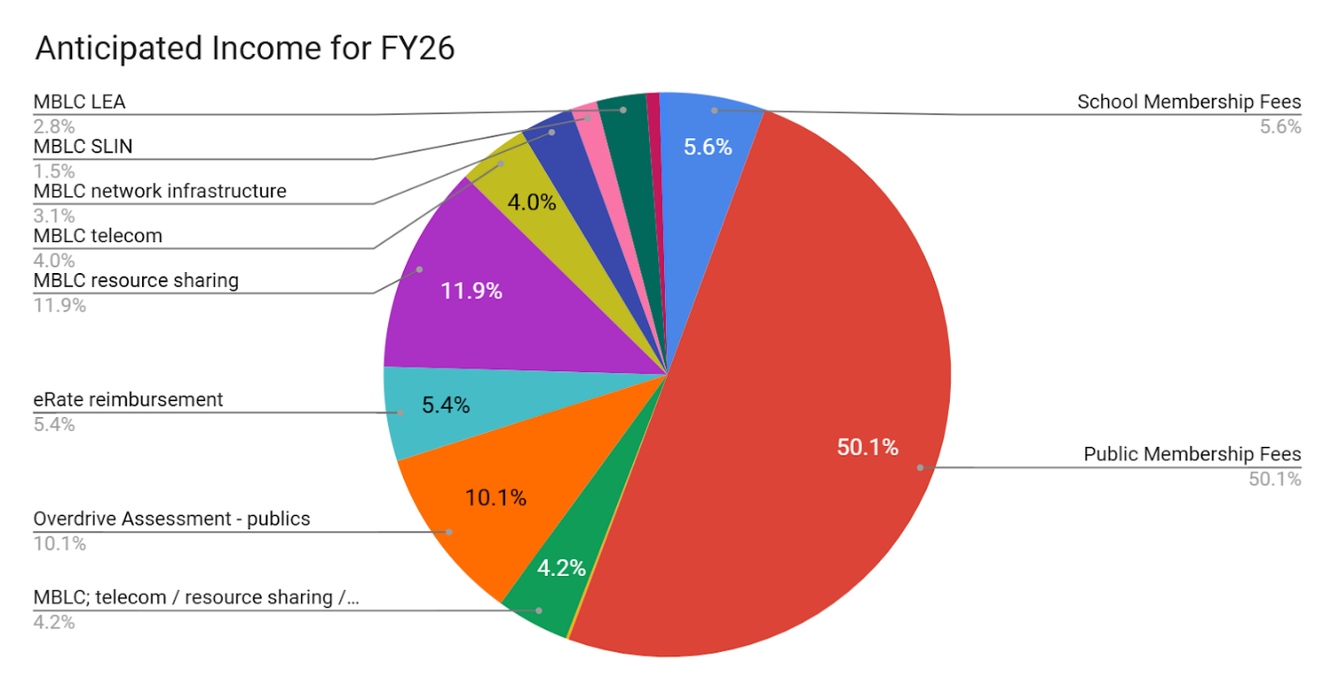
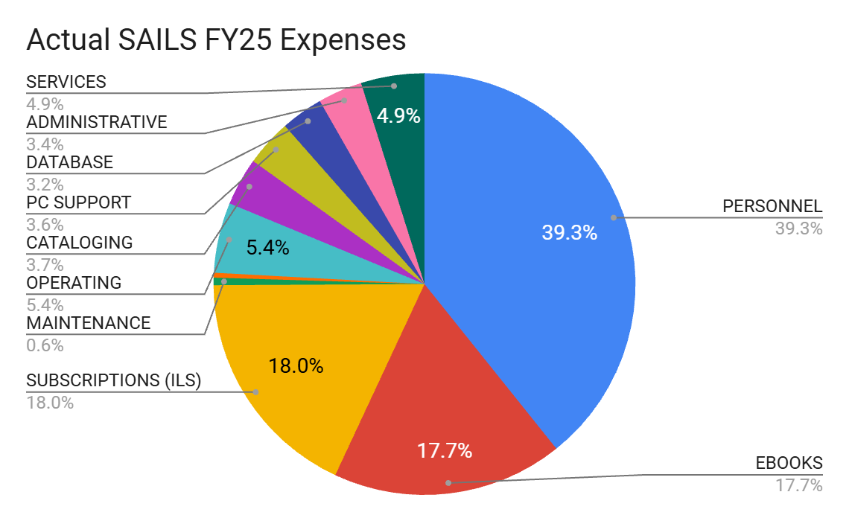

Comments from Courtney Andree, Executive Director, Mass Center for the Book
Mass Center for the Book is entering into its third year of ﬂat funding. Over this period, we have greatly expanded our program oﬀerings and partnerships as we work to bolster literacy and learning across the state. We are serving more libraries than ever before, while working hard to keep expenses in check. That said, this is becoming diﬃcult to sustain, with core inﬂation rising at a rate of 3–4.0% annually across the region. External sources of funding that supplement our activities are also at risk—Mass Cultural Council has phased out its Cultural Investment Portfolio, which provided us with $9,500 in general operating support in FY25. Additionally, the annual funding that we receive to support our participation in National Book Festival is in jeopardy, since it originates with IMLS.
If funding isn’t sustained at the state level, many of the recent gains and program additions that we have made will need to be scaled back or even put on hiatus; programs that may be impacted include Mass Kids Lit Fest, our statewide “one read” program tied to National Book Festival, our student and adult Reading Challenge initiatives, and the Mass Book Awards Speakers Bureau. For many small, Gateway, and rural libraries, the turnkey oﬀerings, program materials and books, and access to quality author programs that we provide (all free of charge) are a lifeline. As resources become increasingly scarce at the local level and municipal budgets are slashed, our programs are needed more than ever to help to ﬁll in the gaps.
We are currently working with a fundraising consultant to see if we can supplement our budget with underwriting, grants, and private gifts. Admittedly, it is a diﬃcult time to enter the fray, with the nonproﬁt sector scrambling to replace lost federal dollars, and overall charitable giving in decline as donors pull back in the face of an unstable economy. While we are cautiously optimistic and have only just begun to approach possible underwriters, no funds have yet been secured, and we are uncertain of what the future holds.

MLA

The MLA Legislative Committee is deeply concerned with the state of local funding as we enter the budget planning process for FY2027. We have heard from many public library directors who have been told to expect tighter budgets in the coming year. We strongly encourage the MBLC to continue seeking significant increases to Public Aid to Local Libraries account 7000-9501 to help alleviate these budget pressures and to also provide incentive for municipal officials to maintain local library funding at a level commensurate with other town departments.

As the MBLC anticipates reductions in federal funding, the MLA Legislative Committee is also concerned about the impact of these cuts on the grants for the automated resource sharing networks. Reductions in these grants are likely to lead to higher assessments for member libraries at a time when they are least able to afford significant increases. We recommend that the MBLC advocate for enough funding in Library Technology and Resource Sharing account 7000-9506 to ensure that these grants remain intact.

Report from Massachusetts Library System

Strategic Initiative 1
MLS ensures its services are sustainable, prioritize member needs, and equitably serve all member types.

Goal | Actions | Measurement of Success | Monthly work towards goal
MLS ensures service value to all member types. | MLS will create new avenues for active member engagement, including task forces, class leaders, and project engagements. | MLS will report to member libraries on an annual basis the number of active member engagements. | Changes made by the new School Library Membership Policy are being implemented.  Sarah Sogigian and Rob Favini (MBLC) launched their 2023 Road Trip program  Two Masscat public library members (Huntington and Becket) have signed contracts to join C/WMARS, with support from MLS.
MLS will continue to strengthen its partnerships and collaborations to allow MLS to focus on what it does uniquely well. | Utilizing the newly created partnership policy and process, MLS will explore possible partnership work with the Library for the Commonwealth and other organizations. | MLS will report to member libraries on an annual basis the value of their partnerships. | We launched the five-part webinar series with ALA on intellectual freedom topics. Three webinars occurred in February with 176 participants at the live events and 94 views of the recordings. Two additional webinars will occur in March. Recordings of the webinars will be available for 18 months.  We continued working with MBLC and other organizations to host a webinar series on mental health supports and libraries. One webinar occurred in February and two will occur in March.  Staff from MLS, MBLC, public libraries, and other New England state libraries began the Touchpoints for Libraries train- the-trainer program to teach the Touchpoints program to Massachusetts library staff. The training will continue in March.  We continued working with other New England states on this year’s Summer Summit, to help libraries prepare for the youth and adult summer library program. The event is scheduled for March 31.
New services will be designed to deliver the greatest statewide impact, able to expand and contract due to available funding and need. | MLS will evaluate current, new, and proposed services using a new internal service review process. | MLS will ensure that services are able to expand and contract due to available funding, need, and capacity.

Strategic Initiative 2
MLS empowers leaders to emerge at every level of library service, connecting staff throughout the stages of their careers.

Goal | Actions | Measurement of Success | Monthly work towards goal
MLS promotes excellence and continuity by providing professional development, conversation, and community around leadership. | Together with our partners, MLS will lead the planning of learning opportunities on leadership and management topics and ensure networking options in our engagements. | MLS will report to member libraries on an annual basis the leadership and management learning opportunities hosted and the reflection from participants. | We scheduled a series of four workshops with the Employers Association of the NorthEast on HR topics relevant for libraries (employment Law, interviewing, performance management, and documentation skills). They will take place March through May.  We are working with EANE to schedule four community chats on HR related topics.
Leadership, professional development, and networking opportunities will have flexible offerings in order to include participants from various library types, library sizes, and resources. | MLS will explore the creation of grants and/or scholarship opportunities to support member library staff in their professional development work. | MLS will report to member libraries on an annual basis the number of opportunities available, awarded, and the reflection from participants. | We launched the Language Learning Grant program and approved 20 applications in February.

Strategic Initiative 3
MLS will take the lead in facilitating important conversations, and support member-facing initiatives focused on DEI: diversity, equity, inclusion, accessibility and social justice.

Goal | Actions | Measurement of Success | Monthly work towards goal
MLS will integrate the core values of diversity, equity, inclusion, accessibility and social justice into its policies, practices, procedures, and programs. | Utilizing learnings from our work last year, MLS will continue its review of documents, resources and practices to ensure they align with core values.  In partnership with trusted experts, MLS will begin an accessibility audit of MLS services. | MLS will demonstrate both increased resource allocation as well as substantive, visible progress in representation throughout MLS services.
Following the lead of trusted experts, MLS will build awareness in using the DEI tenets with member library staff to identify and eliminate barriers to inclusive library services. | Utilizing established services, MLS will showcase member libraries that are using the core values of DEI within their communities. | MLS will report to member libraries on an annual basis the DEI learning opportunities hosted and the reflection from participants.

Unfinished Business and General Orders

PUBLIC COMMENT

OLD BUSINESS

ADJOURNMENT

The meeting adjourned at 12:45 PM

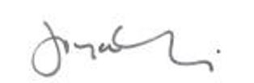

Joyce Linehan
Secretary

