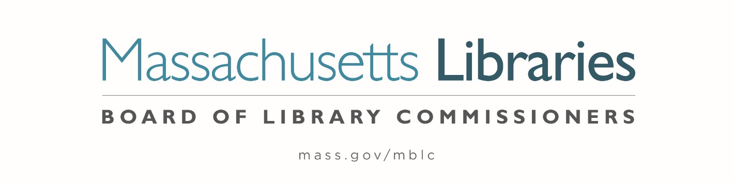

Welcome. Thank you for attending this meeting of the Massachusetts Board of Library Commissioners. Please remember that as part of the meeting agenda there is a time at the end of the meeting for public comment. Should you wish to address the Board during a particular item, please wait to be recognized by the chair.
Note: Agenda may include items not reasonably expected 48 hours before the meeting.
Thursday, September 5, 2024 10:00 A.M./ Refreshments 9:30 A.M.
Charlotte and William Bloomberg Medford Public Library
Zoom Meeting Information
https://us02web.zoom.us/j/89426330887?pwd=mXEgAzTNwaJRBuUnAaGngeU20I15lK.1
Meeting ID: 894 2633 0887/ Passcode: September
Dial in number: (646) 558-8656/ Meeting ID: 894 2633 0887

Agenda- Regular Monthly Meeting
- Call to order

- Welcome

- Roll Call of Commissioners

Speaker: Vicky Biancolo, Chair

- Approval of Minutes- August 1, 2024 Minutes (ACTION)

Speaker: Vicky Biancolo, Chair

- Chair’s Report

Speaker: Vicky Biancolo, Chair

- Commissioner Reports

Speaker: Vicky Biancolo, Chair



- Consideration for the City of Everett requests a change in use for 2,337 square feet of the lower level of the Shute Memorial Library with occupancy transferred from the Everett Public Libraries to the Department of Youth Development and Enrichment. (ACTION)

Speakers: John Russolillo, Director of Youth development & Enrichment
City of Everett
Maureen Amyot, Director
Andrea Bono-Bunker, Library Building Consultant

- Legislative Report

Speaker: Rob Favini, Government Liaison

- Discussion of the FY2026 Legislative Agenda (ACTION)

Speakers: Maureen Amyot, Director
Rob Favini, Government Liaison

- Director’s Report

Speaker: Maureen Amyot, Director

- Report from Massachusetts Library System (MLS)

Speaker: Sarah Sogigian, Executive Director
Massachusetts Library System (MLS)

- Report from the Library for the Commonwealth (LFC)

Speaker: Sarah Jackson, Network Administrator
Boston Public Library (BPL)

- Report from the Worcester Talking Book Library

Speaker: Lee Anne Hooley, Head of Talking Book Services
Worcester Public Library

- Public Comment

- Old Business

- Adjournment Vicky Biancolo, Chair

To review the Massachusetts Board of Library Commissioners current bylaws
(Organizations and Functions of the Board of Library Commissioners)
Visit https://mblc.state.ma.us/about-us/commissioners/index.php

