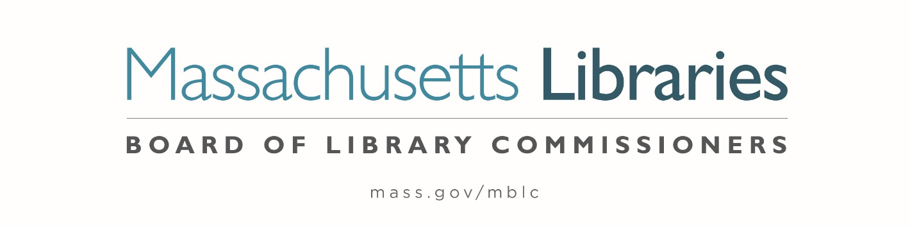

MINUTES OF THE BOARD OF LIBRARY COMMISSIONERS monthly regular meeting

Date : Thursday, September 5, 2024
Time : 10:00 A.M.

Place : Charlotte and William Bloomberg Medford Public Library
Medford, MA

Board
Present : Vicky Biancolo, Chair; Timothy Cherubini, Vice-Chair; Karen Traub, Secretary;
Kate Chang; George Comeau, Esq.; Debby Conrad; Joyce Linehan; Jessica Vilas Novas

Staff Present:
Maureen Amyot, Director; Jessica Branco Colati, Preservation Specialist; Celeste Bruno, Communications Director; Andrea Bono-Bunker, Library Building Consultant; Kate Butler, Library Information Systems Specialist; Tracey Dimant, Head of Operations & Budget / Business Office; Allyson Dowds, Consultant to Special Populations; Susan Faiella, Accountant; Robert Favini, Head of Library Advisory & Development / Government Liaison; Al Hayden, Library Advisory Specialist; Rachel Masse, Assistant to the Director; Jaccavrie McNeely, Electronic Services Specialist; Cate Merlin, Head of State Programs; June Thammasnong, Communications Specialist

Staff Zoom:
Terry D'Angelo, Administrative Assistant / Business Office; Tanesha Deane, Contract Specialist; Allyson Dowds, Consultant to Special Populations; Jennifer Inglis, State Aid Specialist; Uechi Ng, Administrative Assistant; Lilli Sutton, Administrative Assistant

Observers Present:
Courtney Andree, Executive Director, Massachusetts Center for the Book; Noelle Boc, MLA President; Debbie Froggatt, MA School Library Association; Jason Homer, Worcester Public Library/ CMLA; Sarah Jackson, Library for the Commonwealth; Sahal Laher, Everett; Kathy Lussier, North of Boston Library Exchange; Phil McNulty, Minuteman Library Network; John Russolillo, City of Everett; Sarah Sogigian, Executive Director, Massachusetts Library System; Roberto Velasquez, Everett

Observers Zoom:
Deborah Abraham, Former Commissioner, Everett; Will Adamczyk, MLA; Eileen Chandler, Barnstable; Kim Charlson, Library Director, Perkins Library, Watertown; Mary Ann Cluggish, Former Commissioner, Wellesley; Nicole Daviau, Blandford, WMLA President; Lee Anne Hooley, Talking Book Library/Worcester Public Library; Mary Kronholm, Former Commissioner, Blandford; Jeanette Lundgren, C/W MARS; Sulma Rubert Silva, Worcester Public Library; David Slater, OCLN

Meeting called to order by Chair Biancolo
Chair Biancolo called the meeting to order at 10:02 A.M.

Roll Call of Commissioners

Chair Biancolo stated that she is required to take a roll call of Commissioners to comply with the Open Meeting Law for hybrid meetings.

 | Commissioner Cherubini- Present Zoom | Commissioner Linehan- Present
Commissioner Biancolo - Present | Commissioner Comeau- Present | Commissioner Traub- Present Zoom
Commissioner Chang - Present | Commissioner Conrad- Present | Commissioner Vilas Novas- Present

Chair Biancolo explained that she would be making a motion to comply with a consent agenda. A consent agenda is a board meeting practice that groups routine motions into the consent agenda. If there are no objections, the Chair can declare a motion passed, rather than counting votes for each motion separately.

Chair Biancolo moved to adopt a consent agenda for agenda items #2- Approval of Minutes- August 1, 2024, #5 Consideration for the City of Everett requests a change in use for 2,337 square feet of the lower level of the Shute Memorial Library with occupancy transferred from the Everett Public Libraries to the Department of Youth Development and Enrichment, #7 Discussion of the FY2026 Legislative Agenda and #14- Adjournment.

Commissioner Linehan seconded.

Chair Biancolo asked for a roll call vote of the Commissioners for this motion.

 | Commissioner Cherubini- Yes | Commissioner Linehan- Yes
Commissioner Biancolo - Yes | Commissioner Comeau- Yes | Commissioner Traub- Yes
Commissioner Chang - Yes | Commissioner Conrad- Yes | Commissioner Vilas Novas- Yes

The motion passed.

Approval of Minutes from the regular monthly meeting:

August 1, 2024

Chair Biancolo asked for a motion to approve the minutes from the August 1, 2024 Monthly Meeting as presented.

Commissioner Conrad moved and Commissioner Linehan seconded to approve the minutes from the August 1, 2024, Regular Monthly Meeting as presented.

Hearing no objection, Chair Biancolo declared the motion passed under the consent agenda.

Chair’s Report

Chair Biancolo presented the following report:

The month started out well! On August 2, I spoke at the groundbreaking of the new Shutesbury library, the first recipient of a grant through our Small Public Library Pilot project. It was just a lovely event on a gorgeous but steamy day, and with about 100 people in attendance, a good proportion of the population turned out. Also there were Congressman Jim McGovern, State Senator Jo Comerford, and State Representative Aaron Saunders, all of whom spoke to the importance of libraries and the freedom to read. These particular lawmakers have been–and continue to be–steadfast supporters of libraries, and I was reminded that at the height of the news about book challenge and banning legislation in certain states last year, Congressman McGovern read into the Congressional Record the banned children’s book The Life of Rosa Parks by Kathleen Connors. From all of them, as well as from the people of Shutesbury, I heard what I can only describe as an outpouring of gratitude for the MBLC, as well as determination in joining the fight for intellectual freedom and, frankly, democracy. Also there were Maureen Amyot, Andrea Bono-Bunker, and Heather Backman, and two old friends from my Western Mass Regional Library System days. I also met Rosemary (Roe) Waltos, who was the MBLC Library Building Consultant who began the investigation into the best ways to assist small libraries. All in all a great day.

On August 5, I sent a letter to the mayor of the City of Everett, as directed by this board, along with a copy of the executed contract and assurances between the City of Everett and the Commonwealth, the 2010 MPLCP regulations, and the original Everett Grant Award letter. The letter alerted the mayor that the City of Everett must make a formal, in-person request to this board for approval of their proposed change in proportional use of the Shute Memorial Library. I believe a representative from the city is here and we will hear from them today.

You may know that on Thursday, August 9, a staffer of the Worcester Public Library was injured after being attacked by a patron armed with a skateboard. In reaching out to Director Jason Homer, I learned that the staffer, although quite injured, is in good spirits and eager to get back to work. The library was closed that Friday while the leadership and staff pulled together to process and review their security protocols. On Saturday, one day later, the library staff, all of whom have returned to work, proceeded with holding their annual community block party, which I think demonstrates admirable grit. This, coupled with the news from Somerville that Commissioner Lenihan shared with us, are stark reminders that it is tough out there. I wanted to mention it because I have been thinking more and more about how it might feel to work in a public library in 2024, where as we know, “librarian” is only one of the challenging jobs we are expected to do, along with EMT, social worker, and security guard. Librarians are demonstrating inspiring resilience, and they deserve all the support we can give them.

In March, the governor of Utah signed a law that removes books from all public schools when three of the state’s 41 school district boards claim they contain pornographic or indecent material. In August, the first list of 13 books was released when four districts objected to the titles, with a fifth weighing in on one of them. The list includes a National Book Award Finalist, one of Time’s Best YA Books of All Time, and a nominee for the Man Booker Prize. According to PEN America, at the moment least three other states are moving toward putting their state government in the book-banning business. I think we know not to congratulate ourselves too heartily for living in Massachusetts, and we need to stay vigilant. I hope you read the recent article from MassLive that Celeste mentioned at the August meeting. I bring this up because frankly I am getting concerned about battle fatigue. This latest moral panic is not fading away, in fact it seems to be ramping up. So, if you are feeling burned out from this fight please do what you need to do to screw your courage to the sticking place. We have a way to go.
Finally, as expected, the commissioners eagerly volunteered for committee assignments, and I will share those now. To the MBLC staff, I would ask that you please reach out to your commissioner with any information, meeting schedules, etc. that they might need to successfully join your committee.

- Commissioner Chang will serve on the Public Relations Advisory Committee
- Commissioner Cherubini, along with his eBoard responsibility to the Budget Committee as vice chair, will serve as liaison to the Massachusetts Library Association and the Massachusetts Library System
- Commissioner Comeau will continue to serve on the Construction Committee
- Commissioner Conrad will serve on the State Aid to Public Libraries Committee as well as liaison to the Consumer Advisory Board to the Braille and Talking Book Library
- Commissioner Linehan will continue to serve on the Construction Committee
- Commissioner Traub, along with her eBoard responsibility to the Budget Committee as secretary, will serve as liaison to the Center for the Book as well as MFOL/MLTA
- Commissioner Villas Novas will serve as liaison to the State Advisory Council on Libraries (SACL)
- As chair, I serve as ex-officio member of all committees and can assist if necessary

Commissioner Activities

Commissioner Chang
- August 2, 2024- Attended Blades Visit in Pittsfield

Commissioner Cherubini
- August 2, 2024- Attended Blades Visit in Pittsfield

Commissioner Comeau
- August 7, 2024- Attended Blades Visit in Falmouth
- August 20, 2024- Attended Blades Visit in Duxbury

Commissioner Conrad
- August 5, 2024 – Virtual meeting of the MLA Legislative Committee – planning the October advocacy training event
- August 7, 2024 – Summer Reading event at the Falmouth Public Library
- August 12, 2024 – Virtual meeting of the Massachusetts Library System Executive Board
- August 19, 2024 – Virtual meeting of the MLA Legislative Committee – planning the October advocacy training event
- August 21, 2024 – Summer Reading event at the Duxbury Public Library

Commissioner Traub
- August 2, 2024- Attended Blades Visit in Pittsfield
- August 8, 2024- Attended PR Committee Meeting
- August 24, 2024- Attended the National Book Festival in Washington DC
- August 27, 2024- Attended Executive Committee Meeting

Commissioner Vilas Novas
- August 15, 2025- Attended Blades Visit in Brockton

Consideration for the City of Everett requests a change in use for 2,337 square feet of the lower level of the Shute Memorial Library with occupancy transferred from the Everett Public Libraries to the Department of Youth Development and Enrichment

John Russolillo, Director of Youth Development & Enrichment for the City of Everett presented the following report to the Board.

Overview

The Shute Library in Everett, MA is a beautiful building in an excellent location to impact many residents, specifically youth and young people, given its proximity to Everett High School and middle schools in the city. An area of the Shute Library is being proposed to be revitalized, with the help of the Department of Youth Development and Enrichment. The main goal is to improve the foot traffic and health of the library by adding more programs for youth and encouraging them to create library cards and check out books relating to program topics. The Department of Youth Development and Enrichment is responsible for recreation and enrichment programs, workforce development programs as well as substance use prevention programs for the City of Everett. The department interacts and impacts hundreds if not thousands of youths in a given year. We hope this project not only impacts youth in the City of Everett, but also adds to the health of the Shute Library, given the opportunity to have more foot traffic and young adults encouraged to check out books.

Key Objectives and Goals
Provide more youth the chance to participate in programs and resources in the City of Everett.
Revitalize an under-utilized space in the City of Everett.
Improve the overall health of the Shute Library.

Expected Outcomes

Increase in foot traffic at Shute Library, in turn increasing the number of books in circulation, improving the health of the Shute Library.
Increase in the number of youths in Everett that have current jobs or career paths, therefore increasing the public health and economy of the city now and in the future.

Decrease in the number of youths that use substances, due to more opportunities for after school programs, specifically those designed for prevention.

Background Information

The section of the Shute Library determined to be repurposed is mainly a children’s section of the Shute Library. This area has had a vacancy for a children’s librarian since 2019, and the City of Everett has had little to no interest in this position even though it has been posted and advertised for. The area itself is less utilized as the City of Everett would like, and given the fact that the Department of Youth Development and Enrichment is growing and expanding its participants, the city believes this department can help revitalize this area.

The Department of Youth development and Enrichment takes a 3-pronged approach to youth development in the City of Everett.

Recreation and Enrichment: Programs and activities in the city for youth, mostly in the age ranges of 5-14, with regard to physical activity like sports and fitness, educational activities such as STEM and coding and enrichment activities such as art, music and dance. Many of these programs live at the Recreation Center in Everett and have had great success gaining participation.

Workforce Development: Programs and activities in the city for youth, mostly in the age ranges of 14-25, with regard to earning money, improving their career skill set, developing a career path and improving their skills and assets for career acquisition. Programs such as Career Launchpad, Financial Success, Mayor Demaria’s Summer Jobs Training Program, Mayor Demaria’s Year-Round Jobs Training Program are all examples of up and running, successful programs to help youth gain employment and develop the skills necessary to continue to grow in their chosen career path. The programs consist of work to improve resumes, cover letters, salary negotiation, interview prep, budgeting tools and more. The jobs training programs are established internship programs in the city that impact hundreds of youth every year and provide internship opportunities for youth with various city departments and businesses.

Substance Use Prevention: Programs and activities in the city for youth, mostly in the age ranges of 7-18, to help create a solid foundation of values, identity, mindset and integrity, with the idea in mind to build a defense against substance use triggers. Currently have a mental wellness program labeled as HEAT (helping Everett’s adolescents and teens) that gathers as group, brings in adult speakers as role models and mentors and talks as a group about the importance of building values and knowing who you are as a person to build a strong identity.

The area repurposed would mostly be used for workforce development programs and substance use prevention programs. The idea for the programs would to have every participant also sign up for a library card, and to work with the library staff to have books that relate to the programs taking place so the instructors can encourage the youth to check out the books and learn more about the topics. Proposed Area for Repurpose
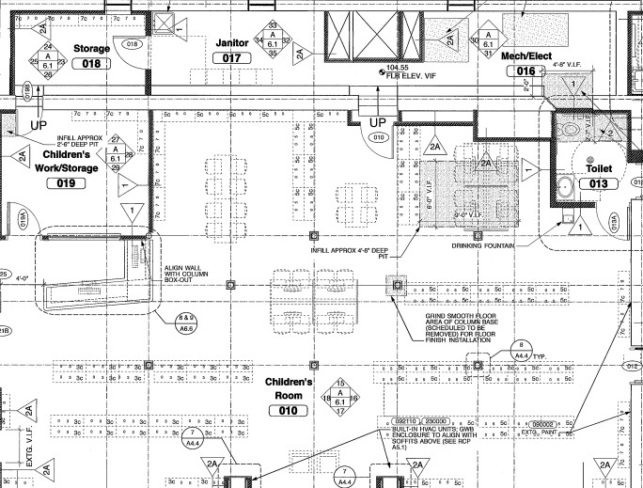

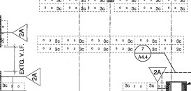

Square Footage: 2337 square feet

Classroom 1

Using dividers, desks and chairs (below in budget), designated area for after school career development and health and wellness programs.
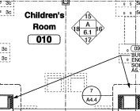

Lounge/Open Area

Keep lounge chairs/couches
Add a TV to be able to utilize the virtual reality devices the Shute Library already purchased.
Use TV for use of StickBall, a virtual reality career readiness software.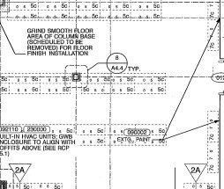

Classroom 2

Using dividers, desks and chairs (below in budget), designated area for after school career development and health and wellness programs.
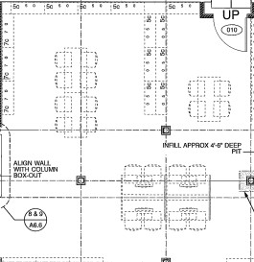

Computer Lab Area

Concept included in budget below.
Area used for drop in resume, application, cover letter help as well as open space for youth to utilize the resources.
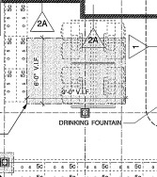

Also, an area for the Digital Navigators (grant funded IT help program) to be able to have designated service hours for Everett residents.

Reading Corner

Placement of children’s books as well as books in relation to career development and health and wellness.

Current After-School Programs

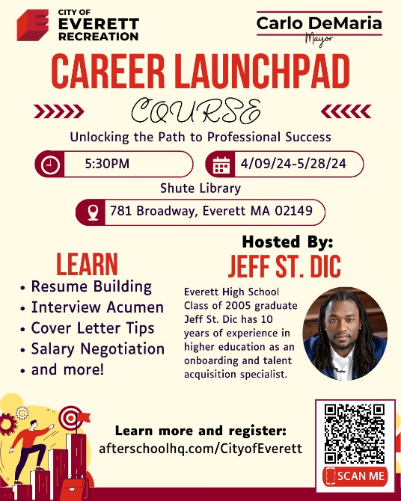
These are a few programs currently up and running by the Department of Youth Development and Enrichment in the City of Everett. The hope is to be able to hold them more frequently with a dedicated space.
All programming and information can be found at everettrecandenrich.com for recreation/enrichment/substance use prevention after-school programs and afterschoolHQ.com/cityofeverett for career development programs.

STEM Robotics/Coding

STEM and Coding programs currently serve youth age 7-14 and a way to spark interests in hobbies that can later be monetized into our career development programs.
These are also a great way to provide after-school programs to youth with interest in these fields outside of typical physical recreation programming

Currently have 2 programs with max capacity of 15 per class, STEM Robotics and Coding. Also ran a STEM Summer Camp at full capacity of 40 youth.

Would have capacity to add more programming with a dedicated computer lab space. Career Launchpad

Career launchpad is a program for young people age 14-25 to help learn and improve on the skills necessary for career development, including resume building, salary negotiation, interview prep, cover letter creation, career path discovery and more.
This program partners with professional and qualified consultants and has great participation from youth in the community.

This program ran 1x per week for 8 weeks and held a maximum of 15 youth at a time.

Financial Success

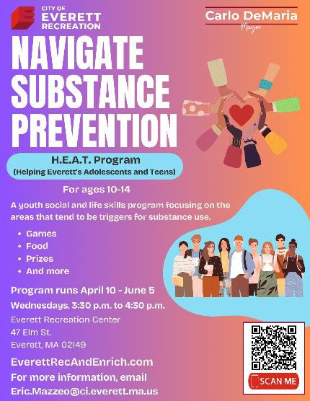

Financial success is a program partnered with Members Plus Credit Union in Everett.
This program aims to teach the basics of personal finances to youth ages 13-25, including budgeting, opening checking and savings accounts, managing investment accounts, filing taxes and more.

This program is hosted by MPCU, but we believe it would be even more successful in a City of Everett building and location with more proximity to EHS.

This program runs 1x per week for 8 weeks and held a maximum of 15 youth at a time.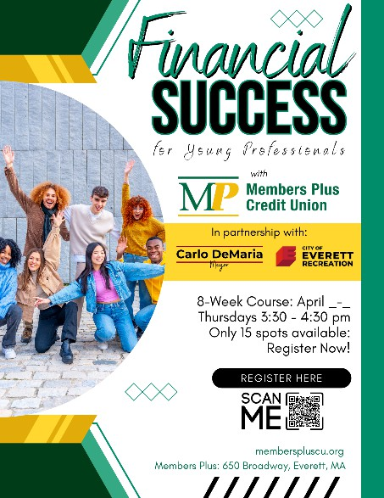

H.E.A.T. Program (Helping Everett’s Adolescents and Teens)

The HEAT Program is designed to have a positive impact on the mindset, values and identities of youth age 10-14 within Everett. Dedicated space for this would help expand the age groups the program can impact.
The program has speakers within the city and outside the city come in for the first half an hour and tell their story of growth, mistakes they made, obstacles they overcame, etc. to become the person they are today. Many of these people have businesses or organizations within the city that are resources to youth.

The second half of the program consists of open discussion about these topics, exploring what it means to have solid moral values, build an identity that people respect and overall becoming a valued member of society.

This is a substance use prevention program run 1x per week for up to 15 participants.

Digital Navigator Program

The digital navigator program is part of a grant the City of Everett received from Metro North Workforce Board for improving the digital literacy of the City’s residents.
There is a budget to train and employ youth to act as IT help desks for residents that need help learning and executing basic tasks on computers.

Part of this funding can also go towards computer lab improvements, which is what would be done with part of the Shute Library space re-purposed.
Currently, the City of Everett has 3 part time youth employees on this program until at least December 2025.

Detailed Objectives

Provide more youth the chance for participation in programs and activities in the City of Everett.

Given the structure of the Youth Development and Enrichment Department and the growing nature of their programs and scope in the city, the project would help serve more youth in a beneficial way.
With workforce development, we have hundreds of youths every year sign up for the summer jobs training and year-round jobs training program, and in order to continue to grow and serve them with the programming we are currently offering, a dedicated space for career development programming would be of great benefit.

Since hiring an Assistant Director of Substance Use prevention, more after-school programming for mental health and wellness have been created, and again having a dedicated space for these gatherings would be beneficial to the youth. Revitalize an under-utilized space in the City of Everett.

The City of Everett believes that this project can help the Shute Library and the youth of Everett tremendously. By adding more programs that are in line with what the middle and high school aged students are participating in, this will allow more of those students to enter the Shute Library and utilize a space that is currently being under-utilized.
The goal is to see the number of library users increase, especially among young people.
Improve the health of the Shute Library.

Given the increased number of programs and participants in the Shute Library, and the idea that every program participant also must obtain a library card, the youth development and enrichment department can encourage the youth to check out books relating to the topics of the programs.

The above idea can help more books be in circulation, improving the overall health of the library

Budget (Main Room)

Products below from Uline.
City of Everett funded and City of Everett Facilities utilized for labor assistance.
Dividers, training tables and chairs all for designated classroom programmed areas.

Portable Room Dividers (youtube.com)
2x/11 Panel/20'6" x 7'4"
2,525 x 2
=$5050
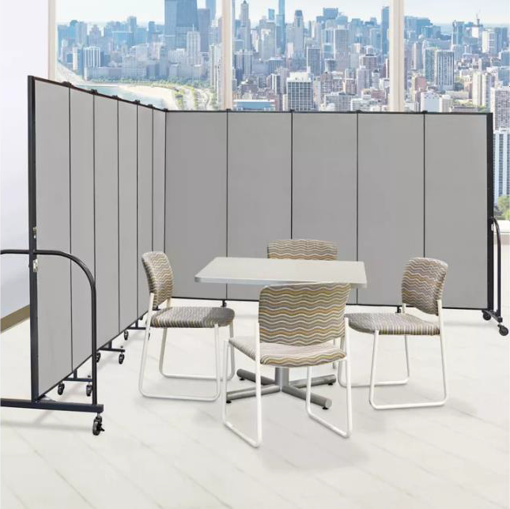
Economy Training Tables in Stock - Uline 8x/ 72 x 24"/ Economy Training Tables
$260 x 8
=$2080
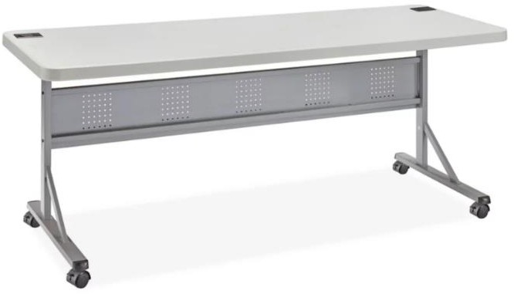
Mesh Stacking Chairs, Stackable Mesh Chairs in Stock - ULINE

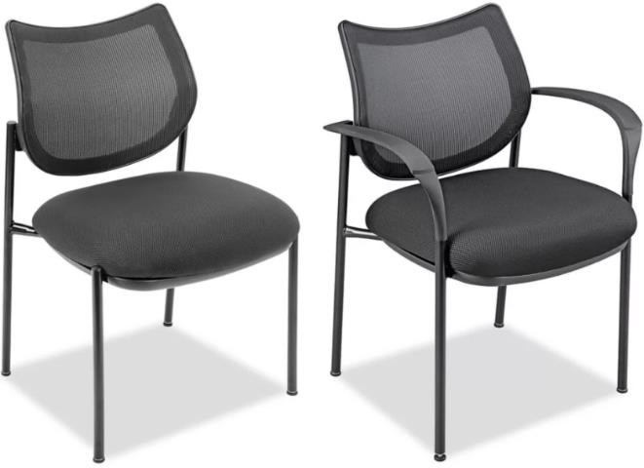

20x Mesh Chairs w/ armrests
$140 each
=$2800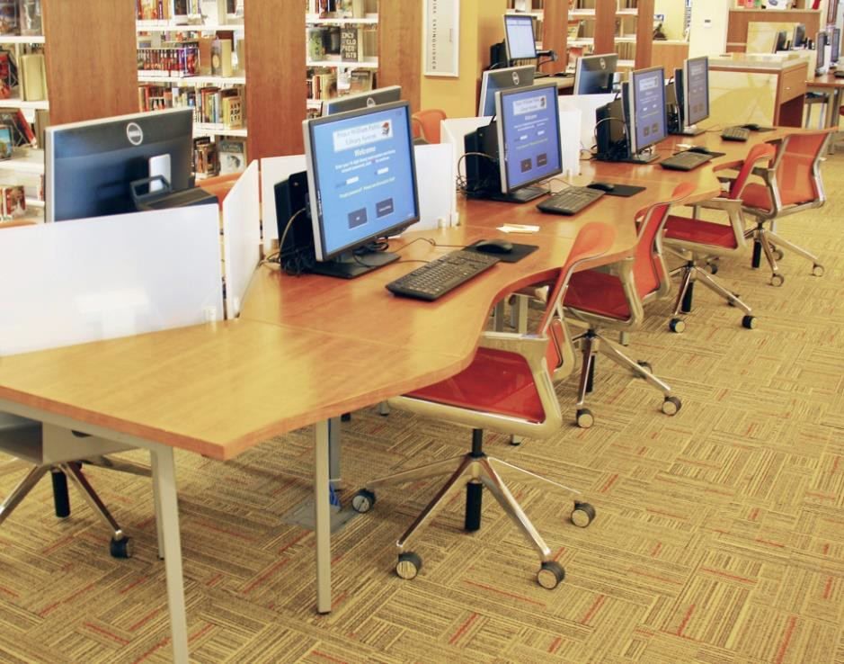
Concept for Computer Lab Area

Quote requested from Manifest Benching | Agati Furniture
Open area for drop in resume, application and career resource help.
Also, an area for Digital Navigators to give drop in help for Everett residents that are do not have digital literacy. City of Everett received grant funding for this initiative until Dec 2025 with positive sentiment of extending.

Evaluation and Measurement

Work with Library staff to evaluate number of average books checked out weekly, monthly, annually from Shute Library as well as overall number of library cards.
Goal is to see an increase in all these numbers once the project is up and running and more youth are visiting the Shute Library.

Action item to successfully achieve goal is to incentivize every youth that participates in the programs to not only get a library card but also check out books in relation to the topics of the programs.

Work with Assistant Directors of Workforce Development and Substance Use Prevention to track data of improved respective missions.

Decrease in the unemployment rate in Everett over the next year, 5 years, 10 years, specifically those in the 18–25-year-old age range.
Decrease in the substance use rate in Everett over the next year, 5 years, 10 years, specifically those in the 14–25-year-old age range.

Conclusion

Revitalizing a section of the Shute Library in Everett, MA, offers a unique opportunity to enhance community engagement and address pressing local needs. By repurposing this space, we aim to create a vibrant hub that supports youth through innovative programs focused on career development and health and wellness. These initiatives will not only improve the library's utilization but also foster a sense of community, providing invaluable resources to young people as they navigate their future paths.

Investing in this project will yield significant benefits, including increased library attendance and book circulation, enhanced community health, and strengthened ties between youth and their local library. We invite you to join us in bringing this vision to life, creating a sustainable impact for Everett's youth and broader community. Your support will be instrumental in transforming the Shute Library into a beacon of opportunity and well-being for all.

Commissioners expressed how unfortunate it is that someone from the library isn’t present.

Commissioner Linehan made a motion to remove Agenda 5 from Consent Agenda and have a roll call vote. Commissioner Comeau seconded.

Commissioner Comeau moved and Commissioner Conrad seconded that the Massachusetts Board of Library Commissioners does not approve the City of Everett request to change in use of the lower level of the Shute Memorial Library with occupancy transferred from the Everett Public Libraries to the Department of Youth Development and Enrichment.

 | Commissioner Cherubini- Yes | Commissioner Linehan- Yes
Commissioner Biancolo - Yes | Commissioner Comeau- Yes | Commissioner Traub- Yes
Commissioner Chang - Yes | Commissioner Conrad- Yes | Commissioner Vilas Novas- Yes

Legislative Report

“Library Bills” Next Steps

Both S.2839 An Act to Ensure Access to Library Resources and Services and H.4802 An Act Addressing Challenges facing Public Libraries and Digital Resource Collections failed to make it to the floor for a vote before the expiration of the legislative session. There is a chance that the legislature will be called back into special session to vote outstanding bills. But with several high-profile, economically impactful bills are still unresolved, it is not likely that the library bills will make it to a vote.

If these bills are not voted on in special session, they will most likely be re-introduced at the beginning of the next Legislative session that begins in January 2025. H.4802 An Act Addressing Challenges facing Public Libraries and Digital Resource Collections will be looking for a new sponsor as Rep. Balser is retiring.

Economic Development Bond Bill
Like the library bills, H.4789 Economic Development Bond Bill did not make it to the floor for a vote. Unlike the library bills, H.4789 has a significant economic impact on the Commonwealth including the funding of the MBLC’s $150 million library construction bond. It appears that there is motivation to pass this bill in special session. According to the Statehouse News Service’s Bill Tracker Governor Healy said she has “a commitment from House and Senate leadership that it will pass this year.” Stay tuned.

Massachusetts Library Association, Advocacy Training, October 10, 2024
Save the date! The MLA Legislative Committee will sponsor an advocacy training session on October 10, 2024, at the Worcester Public Library. Program and registration details will be coming soon.

EveryLibrary Releases Statement on FY25 Institute of Museum and Library Services (IMLS)
The national library advocacy group EveryLibrary released a statement in support of the Senate version of IMLS reauthorization funding that “reflects a federal commitment to maintaining and enhancing the services that our institutions - especially state libraries - provide to communities across the country.” The MBLC depends on IMLS funding to provide statewide databases, direct and special grants to libraries, and staff salaries. Reauthorization is scheduled to take place before the end of the federal fiscal year on September 30, 2024. But typically runs into the next fiscal year.

Discussion of the FY2026 Legislative Agenda

Nicole Daviau, Director, Porter Memorial Library, President, WMLA
Thank you for inviting me to speak today! I would like to thank the Commissioners for the hard work they have been doing to achieve the funding successes of this fiscal year, including the MBLC Construction program, digital equity and access, and legislation for the Right to Read.
I was asked to speak today as the president of WMLA about the budgetary challenges libraries in Western Massachusetts are facing, success stories made possible with state funding, and what key programs and services will be made possible with future funding. With that in mind I will try to be brief!

Libraries in Western Massachusetts face many of the same budgetary challenges as those in the rest of the state, including book challenges, unfair eBook pricing, aging and inaccessible buildings, just to name a few. However, the rural nature of many of Western Massachusetts libraries provides us with an additional set of challenges - including limited access to technology training and internet access, outdated and insufficient infrastructure that is often not accessible, and limited funding from municipalities that have smaller budgets with less financial resilience.

When reaching out to librarians there were many needs expressed, but something that all of the directors and staff mentioned as a core challenge is a lack of paid TIME for library employees to do their job and make use of the resources provided by the MLBC, MLS, Center of the Book, and other organizations. Without the time to utilize these resources it is as if they don't exist.
Smaller libraries have directors who are responsible for collection development, technology management, plan and produce the programming and marketing, building management, grant writing, staff scheduling and training, payroll and submitting invoices, all the state reports, attend town and trustee meetings, regularly work the circ desk, the list goes on.

And many of these directors - including myself- do this without an office!

Library leaders at all levels in small and rural libraries are so busy singlehandedly doing the jobs of many staff in larger libraries and learning all the things, that they cannot take the time to serve on boards such as WMLA, MLA, and MLS, leaving these libraries - disproportionately those in Western Mass - without a seat at the table and a voice in the conversation. These smaller libraries are often geographically isolated, making it even more challenging to form connections and find support.

Many of the directors I spoke with are paid for far fewer hours than they work. They also have minimal hours for other staff and often work alone on shifts to provide maximum open hours and volunteers are relied on regularly. Librarians are a resourceful and determined bunch, and we have seen notable successes from many libraries because of this energy.
So what would the librarians do with the extra time?

Here are some of the things that they said they would like to do if they were given even a few additional hours every week:
- Have staff meetings, and attend workshops/conferences
- Start a memory cafe for seniors
- Keep up with their library website
- Apply for grants
- Work on strategic planning and long term goals
- Connect with schools and other groups to collaborate for outreach
- Meet other librarians and see other libraries for different perspectives

Here is that success story: In 2018 I was hired as the director at Porter Memorial Library while still working full time in a school library. The director position was given 16 hours a week. This was far less than the amount of time it actually took to do the work required that had nothing to do with books or patrons, but would be better described as business management. I had the great fortune to have outstanding trustees, who listened when I told them that the position needed more hours. With their advocacy and the support of the community, residents voted for a budget that allowed the library to increase my hours, and over four years the position increased to 28 hours a week, without reducing hours for other staff. The library transformed from a place people stopped by into a place people went to. Since 2018, foot traffic increased 123% and circulation increased 202%. Last year alone we had a 77% increase in program attendance. This shows that investing in the time of librarians, allows librarians to transform their libraries and communities.

I recognize the significant budgetary challenges facing libraries and our state. Looking at the AIRS reporting of library hours for directors, it is clear that there are vast inequities for the amount of time to manage libraries. I do not have a magic funding solution for how to help small and struggling communities afford the increases that are necessary for staffing successful libraries. I do know that we need to start having the conversion on a larger scale.
State Aid is a savior for many libraries in their budget, unlike many other funding sources, it can be used for staffing. Some larger libraries I have heard from, such as Springfield, do use their State Aid for staffing. This summer we found it necessary to use some of our State Aid funding to pay for extra staff hours before the library opened because we are now so busy that it couldn't efficiently process materials when the library was open. However, most of the small libraries I have spoken with use State Aid for "necessary" items their budget didn't cover, such as replacing aging technology, funding summer reading programs, and emergency funds for repairs or unexpected issues.

It is time that TIME is thought of as a necessary resource that must be paid for, that is advocated for, because the most valuable resource in any library is not the computers, the books, or the programs - it is the LIBRARIANS, who make access to all of these resources possible, and whose time is valuable.

Increased funding for State Aid is a wonderful place to start helping libraries address these inequities. Having these conversations, and looking at ways to systematically address funding for appropriately staffing libraries is essential for continued growth and success.
Thank you for taking the time to listen to our needs today.

Sarah Jackson, Library for the Commonwealth
The Boston Public Library’s Library for the Commonwealth program has benefited greatly from the strong economy of the past few years, that saw increases in our shared line with the Massachusetts Library System.

Over the past couple of years we have been able to bolster staff, including a new full-time position to support the Statewide Digitization program which allows any cultural institution in the Commonwealth to take advantage of the BPL and the Internet Archive’s digitization services, including metadata creation, and hosting and storage as part of Digital Commonwealth, the statewide repository, built and maintained by the BPL.

Another position we have used LFC funding to support is our new Community History Supervisor. This position leads a new, grant-funded department that focuses on hyper-local histories of communities that have often been overlooked. The program started by focusing on four distinct Boston neighborhoods, East Boston, Chinatown, Roxbury, and the South End, and with the new position, we plan on working with libraries across the State to develop their own Community History projects. The emphasis is moving away from collecting these histories, which can come in many forms including, written documents, photographs, oral histories, maps, and more; to teaching communities and giving them the tools to create and stores these histories on their own. Ultimately, we hope to include a directory of these histories on Digital Commonwealth.

We have expanded access to eBooks through our Books Unbanned program, making ecards available to young adults ages 13 – 26 anywhere in the country. We have made our Excel Online High School program available to adults across the Commonwealth, including a recent graduation ceremony for a group of folks who completed the online program. And we have partnered with the Massachusetts Library System to expand our Browse, Borrow, Board program which makes magazines, newspapers, and additional e-content in multiple languages available for download at bus shelters and RAIL Systems across the state. We are in early discussions to expand this service with MLS to other venues.

Should funding continue, we will be focusing on two very important areas of our Digital Services: 1) a revamp of the Digital Commonwealth public interface, providing many features that members have been asking for, and 2) Digital Preservation, to explore how we must preserve these digital collections in perpetuity. Regarding budgetary challenges for LFC, maintenance at minimum is vital. We hope to grow our development capability, increase our digital and streaming content, and expand our Community History program. This could only happen with an increase in the budget.

All of this said, as for the Legislative Agenda, we feel the time has come to truly focus once more on State Side for Public Libraries, an expansive program that will support all public libraries across the Commonwealth in a way that is flexible, and adaptable. We feel strongly that State Aid to Public Libraries is a program that gives libraries the flexibility to expand programming and services in ways not always possible with traditional funding streams. State Aid funds teen programs, purchases board games and craft supplies, funds Spanish language magazine collections and Library of Things items; state aid can pay part time staff members who keep doors open. The ability to plan for larger expenditures that might not be funded out of a municipal budget, by carrying over state aid funds, helps all MA libraries, from the small, rural library, to larger systems. We feel that prioritizing State Aid to Public Libraries in the FY26 Legislative Agenda benefits every community in the Commonwealth.

Philip E. McNulty, Executive Director Minuteman Library Network, Library Networks
First congratulations on a successful outcome to last year's legislative agenda. You obtained significant increases in the priorities for state aid, support of regional library systems and even for your administrative lines. While the $308,000 you had hoped to add to the Technology and Resource sharing line did not come through, we hope you will try again.

The most important thing that the Board of Library Commissioners does is to foster an ecosystem of library cooperation in Massachusetts. Massachusetts is a beacon in the library cooperation space.
- You go to most other states and you do not find nearly complete statewide reciprocal borrowing.
- You don't find library cards being honored across systems.
- You don't find such well established interlibrary loan flows. When we networks talk to vendors, we have a hard time getting many of them to understand what our reserve system tracking needs are, so used are they to systems that don't exchange materials at the rate that we do. In MLN the average checkout rate of other library's books is 19.9%. One in five books that you check out at your local library is likely to have come from another library's collection!
- You'll also rarely find statewide delivery done so well and at such a low unit cost.

You as commissioners have care of some of the key linchpins of this cooperative ecosystem.
- First and foremost of these is the state certification system and the state aid to public libraries funding that makes it relevant. I believe this program started in the 60s and its creation of nearly universal statewide borrowing privileges is the foundation of all of the cooperative elements we enjoy today.
- Next comes the delivery services that you support through the regional library systems. My first experience with that was as an assistant custodian at the Morrill Memorial Library in Norwood in the late 70s, when I would let in Charlie, the Wellesley sub-region's driver, to make his drop-offs. In the early 00s I actually managed the new statewide delivery contract for a few years when I was in the Boston Public Library's Boston Region office. Today Sarah Sogigian’s office manages a delivery contract and service that surpasses anything done before and should serve as a nationwide model. You are the people that make MLS able to do that, please keep it up.
- Then we come to the factor that caused the explosion in interlibrary lending that we still see today. That is your support of the creation of the Library Resource Sharing Networks using LSTA grant funding in the early and mid 80s. What was created werea potent set of nonprofits with local operational funding and control and state and federal capital support. These networks not only provided members with automated circulation and catalog systems, but they developed in a way that made Resource Sharing a core principle and fostered an explosion in Inter-Library Loan. That focus was only possible because your agency had promoted a library ecosystem that provided three key elements, statewide borrowing privileges, a strong delivery system and the capital investments to get it all started.

Today the Library automation world is no longer focused on big system purchases, but annual hosting fees and especially telecommunications.
Your Network Infrastructure grants to networks help us deploy core telecomm equipment at member libraries where they don't have the local expertise and resources to support them. It also supports the hosting fees at many networks.
Your Telecommunications grant to networks support the costs of internet service providers for the core connectivity that makes our systems possible. That grant has two caps, an overall 85% of total network telecomm costs, plus a cap of $1750 for average line costs. That latter cap is something we are rapidly outstripping as networks deploy more robust lines at member libraries. It is an area that I would urge MBLC to consider raising by some $500 (per line supported). That would be a very productive investment in one of the core infrastructures supporting our sharing ecosystem.
Your Resource Sharing grant is the largest of the network focused grants you provide. Different networks use that in different ways. At MLN we use it to keep our cataloging services and systems robust.
The most direct resource sharing project that MBLC supports today is of course the LEA system. The reciprocal borrowing of ebooks and e-audiobooks reinforced by the LEA grants. This is an area we would like you to consider small but consistent inflationary increases every year. FY24 saw a 6.7% increase in unit prices for the permanent retention usage models for the set of titles MLN bought. Unfortunately, they are mostly e-audio as almost none of the ebook titles that our patrons want us to buy are now available in those permanent licenses - meaning that, in the absence of the legislation that Rob earlier mentioned as languishing in the legislature, we have to keep re-buying titles of lasting interest. That is the rationale for asking for a continual small steady increase in this line - it maintains our ability to purchase the newest titles as we face the task of re-buying that growing set of older core titles that are still in demand.
(In answer to Commissioner Conrad's question as to what I would like to see as an annual percentage increase for LEA, I answered: "While 10% would provide the most robust collection, 5% would be the sweet spot to maintaining service levels and 3% or 2.5% would be the floor you would want to consider."

Debora Lang Froggatt, MSLA Outreach Director, MA School Library Association
- MSLA Meeting with Kate Doneghy, Undersecretary and Chief of Staff for Department of Education/Secretary Tutwiler - 8/20/21
- DESE Data Request
- Literacy Launch Steering Committee - 2 MSLA reps
- Equitable Access to School Libraries Policy Brief
- MBLC & DESE Director Connections

- MSLA Status Letters to Senator Lewis, Senator Cyr & Rep Moran
- Thank you for H.4802 support & MLA rep on ebook/ library market commission
-Thank you for proactive language regarding school selection policies and school librarian protections in S.2839.
- In upcoming legislative session, possibly include compulsory, funded equitable, effective school library access.

- MSLA PD Focus SY25 - DESE PDP’s
- Understanding Assessment & Grading Practices: Grading for Equit
- Guiding Action Research (Research will vary by district need)
- Science of Reading: Understandings and how the school librarian influences

- MSLA Strategic Plan Update

- MSLA Retreat Board Meeting - 9/15/25

- MBLC Legislative 26 Agenda & Equitable Access to School Libraries
Commissioner Linehan moved and Commissioner Traub seconded to approve the FY2026 Legislative Agenda Totals as presented.

DIRECTOR’S REPORT

Director Amyot presented the following report:

August has been a busy month across the agency. Here are some of the highlights from our units this month.

Library Advisory and Development Unit
Digital Accessibility Training from Perkins Access.
As we reported earlier, we are partnering with Perkins Access (a division of Perkins School for the Blind) to deliver a training series to support Massachusetts libraries in creating digital materials of all types that are accessible to users with disabilities. There are 14 sessions, covering topics like digital accessibility, creating web content, describing images and multimedia, testing for accessibility and crating accessible digital documents.

We ran this series during COVID using ARPA funds and it was so popular we decided to run it again. These free training sessions are open to library staff in all types of Massachusetts libraries, and there is no limit to the number of sessions they can attend. Funding for this series is provided by the Institute of Museum and Library Services.

MBLC and MLS Cosponsoring Library Social Services Network Meeting
Another reminder that MBLC (Ally Dowds) and MLS (Michelle Eberle) are co-sponsoring an upcoming Library Social Services Network Meeting. The in-person event will take place on Friday, September 27, 2024, from 10:00am – 2:00pm at the Shrewsbury Public Library. The event will center on connection with fellow library workers and social services providers for meaningful discussions about the unique challenges libraries face in offering social services in public libraries. The event will feature David Perez, a bilingual Library Social Worker at the Long Branch Free Public Library and the first social worker hired by a public library in New Jersey. Ally will give a report on the event at the next board meeting.

Data, Technology, Construction, and State Aid Unit
The Construction team continues to act as a resource for reviewers as they complete the evaluation process for the 2023-2024 grant round as well as to assist active MPLCP projects through the final stages of design and through construction and post-occupancy. Regionally, they are working with state agencies and entities from Maine to Maryland on three webinars on climate adaptation and resilience for library facilities, the first of which is September 24. MBLC will take the lead with MLS and Delaware for the February webinar.

The current State Aid cycle continues, with the ARIS report having closed in August, and Financial Reporting underway. The State Aid team has led three trainings thus far, with three more scheduled, plus a dedicated Waiver training schedule for mid-September. The Financial Report closes on Friday, October 4th (with later deadlines for multiple independent libraries and libraries applying for waivers), and the team will continue checking and finalizing State Aid applications for presentation to the Board beginning in November.

Communications Unit

It’s been another busy month for Communications, with Blades visits wrapping up, the National Book Festival, and prep for the Boston Book Festival.

Bruins/Blades events were held in Pittsfield, Falmouth, Brocton, and Duxbury. We had so much fun meeting library staff and patrons. Huge thanks to the staff and Commissioners who attended and helped with trivia, stories, crafts, and games. We also appreciate Lt. Sandy and her sidekick Oliver the therapy dog, who made it to almost all the visits. Photos are online at https://www.flickr.com/photos/mblclibraries/albums if you’d like to see all the fun!

Over the weekend of August 23-25, Rachel Masse attended the National Book Festival in Washington, DC, with Commissioner Traub and Karolina Zapal, program Manager at the Massachusetts Center for the Book. I will ask Rachel and Commissioner Traub to share a little about the experience at the board meeting.

Director Activities

I was thrilled to be able to attend my first groundbreaking, at the Shutesbury Library on August 2. It was an absolutely gorgeous summer day, and the joy and excitement the participants felt was a beautiful thing. It was a sea of smiling, happy residents, town officials, the state delegation, and even U.S. Representative McGovern was present. Commissioner Biancolo gave heartfelt remarks, and everyone was invited to dig with the ceremonial shovels. It was a memorable day for all.

I’ve continued my one-on-one meetings with staff, and I only have a few more left to complete. Our in-person monthly staff meetings are scheduled out through the rest of the fiscal year, and they’ve been very helpful as a way for all of us to know what’s happening now, and what’s coming up, across the agency.

The Review Team for the Strategic Planning Consultant RFQ is working on edits to the document, and we are on track to have it ready to launch in late October. Members of the team are Tracey Dimant, Rob Favini, Cate Merlin, Celeste Bruno, and me. Tanesha Deane, our Contracts Specialist, has been a huge help getting it drafted, organized, and ready to go.

I was able to connect this month with COSLA, the Chief Officers of State Library Agencies, which is another interesting group. I learned that over 25 of the State Librarians/Directors nationwide are new within the last 5 years. COSLA holds an annual conference in the fall – this year’s is in late October in Huntsville, Alabama, and will include continuing education, networking, and an afternoon at Space Camp.

I’ve been working on setting up meetings with our affiliates, and have dates in my calendar for September with the Center for the Book and MLS/Library for the Commonwealth. James used to meet regularly with David Leonard (BPL/LFC) and Sarah Sogigian (MLS) and we’re bringing those meetings back. I had a great meeting with the leadership of the Massachusetts School Library Association, where we talked about the upcoming legislative agenda and advocacy. It’s been busy, and I’ve been enjoying the mix of public-facing and agency-specific work.

Report from Massachusetts Library System

Sarah Sogigian presented the following report.

Commonwealth eBook Collection (CEC)
- Total Items in Collection = 295,425 - 80,000 more items added compared to FY23.
-Four months topped over 200,000 circulations!
-350+ magazines added to Sora platform.
- Total Circulation= 2,132,093 - Over 530,000 more circs compared to FY23!
- Total Member Library enrollment= 665 - the largest fee-based service ever offered to MLS members

Interlibrary Loan
- Items Borrowed for MLS member libraries= 11,173 - 73% requests successfully filled
- Items Requested by MLS member libraries = 15,272 - 1,000 fewer compared to FY23
- Items Loaned to other libraries by MLS member libraries = 3,687 - 1,300 more than FY23
- Document Delivery (e-documents) via Boston Public Library's ILLiad = 4,247 - 700 more than FY23
- Borrowed items in over 30 languages, the most popular include: French; Chinese; Russian; German. 90% of items borrowed were in English.
- Borrowed item types included: 83% books; 9% video; 6% sound recordings.

MassCat Library Network
- Total Member Libraries= 37 /Total Patrons= 47,789
-Comparable in size to CLAMS (35) and MVLC (36) networks.
-Of eleven networks, only three are larger: CW MARS (160); SAILS (60); Minuteman (43).
-Seven libraries left the network FY23 due school closures, moving to other vendors / networks, and loss of librarian positions.
- Memberships by type (Academic / Public / School / Special) = 3 / 7 / 20 / 7
- Total Holdings= 445,930 / Total Circulation= 129,924 - slight drops with loss of member libraries
- Total network Holds= 3,102 - slight drop with loss of member libraries

MassCat Libraries moved to CW MARS - Delivery & Holds stats:

Public Library/ Selected Stats | Delivery Survey 2022/23 in MassCat | Delivery Survey 2024 in CW MARS | Network Holds Filled in MassCat FY20 | Network Holds Filled in CW MARS FY24
Becket | 27 | 81 | 107 | 749
Chester | n/a | n/a | 58 | 202
Huntington | 15 | 49 | 251 | 445

State-wide Databases (Britannica. Gale, PebbleGo, PQ, Transparent Language)
- Total Support Tickets answered by MLS staff =260 - 221 fewer tickets than FY23
- Total Articles Retrieved = 9,299,961 - increase of over 995,000 compared to FY23!

- Individual Usage by Library Type (no. of members):
- Academics (114) = 17,600 - 2 ½ times more usage than K-12 libraries, an increase of 6,000 over FY23
- K-12 Schools (865) = 7,150
- Publics (370) = 2,060
- Specials (117) = 1,237

- Total Usage by Library Type:
- K-12 Schools= 6,185,108 - leveling off, an increase of 380,000 compared to FY23, also 2 mil higher than pre-COVID levels.
- Academics= 2,006,286 - increase of 600,000 compared to FY23
- Publics = 726,245 - slight increase of 93,000 compared to FY23
- Specials= 144,717 - decrease of 58,000 compared to FY23

- Databases Usage by Vendor, ranked (totals):
- Gale (3.75 mil) - usage by Academics 3x times higher than K-12 Schools
- Britannica (2.57 mil) - total usage by Schools 3x times higher than other library types
- PebbleGo (2.04 mil) - usage is nearly all usage is K-12 and only two database modules
- ProQuest (866,200) - overwhelming used by Academics (697,000)
- Transparent Languages (50,980) - 50% usage by Publics

Report from Library from the Commonwealth

Sarah Jackson, Metro-Boston Library Network Administrator presented the Board the following report.

Newly redesigned Boston Public Library Research Webpages:
The new Research at BPL page (bpl.org/research) serves as a landing page for people looking for a wide variety of research resources at the library, and points them to research databases, research guides, points of service, blog posts, research FAQs, and more. This page is accessible in the [BPL] navigation menu under "Learning and Research."
The new Local History at BPL webpage (bpl.org/local-history) links to past recordings, local history research guides, tools and databases, and photo and video collections on Digital Commonwealth.

The Kirstein Business Library & Innovation Center (KBLIC) has several upcoming programs coming up in September:

Personal Budgeting: Presented by the City of Boston Credit Union Hybrid 9/17 @ 11A
TechTalk: IT Support Careers – Navigating Opportunities in the Tech Industry Virtual 9/17 @ 12P
Intro to Canva for Small Businesses In-Person In-Person9/20 @1P
Mission Impossible: Cracking the Code on Grants and Grant Writing In-Person 9/23 @6P
Making the Most of Workplace Benefits with the Babson Financial Literacy Project Virtual 9/25 @ 6:30
KBLIC EIR: The application period for KBLICs third Entrepreneur-In-Residence has now closed. We are currently reviewing applicants and expect to make our selection this month. The EIR will offer entrepreneurs the opportunity to meet 1-1 to discuss planning, starting, and growing one's small business. The EIR will also be offering small business workshops and will be facilitating networking opportunities throughout the residency.
The KBLIC EIR residency is anticipated to run October-May 20025 and is a 15 hour per week position.

From the BPL Community Learning Department:

On Saturday, August 3, the Boston Public Library proudly hosted its first graduation reception for the Excel Adult High School program graduates. The event, held in the McKim Exhibition Hall at the Central Library in Copley Square, marked a significant milestone for five of this year’s graduates, who attended with their families and friends. To date, the program has a total of 63 graduates who have completed the program and 35 students are actively enrolled in Excel Adult High school.
A generous $50,000 donation to the Boston Public Library Fund has been instrumental in supporting scholarships for the program, ensuring there is no cost to students and making this memorable occasion possible.

Digital Commonwealth Report- July

Hosted collections added:

- Boston Public Library - The Ashland Advertiser (356 items; issues of the weekly newspaper from 1907-1913)
- Boston Public Library - Barre Gazette (1,249 items; issues of the weekly newspaper from 1872-1895)
- Boston Public Library - Boston Chronicle (1,083 items; issues of the weekly African American newspaper from 1939-1960)
- Boston Public Library - The Daily Transcript (683 items; issues of the daily Holyoke newspaper from 1882-1884)
- Boston Public Library - Dorchester Argus-Citizen (52 items; issues of the weekly newspaper from 1962)
- Boston Public Library - The Dorchester Citizen (454 items; issues of the weekly newspaper from 1949-1956)
- Boston Public Library - Evening Standard (3,313 items; issues of the daily New Bedford newspaper from 1895-1910)
- Boston Public Library - The Fenway News (488 items; issues of the monthly newspaper from 1974-2019)
- Boston Public Library - Francisco de Goya (1746-1828). Prints Collection (228 items; drawings and prints from the Spanish artist covering war, politics, and bullfighting from 1799-1877)
- Boston Public Library - Hyde Park Tribune (305 items; issues of the weekly newspaper from 1959-1964)
- Boston Public Library - The Jamaica Plain Citizen (200 items; issues of the weekly newspaper from1959-1963)
- Boston Public Library - The Mashpee Enterprise (26 items; issues of the semiweekly newspaper from 2002)
- Boston Public Library - Mattapan Tribune (672 items; issues of the weekly newspaper from 1942-1961)
- Boston Public Library - Medieval and Early Renaissance Manuscripts (6 items; religious texts and manuscripts dating from 1250-1500)
- Boston Public Library - Paintings and Fine Arts Collection (16 items; studies from John Singer Sargent's 'Triumph of Religion' mural series)
- Boston Public Library - The Roxbury Citizen (119 items; issues of the weekly newspaper from 1936-1939)
- Boston Public Library - Roxbury Citizen and South End Citizen (255 items; issues of the weekly newspaper from 1959-1963)
- Boston Public Library - South Boston Tribune (101 items; issues of the weekly newspaper from 1949-1950)
- Chelsea Historical Commission - Arnold Jarmak Collection (1,481 items; photographs of Chelsea and surrounding cities from 1974-1990)
- The Eliot School of Fine & Applied Arts - صنع في أمريكا (Made in USA): Artwork from the Eliot School of Fine & Applied Arts 2023 Artist in Residence Project (52 items; photographs, artwork. and oral histories)
- Hammond Castle Museum - Hammond Castle Museum Audio Collection (43 items; organ and piano music recorded in the Great Hall of Hammond Castle)
- Uxbridge Historical Society - Junie Albin Collection (15 items; photographs of Uxbridge from the mid-1900s)
- Uxbridge Historical Society - The Uxbridge Historical Society Collection (photographs and documents related to Uxbridge from 1800-2000)
- Wayland Free Public Library - Wayland Waterworks Centre Systems 1926-1927 (126 items; photographs documenting the construction of a new municipal water system in Wayland from 1926-1927)
- Wayland Free Public Library - Wayland Historical Maps and Plans (126 items; maps of Wayland and Sudbury from 1638-2023)

Harvested collections added:

No harvests in July.

Stats:

Item views: 166,887
Total item-level records: 1,261,863
Total hosted items: 586,125

Digital Commonwealth Report: August

Hosted collections added:
- Boston Public Library - The Daily Transcript (1,855 items; issues of the daily Holyoke newspaper from 1885-1890)
- Boston Public Library - The Evening Journal (18 items; issues of the daily New Bedford newspaper from 1892)
- Boston Public Library - Evening Standard (3,094 items; issues of the daily New Bedford newspaper from 1910-1920)
- Boston Public Library - The Holyoke Daily Transcript (4,589 items; issues of the daily newspaper from 1891-1905)
- Boston Public Library - Maginnis & Walsh Architectural Records (165 items; drawings and blueprints from Vermont churches created by the Boston-based architecture firm)
- Boston Public Library - New Bedford Evening Journal (83 items; issues of the daily New Bedford newspaper from 1892)
- Boston Public Library - Norman B. Leventhal Map Center Collection (3 items; various maps for upcoming LMEC exhibition)
- Congregation of the Sisters of Saint Joseph of Boston - Throw Open the Windows! Digitizing the Experiences of the Sisters of Saint Joseph During the Era of Vatican II (8 items; oral history interviews conducted from the 1970s-1990s and audio from the congregation's Chapter Meetings)
- Hyde Park Historical Society - History Hyde Park Library (1 item; architectural drawings for the Hyde Park Public Library)
- Osterville Village Library - Village View Articles by Andrea Leonard in the Village Advertiser (212 items; editorials and stories from the Barnstable community newspaper from 1914-1973)
- Phillips Academy - Sidney R. Knafel Map Collection at Phillips Academy (12 items; unique historical maps from 1478-1810)

Harvested collections added:
- Brandeis University Library (24 new collections, 7,366 new items)

Stats:

Item views: 133,183
Total item-level records: 1,279,912
Total hosted items: 596,809

Report from Worcester Talking Book Library

Lee Ann Hooley presented the following report.

It’s been a busy but productive summer here at the Worcester Talking Book Library! We’ve had lots going on and are eager to share what we’ve been up to.

One of the most surprising things that has happened to us involves the budget. The Talking Book Library budget (line 7000-9402) was set to be level funded to $678,040. However, due to the work of the Library Caucus, the MBLC, the Talking Book Libraries and WPL, among other advocates, the FY25 budget is $711, 942. After the 30% increase last year and the bump this year, library staff are thrilled with the opportunities we will have to now serve our patrons even better.

For decades, the Library of Congress has provided recorded audio magazines to patrons from fulfillment centers around the country. To streamline, the National Library Service for the Blind and Print Disabled has provided talking book libraries with the resources and tools to locally circulate magazines using our duplication on demand system. This will allow us to report on our patron circulation better, as well as be able to answer questions about the service to out patrons. Worcester began to circulate magazines for folks in June and thus far it has gone off without a hitch.

The NLS Is actively working to improve resources and accessibility for their patrons, and it is having a positive impact on Worcester’s services. Recently, the NLS worked with us to facilitate a service where patrons with email addresses will automatically be enrolled in BARD, an application like service that allows registered patrons to stream talking books to their smartphones and tablets. The project has been underway since at least October of 2023, and despite a few road blocks, is now live. The NLS is also working to make BARD usable for desk top computers, which will no doubt help us to expand access.

We have also been working to start a dementia friendly reading group with the folks at Reading2Connect. So far, we have purchased and cataloged several books, and have had interested from one patron who is excited for us to begin this program.

After a long hiatus, TBL is trying to start up its Consumer Advisory Council! So far, we’ve had one meeting which was not well attended, but there has been a lot of enthusiasm and interest from others who would like to join. Please help us get the word out! We meet quarterly over Zoom

After a lot of work and many meetings, the Worcester Talking Book Library has a certified recording studio program! This means that we are now able to record and upload audio books into BARD that can be accessed not only to our own patrons, but thanks to the Marrakesh treaty patrons all over the world. Our first book, recoded by our very own Joel Keisling, is now available. We have one regular volunteer, a few staff people who record when they can, and some interest from out in the community to help us get more books into BARD. It’s a lot of work, but we are absolutely thrilled to be here.

Lee Anne and Kim have been working to bring a large traveling tactile art program to their talking book libraries. Tactile Images, a company out of upstate New York, develops traveling exhibits that can illustrate works out art to the blind and low vision community using touch. TBL is hoping to host this event in May of 2025, and is getting started on all of the paperwork and logistics that will go into this. We hope to host the program for 4 weeks.

Coming up in the next quarter: we are hoping to hire a new professional librarian as the most recent person has left WPL for another opportunity. We’re working on having more programming in the fall and winter, and are also trying to connect with Kulture City to create a sensory friendly library system. We’re hoping that we can do a lot of good for the community in FY25!

NEW BUSINESS
There was no new business.

OLD BUSINESS
There was no old business.

ADJOURNMENT

Commissioner Comeau moved and Commissioner Vilas Novas seconded to adjourn the September 5, 2024 Board Meeting.

The meeting adjourned at 1: 09 P.M.

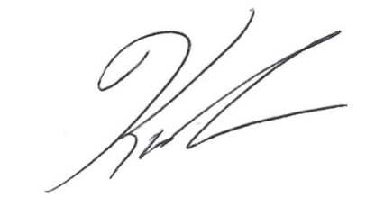

Karen Traub
Secretary

