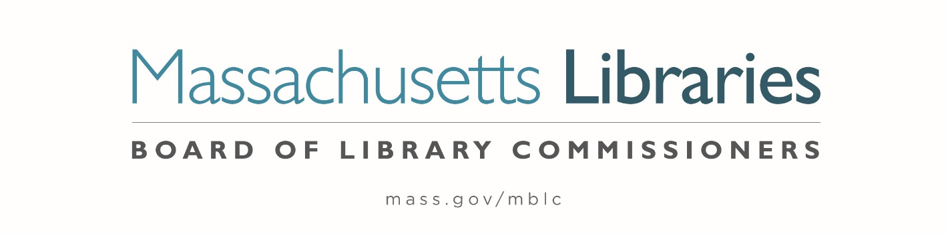

Welcome. Thank you for attending this meeting of the Massachusetts Board of Library Commissioners. Please remember that as part of the meeting agenda there is a time at the end of the meeting for public comment. Should you wish to address the Board during a particular item, please wait to be recognized by the chair.
Note: Agenda may include items not reasonably expected 48 hours before the meeting.
Thursday, October 3, 2024 10:00 A.M./ Refreshments 9:30 A.M.
North Branch Library, Dartmouth
Zoom Meeting Information
https://us02web.zoom.us/j/83027873646?pwd=xEQoIuGivDoksp9irunqq2MgQrZeWe.1
Meeting ID: 830 2787 3646/ Passcode: October
Dial in number: (646) 558-8656/ Meeting ID: 830 2787 3646

Agenda- Regular Monthly Meeting
- Call to order

- Welcome

Speaker: Dina St. Pierre, Director of Libraries

- Roll Call of Commissioners

Speaker: Vicky Biancolo, Chair

- Approval of Minutes- September 5, 2024 Minutes (ACTION)

Speaker: Vicky Biancolo, Chair

- Chair’s Report

Speaker: Vicky Biancolo, Chair

- Commissioner Reports

Speaker: Vicky Biancolo, Chair

- Director’s Report

Speaker: Maureen Amyot, Director

- Legislative Report

Speaker: Rob Favini, Government Liaison

- Consideration of Network Grant Awards under account 7000-9506
a. FY2025 Small Libraries in Networks Recommendation (ACTION)
b. FY2025 Telecommunications for Resource Sharing Recommendation (ACTION)
c. FY2025 Network Infrastructure Recommendation (ACTION)
d. FY2025 Resource Sharing Program Recommendation (ACTION)

Speaker: Kate Butler, Library Information Systems Specialist

- Consideration of approval for the Library eBooks and Audiobooks (LEA) Content Grants
(ACTION)
Speaker: Jaccavrie McNeely, Electronic Systems Specialist

- Consideration of approval of two Planning and Design Grants for the Small Population Grant Type (ACTION)

Speakers: Andrea Bono-Bunker, Library Building Consultant
Heather Backman, Library Building Specialist

- Presentation of FY2025 MBLC Budget

Speaker: Tracey Dimant, Head of Operations and Budget

- Report from Massachusetts Library System (MLS)

Speaker: Sarah Sogigian, Executive Director
Massachusetts Library System (MLS)

- Report from the Library for the Commonwealth (LFC)

Speaker: Sarah Jackson, Network Administrator
Boston Public Library (BPL)
- Quarterly Report from Massachusetts Center for the Book

Speaker: Courtney Andree, Executive Director
Massachusetts Center for the Book

- Public Comment

- Old Business

- Adjournment Vicky Biancolo, Chair

To review the Massachusetts Board of Library Commissioners current bylaws
(Organizations and Functions of the Board of Library Commissioners)
Visit https://mblc.state.ma.us/about-us/commissioners/index.php

