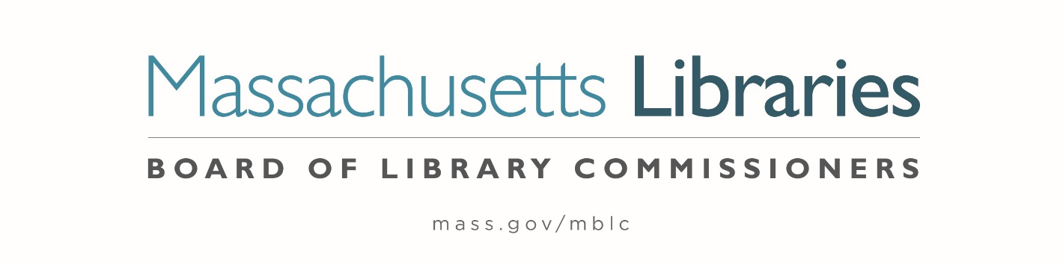

Welcome. Thank you for attending this meeting of the Massachusetts Board of Library Commissioners. Please remember that as part of the meeting agenda there is a time at the end of the meeting for public comment. Should you wish to address the Board during a particular item, please wait to be recognized by the chair.
Note: Agenda may include items not reasonably expected 48 hours before the meeting.
Thursday, November 7, 2024 10:00 A.M./ Refreshments 9:30 A.M.
Greenfield Public Library
Zoom Meeting Information
https://us02web.zoom.us/j/83736126133?pwd=zaexN2aSNcg7d9h1SboiLYaQ7kCJxG.1
Meeting ID: 837 3612 6133/ Passcode: November
Dial in number: (646) 558-8656/ Meeting ID: 837 3612 6133

Agenda- Regular Monthly Meeting
- Call to order

- Welcome

Speaker: Anna Bognolo, Library Director

- Roll Call of Commissioners

Speaker: Karen Traub, Secretary

- Approval of Minutes- October 3, 2024 Minutes (ACTION)

Speaker: Vicky Biancolo, Chair

- Chair’s Report

Speaker: Vicky Biancolo, Chair

- Commissioner Reports

Speaker: Vicky Biancolo, Chair

- Director’s Report

Speaker: Maureen Amyot, Director

- Legislative Report

Speaker: Rob Favini, Government Liaison

- Consideration of approval of municipalities meeting the requirements for the FY2025 State Aid to Public Libraries based on eligibility established in FY2025 for the Municipal Appropriation Requirement and in FY2024 for the minimum standards (ACTION)

Speakers: Cate Merlin, Head of State Programs
Jen Inglis, State Aid Specialist

- Consideration of approval of the FY2026 Library Services and Technology Act (LSTA) Direct Grant Round Program & Budget (ACTION)

Speaker: Rob Favini, Head of Library Advisory & Development

- Consideration of appointments to the State Advisory Council on Libraries (SACL) (ACTION)

Speaker: Rob Favini, Head of Library Advisory & Development

- Updated totals for Small Libraries in Networks Grants and Resource Sharing Grants (ACTION)

Speakers: Kate Butler, Library Information Systems Specialist
Rob Favini, Head of Library Advisory & Development

- Report from Massachusetts Library System (MLS)

Speaker: Sarah Sogigian, Executive Director
Massachusetts Library System (MLS)

- Report from the Library for the Commonwealth (LFC)

Speaker: Sarah Jackson, Network Administrator
Boston Public Library (BPL)

- Quarterly Report from Perkins Library

Speaker: Kim Charlson, Library Director
Perkins Library

- Report from Simmons University

Speakers: Eric Poulin, Assistant Professor & Director of SLIS West
Dr. Sandra Erdelez, Dean of the School of Library & Information Science

- Unfinished Business and General Orders

- Public Comment

- Adjournment Vicky Biancolo, Chair

To review the Massachusetts Board of Library Commissioners current bylaws
(Organizations and Functions of the Board of Library Commissioners)
Visit https://mblc.state.ma.us/about-us/commissioners/index.php

