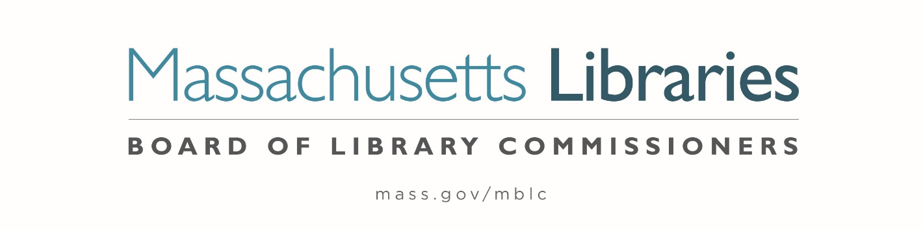

Welcome. Thank you for attending this meeting of the Massachusetts Board of Library Commissioners. Please remember that as part of the meeting agenda there is a time at the end of the meeting for public comment. Should you wish to address the Board during a particular item, please wait to be recognized by the chair.
Note: Agenda may include items not reasonably expected 48 hours before the meeting.
Thursday, March 6, 2025 10:00 A.M./ Refreshments 9:30 A.M.
Massachusetts Library System, Marlborough
Zoom Meeting Information
https://us02web.zoom.us/j/87969276770?pwd=tfn9r18bGH1Xqpdk2jxrkjhyYu4Uhp.1
Dial in number: (646) 558-8656/ Meeting ID: 879 6927 6770

Agenda- Regular Monthly Meeting
- Call to order

Speaker: Betsy Meaden, Business/ HR Director
Massachusetts Library System (MLS)

- Roll Call of Commissioners

Speaker: Karen Traub, Secretary

- Approval of Minutes- February 6, 2025 Minutes

Speaker: Vicky Biancolo, Chair

- Chair’s Report

Speaker: Vicky Biancolo, Chair

- Commissioner Reports

Speaker: Vicky Biancolo, Chair


- Director’s Report and Legislative Report
Speaker: Vicky Biancolo, Chair

- Consideration of an extension request by the Jones Library, Amherst for the deadline to sign a contract with a general contractor to April 30, 2025. In accordance with the 2015 Massachusetts Public Library Construction Program’s regulations, the deadline for this milestone was June 30, 2024, which was extended at the Town and Library's request to December 31, 2024 then March 31, 2025. (ACTION)

Speakers: Sharon Sharry, Director, Jones Library, Amherst
Maureen Amyot, Director
Andrea Bono-Bunker, Library Building Consultant

- Consideration of approval of the FY2026 Plan of Service and Program and Budget for the Massachusetts Library System (MLS) and Monthly Report (ACTION)

Speaker: Betsy Meaden, Business/ HR Director
Massachusetts Library System (MLS)

- Discussion/ review of policies for the FY2027 State Aid to Public Libraries Program

Speakers: Cate Merlin, Head of State Programs
Jen Inglis, State Aid Specialist

- Presentation and discussion of the FY2026 Plan of Service and Program and Budget for the Library for the Commonwealth (LFC) and Monthly Report

Speaker: Sarah Jackson, Network Administrator
Library for the Commonwealth/ Boston Public Library (BPL)

- Quarterly Report from the Worcester Talking Book Library

Speaker: Lee Anne Hooley, Library Director
Worcester Talking Book Library
- Unfinished Business and General Orders
- Public Comment

- Adjournment Vicky Biancolo, Chair

To review the Massachusetts Board of Library Commissioners current bylaws
(Organizations and Functions of the Board of Library Commissioners)
Visit https://mblc.state.ma.us/about-us/commissioners/index.php

