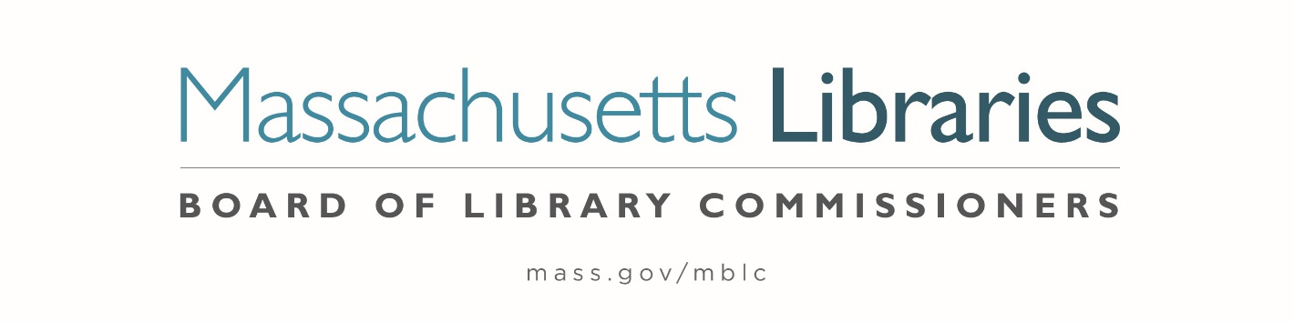

Welcome. Thank you for attending this meeting of the Massachusetts Board of Library Commissioners. Please remember that as part of the meeting agenda there is a time at the end of the meeting for public comment. Should you wish to address the Board during a particular item, please wait to be recognized by the chair.
Note: Agenda may include items not reasonably expected 48 hours before the meeting.
Thursday, July 11, 2024 10:00 A.M.
MBLC Offices, Boston
Zoom Meeting Information
https://us02web.zoom.us/j/86494428898?pwd=0L61FIQJdwvyQzakQp7jUpq4TSpXSW.1
Meeting ID: 864 9442 8898/ Passcode: July
Dial in number: (646) 558-8656/ Meeting ID: 864 9442 8898

Agenda- Regular Monthly Meeting
- Call to order

- Welcome

Speaker: Debby Conrad, Chair

- Roll Call of Commissioners

Speaker: Debby Conrad, Chair

- Approval of Minutes- June 6, 2024 Minutes (ACTION)

Speaker: Debby Conrad, Chair

- Chair’s Report

Speaker: Debby Conrad, Chair


Posted: Friday, July 5, 2024 at 5:00 P.M.
:00 P.M.
- Commissioner Reports

Speaker: Debby Conrad, Chair

- Director’s Report

Speaker: Maureen Amyot, Director

- Legislative Report

Speaker: Rob Favini, Head of Library Advisory and Development Government Liaison

- Consideration of approval of the FY2025 Library Services and Technology Act (LSTA) Grant Awards

- Access for All (ACTION)
- Creative Communities (ACTION)
- Dig In (ACTION)
- Health and Wellness (ACTION)
- Mind in the Making
- Open (ACTION)

Speaker: Rob Favini, Head of Library Advisory and Development

- Update on Small Public Library Pilot Project

Speaker: Andrea Bono-Bunker, Library Building Consultant
Heather Backman, Library Building Specialist

- Report from Massachusetts Library System (MLS)

Speaker: Sarah Sogigian, Executive Director
Massachusetts Library System (MLS)

- Report from Library for the Commonwealth (LFC)

Speaker: Sarah Jackson, Network Administrator
Boston Public Library (BPL)

- Quarterly Report from the Massachusetts Center for the Book

Speaker: Courtney Andree, Executive Director
Massachusetts Center for the Book

- Election of Officers for FY2025 (ACTION)

Speaker: Karen Traub, Secretary

- Public Comment

- Old Business

- Adjournment Debby Conrad, Chair

To review the Massachusetts Board of Library Commissioners current bylaws
(Organizations and Functions of the Board of Library Commissioners)
Visit https://mblc.state.ma.us/about-us/commissioners/index.php

