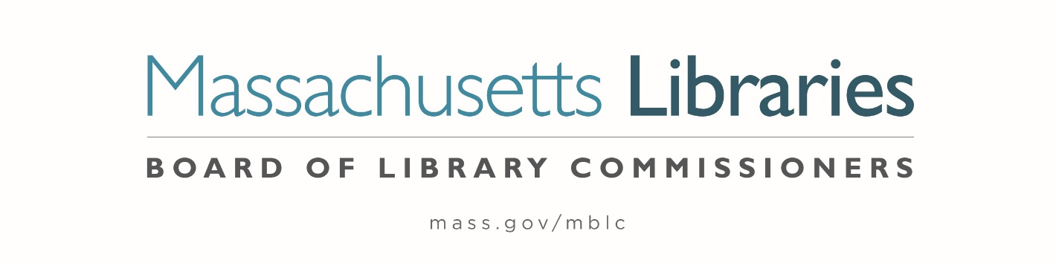

Welcome. Thank you for attending this meeting of the Massachusetts Board of Library Commissioners. Please remember that as part of the meeting agenda there is a time at the end of the meeting for public comment. Should you wish to address the Board during a particular item, please wait to be recognized by the chair.
Note: Agenda may include items not reasonably expected 48 hours before the meeting.
Thursday, February 6, 2025 10:00 A.M./ Refreshments 9:30 A.M.
MBLC Offices, Boston
Zoom Meeting Information
https://us02web.zoom.us/j/86913995310?pwd=NR7NSPSEQuArivMHaCacUpExSr2esd.1
Dial in number: (646) 558-8656/ Meeting ID: 890 0234 4762

Agenda- Regular Monthly Meeting
- Call to order

- Welcome- Lieutenant Governor Kim Driscoll

- Roll Call of Commissioners

Speaker: Karen Traub, Secretary

- Approval of Minutes- January 9, 2025 Minutes

Speaker: Vicky Biancolo, Chair

- Chair’s Report

Speaker: Vicky Biancolo, Chair

- Commissioner Reports

Speaker: Vicky Biancolo, Chair


- Director’s Report

Speaker: Maureen Amyot, Director

- Legislative Report

Speaker: Rob Favini, Government Liaison

- Consideration of approval of municipalities requesting waivers for the FY2025 municipal appropriation requirement in the FY2025 State Aid to Public Libraries Program within the 5% threshold (ACTION)

Speakers: Cate Merlin, Head of State Programs

- Consideration of approval of a petition for a waiver of the municipal appropriation requirement for the FY2025 State Aid to Public Libraries Program above the 5% threshold (ACTION)
a. Wales 6.11%

Speaker: Cate Merlin, Head of State Programs

- Consideration of approval of the FY2026 Plan of Service and Program and Budget for the Massachusetts Center for the Book (ACTION)

Speaker: Courtney Andree, Executive Director
Massachusetts Center for the Book

- Presentation and discussion of the FY2026 Plan of Service and Program and Budget for the Massachusetts Library System (MLS) and Monthly Report

Speaker: Sarah Sogigian, Executive Director
Massachusetts Library System (MLS)

- Report from the Library for the Commonwealth

Speaker: Sarah Jackson, Network Administrator
Library for the Commonwealth/ Boston Public Library (BPL)

- Quarterly Report from the Perkins Talking Book Library

Speaker: Kim Charlson, Library Director
Perkins Talking Book Library, Watertown

- Unfinished Business and General Orders

- Establish a subcommittee to update the Commissioners’ Roles and Responsibilities

- Public Comment

- Adjournment Vicky Biancolo, Chair

To review the Massachusetts Board of Library Commissioners current bylaws
(Organizations and Functions of the Board of Library Commissioners)
Visit https://mblc.state.ma.us/about-us/commissioners/index.php

