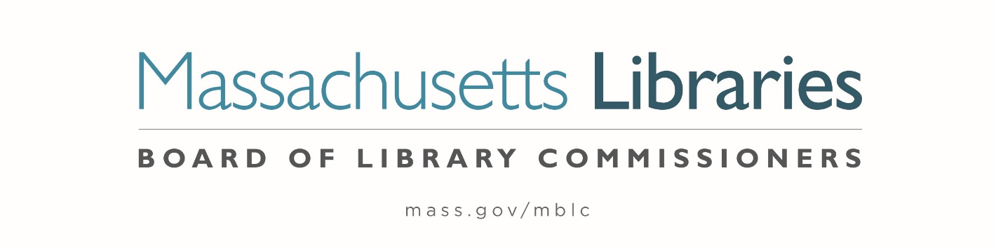

Welcome. Thank you for attending this meeting of the Massachusetts Board of Library Commissioners. Please remember that as part of the meeting agenda there is a time at the end of the meeting for public comment. Should you wish to address the Board during a particular item, please wait to be recognized by the chair.
Note: Agenda may include items not reasonably expected 48 hours before the meeting.
Thursday, August 1, 2024 10:00 A.M./ Refreshments 9:30 A.M.
Perkins School, Grousbeck Center, Watertown
Zoom Meeting Information
https://us02web.zoom.us/j/81988926269?pwd=abL3POau4Uum7eEam1UXgmrmSGiAvC.1
Meeting ID: 819 8892 6269/ Passcode: August
Dial in number: (646) 558-8656/ Meeting ID: 819 8892 6269

Agenda- Regular Monthly Meeting
- Call to order

- Welcome

Speaker: Kim Charlson, Library Director

- Roll Call of Commissioners

Speaker: Vicky Biancolo, Chair

- Approval of Minutes- July 11, 2024 Minutes (ACTION)

Speaker: Vicky Biancolo, Chair

- Chair’s Report

Speaker: Vicky Biancolo, Chair

- Commissioner Reports


Speaker: Vicky Biancolo, Chair
Posted: Friday, July 26, 2024 at 5:00 P.M.

- Director’s Report

Speaker: Maureen Amyot, Director

- Perkins Report

Speaker: Kim Charlson, Executive Director
Perkins School Library

- Legislative Report

Speaker: Rob Favini, Government Liaison

- Presentation of New Consumer Portal

Speakers: Celeste Bruno, Communications Director
Kate Butler, Library Information Systems Specialist
Jaccavrie McNeely, Electronic Services Specialist

- Report from Massachusetts Library System (MLS)

Speaker: Sarah Sogigian, Executive Director
Massachusetts Library System (MLS)

- Report from the Library for the Commonwealth (LFC)

Speaker: Sarah Jackson, Network Administrator
Boston Public Library (BPL)

- Preliminary discussion of the FY2025 Legislative Agenda

Speakers: Maureen Amyot, Director
Rob Favini, Government Liaison

- Public Comment

- Old Business

- Adjournment Vicky Biancolo, Chair

Lunch will be provided after the meeting.

To review the Massachusetts Board of Library Commissioners current bylaws
(Organizations and Functions of the Board of Library Commissioners)
Visit https://mblc.state.ma.us/about-us/commissioners/index.php

