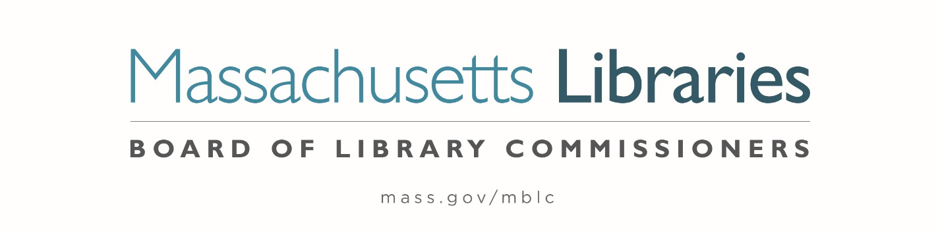

Welcome. Thank you for attending this meeting of the Massachusetts Board of Library Commissioners. Please remember that as part of the meeting agenda there is a time at the end of the meeting for public comment. Should you wish to address the Board during a particular item, please wait to be recognized by the chair.
Note: Agenda may include items not reasonably expected 48 hours before the meeting.
Thursday, April 3, 2025 10:00 A.M./ Refreshments 9:30 A.M.
Massachusetts Board of Library Commissioners Offices
Zoom Meeting Information
https://us02web.zoom.us/j/81331604730?pwd=UQ32f2v2HVqkGBZlb5pPVdomHNNM6t.1
Dial in number: (646) 558-8656/ Meeting ID: 813 3160 4730

Agenda- Regular Monthly Meeting
- Call to order

- Roll Call of Commissioners

Speaker: Karen Traub, Secretary

- Approval of Minutes- March 6, 2025 Minutes

Speaker: Vicky Biancolo, Chair

- Chair’s Report

Speaker: Vicky Biancolo, Chair

- Commissioner Reports

Speaker: Vicky Biancolo, Chair


- Director’s Report

Speaker: Maureen Amyot, Director

- Legislative Report

Speaker: Rob Favini, Government Liaison

- Consideration of approval of an increase to the eligible cost for the Small Library Pilot Project (ACTION)

Speakers: Andrea Bono-Bunker, Library Building Consultant
Heather Backman, Library Building Specialist

- Consideration of approval of the policies for the FY2027 State Aid to Public Libraries Program (ACTION)

Speakers: Cate Merlin, Head of State Programs
Jen Inglis, State Aid Specialist

- Consideration of approval of the FY2026 Plan of Service and Program and Budget for the Library for the Commonwealth (LFC) (ACTION)

Speaker: Sarah Jackson, Network Administrator
Library for the Commonwealth/ Boston Public Library (BPL)

- Report of the results of the Small Libraries in Network (SLIN) Review Committee and the recommendation for updates to the SLIN program

Speaker: Kate Butler, Library Information Systems Specialist

- Report from the Massachusetts Library System (MLS)

Speaker: Sarah Sogigian, Executive Director
Massachusetts Library System (MLS)

- Report from the Library for the Commonwealth

Speaker: Sarah Jackson, Network Administrator
Library for the Commonwealth/ Boston Public Library (BPL)

- Quarterly Report from the Massachusetts Center for the Book

Speaker: Courtney Andree, Executive Director
Massachusetts Center for the Book

- Quarterly Report from the Worcester Talking Book Library

Speaker: Lee Anne Hooley, Library Director
Worcester Talking Book Library

- Unfinished Business and General Orders

- Public Comment

- Adjournment Vicky Biancolo, Chair

To review the Massachusetts Board of Library Commissioners current bylaws
(Organizations and Functions of the Board of Library Commissioners)
Visit https://mblc.state.ma.us/about-us/commissioners/index.php

