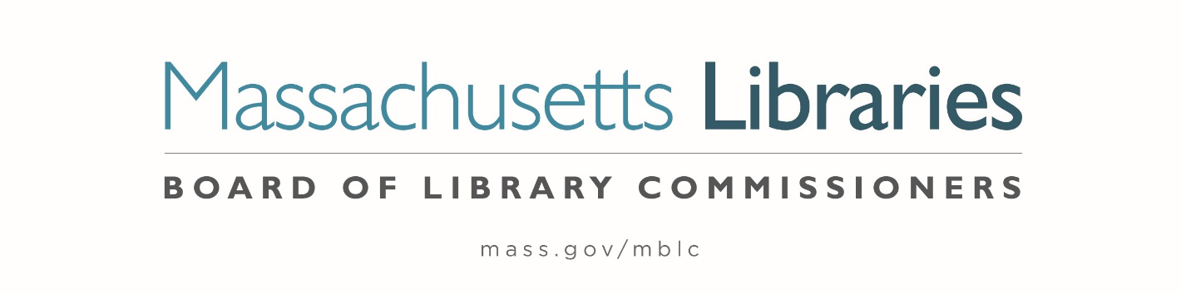

Welcome. Thank you for attending this meeting of the Massachusetts Board of Library Commissioners. Please remember that as part of the meeting agenda there is a time at the end of the meeting for public comment. Should you wish to address the Board during a particular item, please wait to be recognized by the chair.
Note: Agenda may include items not reasonably expected 48 hours before the meeting.
Thursday, September 7, 2023 10:00 A.M./ Refreshments 9:30 A.M.
Massachusetts Library System (MLS), Northampton Offices
Zoom Meeting Information
https://us02web.zoom.us/j/83548842221?pwd=dWIrS0xDZ2NZN01BQVlIRzAzcjRGdz09

Meeting ID: 835 4884 2221 / Passcode: September
Dial in number: (646) 558-8656/ Meeting ID: 835 4884 2221

Agenda- Regular Monthly Meeting
- Call to order

- Welcome

Speaker: Sarah Sogigian, Executive Director

- Roll Call of Commissioners

Speaker: Debby Conrad, Chair

- Approval of Minutes- August 3, 2023 Minutes (ACTION)

Speaker: Debby Conrad, Chair

- Chair’s Report

Speaker: Debby Conrad, Chair


Posted: Thursday, August 31, 2023 at 5:00 P.M.
:00 P.M.
- Commissioner Reports

Speaker: Debby Conrad, Chair

- Director’s Report

Speaker: James M. Lonergan, Director

- Legislative Report

Speaker: Mary Rose Quinn, Head of State Programs/ Government Liaison

- Discussion of the FY2025 Legislative Agenda (ACTION)

Speakers: James Lonergan, Director
Mary Rose Quinn, Head of State Programs/ Government Liaison

- Discussion/ review of policies for the FY2026 State Aid to Public Libraries Program

Speakers: Mary Rose Quinn, Head of State Programs/ Government Liaison
Jen Inglis, State Aid Specialist

- Report from the Griswold Memorial Library, Colrain and the Belding Memorial Library in Ashfield about their LSTA Grant

Speakers: Chelsea Jordan Makely, Library Director
Sarah Hertel-Fernandez, Library Director

- Report from Massachusetts Library System (MLS)

Speaker: Sarah Sogigian, Executive Director
Massachusetts Library System (MLS)

- Report from Library for the Commonwealth (LFC)

Speaker: Michael Colford, Director of Library Services
Boston Public Library (BPL)

- Public Comment

- Old Business

- Adjournment Debby Conrad, Chair

To review the Massachusetts Board of Library Commissioners current bylaws
(Organizations and Functions of the Board of Library Commissioners)
Visit https://mblc.state.ma.us/about-us/commissioners/index.php

