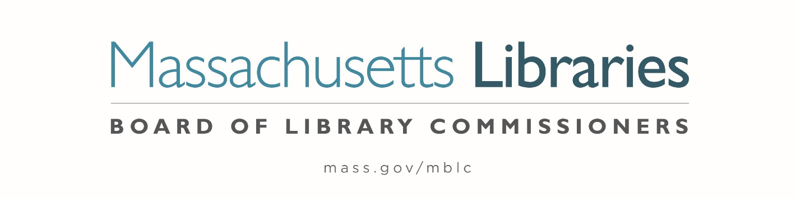

Welcome. Thank you for attending this meeting of the Massachusetts Board of Library Commissioners. Please remember that as part of the meeting agenda there is a time at the end of the meeting for public comment. Should you wish to address the Board during a particular item, please wait to be recognized by the chair.
Note: Agenda may include items not reasonably expected 48 hours before the meeting.
Thursday, October 5, 2023 10:00 A.M./ Refreshments 9:30 A.M.
Eastham Public Library
Zoom Meeting Information
https://us02web.zoom.us/j/84659604020?pwd=b1VvSzZ4RTg1WHFYenpBZ0JXVUpUdz09
Meeting ID: 846 5960 4020/ Passcode: 547829
Dial in number: (646) 558-8656/ Meeting ID: 846 5960 4020

Agenda- Regular Monthly Meeting
- Call to order

- Welcome

Speaker: Melanie McKenzie – Library Director
- Roll Call of Commissioners

Speaker: Debby Conrad, Chair

- Approval of Minutes- September 7, 2023 Minutes (ACTION)

Speaker: Debby Conrad, Chair

- Chair’s Report

Speaker: Debby Conrad, Chair


Posted: Friday, September 29, 2023 at 5:00 P.M.
:00 P.M.
- Commissioner Reports

Speaker: Debby Conrad, Chair

- Director’s Report

Speaker: James M. Lonergan, Director

- Legislative Report

Speaker: Mary Rose Quinn, Head of State Programs/ Government Liaison

- Consideration of approval of policies for the FY2026 State Aid to Public Libraries Program (ACTION)

Speakers: Mary Rose Quinn, Head of State Programs/ Government Liaison
Jen Inglis, State Aid Specialist

- Consideration of approval of Board Policy on Budget Revisions for Budget Line-Item Programs (ACTION)

Speaker: James M. Lonergan, Director

- Consideration of Network Grant Awards under account 7000-9506
a. FY2024 Small Libraries in Networks Recommendation (ACTION)
b. FY2024 Telecommunications for Resource Sharing Recommendation (ACTION)
c. FY2024 Network Infrastructure Recommendation (ACTION)
d. FY2024 Resource Sharing Program Recommendation (ACTION)

Speaker: Paul Kissman, Library Information Systems Specialist

- Consideration of approval for the Library eBooks and Audiobooks (LEA) Content Grants
(ACTION)
Speaker: Kate Butler, Electronic Systems Specialist
- Consideration of approval of extension request for construction documents for Amherst (ACTION)

Speaker: Andrea Bono-Bunker, Library Building Specialist

- Report from the Griswold Memorial Library, Colrain and the Belding Memorial Library in Ashfield about their LSTA Grant

Speakers: Chelsea Jordan Makely, Library Director
Sarah Hertel-Fernandez, Library Director

- Presentation of FY2024 MBLC Budget

Speaker: Tracey Dimant, Head of Operations and Budget

- Report from Massachusetts Library System (MLS)

Speaker: Sarah Sogigian, Executive Director
Massachusetts Library System (MLS)

- Report from Library for the Commonwealth (LFC)

Speaker: Jessica Chapel, Chief of Digital & Online Services
Boston Public Library (BPL)

- Public Comment

- Old Business

- Adjournment Debby Conrad, Chair

To review the Massachusetts Board of Library Commissioners current bylaws
(Organizations and Functions of the Board of Library Commissioners)
Visit https://mblc.state.ma.us/about-us/commissioners/index.php

