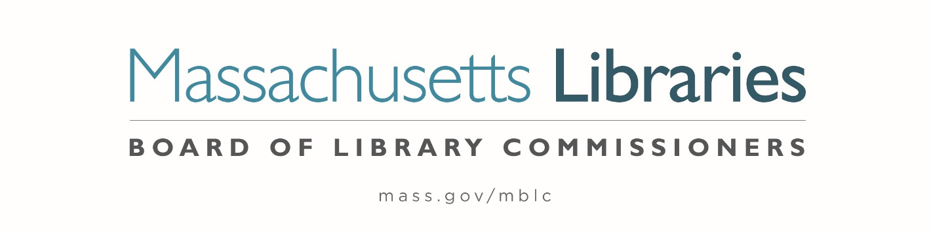

Welcome. Thank you for attending this meeting of the Massachusetts Board of Library Commissioners. Please remember that as part of the meeting agenda there is a time at the end of the meeting for public comment. Should you wish to address the Board during a particular item, please wait to be recognized by the chair.
Note: Agenda may include items not reasonably expected 48 hours before the meeting.
Thursday, November 2, 2023 10:00 A.M./ Refreshments 9:30 A.M.
Sherborn Library
Zoom Meeting Information
https://us02web.zoom.us/j/88319850163?pwd=VEQ5d2lHT3RnTmJIdy9DK1o1dWlPQT09
Meeting ID: 883 1985 0163/Passcode: 165921
Dial in number: (646) 558-8656/ Meeting ID: 883 1985 0163

Agenda- Regular Monthly Meeting
- Call to order

- Welcome

Speaker: Liz Anderson, Library Director
- Roll Call of Commissioners

Speaker: Debby Conrad, Chair

- Approval of Minutes- October 5, 2023 Minutes (ACTION)

Speaker: Debby Conrad, Chair

- Chair’s Report

Speaker: Debby Conrad, Chair


Posted: Friday, October 27, 2023 at 5:00 P.M.
:00 P.M.
- Commissioner Reports

Speaker: Debby Conrad, Chair

- Director’s Report

Speaker: James M. Lonergan, Director

- Legislative Report

Speaker: Mary Rose Quinn, Head of State Programs/ Government Liaison

- Consideration of approval of municipalities meeting the requirements for the FY2024 State Aid to Public Libraries based on eligibility established in FY2024 for the Municipal Appropriation Requirement and in FY2023 for the minimum standards (ACTION)

Speakers: Jen Inglis, State Aid Specialist

- Consideration of approval of the FY2025 Library Services and Technology Act (LSTA) Direct Grant Round Program & Budget (ACTION)

Speaker: Rob Favini, Head of Library Advisory & Development

- Consideration of appointments to the State Advisory Council on Libraries (SACL) (ACTION)

Speaker: Rob Favini, Head of Library Advisory & Development

- Consideration of budget revision for the Massachusetts Library System (MLS)
(ACTION)
Speaker: Sarah Sogigian, Executive Director
- Presenting an overview of the State Aid to Public Libraries Waiver Program/ Plan

Speaker: Mary Rose Quinn, Head of State Programs/ Government Liaison

- Report from Massachusetts Library System (MLS)

Speaker: Sarah Sogigian, Executive Director
Massachusetts Library System (MLS)

- Report from Library for the Commonwealth (LFC)

Speaker: Angela Veizaga, Director of Strategic Partnerships
Boston Public Library (BPL)

- Public Comment

- Old Business

- Adjournment Debby Conrad, Chair

To review the Massachusetts Board of Library Commissioners current bylaws
(Organizations and Functions of the Board of Library Commissioners)
Visit https://mblc.state.ma.us/about-us/commissioners/index.php

