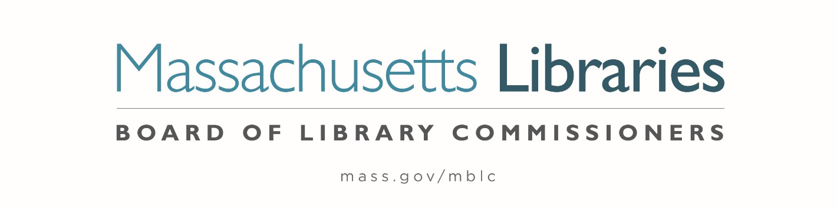

Welcome. Thank you for attending this meeting of the Massachusetts Board of Library Commissioners. Please remember that as part of the meeting agenda there is a time at the end of the meeting for public comment. Should you wish to address the Board during a particular item, please wait to be recognized by the chair.
Note: Agenda may include items not reasonably expected 48 hours before the meeting.
Thursday, May 2, 2024 10:00 A.M./ Refreshments 9:30 A.M.
Samuel L. Pollard Library, Lowell
Zoom Meeting Information
https://us02web.zoom.us/j/89605212455?pwd=RVFORDUrRWdJRUFRdVZlSWlEcVdlQT09
Meeting ID: 896 0521 2455/ Passcode: May
Dial in number: (646) 558-8656/ Meeting ID: 896 0521 2455

Agenda- Regular Monthly Meeting
- Call to order

- Welcome

Speaker: Bridget Cooley, Acting Director

- Roll Call of Commissioners

Speaker: Debby Conrad, Chair

- Approval of Minutes-
- April 2, 2024 Minutes (ACTION)
- April 17, 2024 (AM) Minutes (ACTION)
- April 17, 2024 (PM) Minutes (ACTION)

Speaker: Debby Conrad, Chair

- Chair’s Report

Speaker: Debby Conrad, Chair


- Commissioner Reports

Speaker: Debby Conrad, Chair

- Director’s Report

Speaker: James M. Lonergan, Director

- Legislative Report

Speaker: Rob Favini, Government Liaison

- Discussion and approval of correction to the due dates of the FY2025 State Aid to Public Libraries Program “Determining Eligibility for a Waiver of the FY2025 Municipal Appropriation Requirement (MAR)” (ACTION)

Speaker: Jen Inglis, State Aid Specialist

- Update and discussion about advocacy for $150 million for the Massachusetts Public Library Construction Program (MPLCP) in H. 4459, An Act Relative to Strengthening Massachusetts’ Economic Leadership

Speakers: Andrea Bono-Bunker, Library Building Consultant
James M. Lonergan, Director

- Report from Massachusetts Library System (MLS)

Speaker: Jack Martin, Communications Manager
Massachusetts Library System (MLS)

- Report from the Library for the Commonwealth (LFC)

- Public Comment

- Old Business

- Adjournment Debby Conrad, Chair
To review the Massachusetts Board of Library Commissioners current bylaws
(Organizations and Functions of the Board of Library Commissioners)
Visit https://mblc.state.ma.us/about-us/commissioners/index.php

