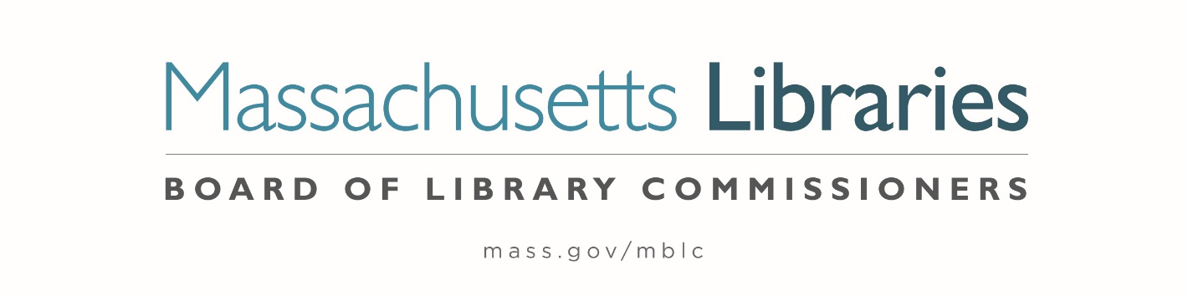

Welcome. Thank you for attending this meeting of the Massachusetts Board of Library Commissioners. Please remember that as part of the meeting agenda there is a time at the end of the meeting for public comment. Should you wish to address the Board during a particular item, please wait to be recognized by the chair.
Note: Agenda may include items not reasonably expected 48 hours before the meeting.
Thursday, March 7, 2024 10:00 A.M./ Refreshments 9:30 A.M.
MBLC Offices, Boston
Zoom Meeting Information
https://us02web.zoom.us/j/83388777853?pwd=YWV2YjVLZGNIY1JFV1JMM3dab3U2QT09
Meeting ID: 833 8877 7853/Passcode: March
Dial in number: (646) 558-8656/ Meeting ID: 833 8877 7853

Agenda- Regular Monthly Meeting
- Call to order

- Welcome

- Roll Call of Commissioners

Speaker: Debby Conrad, Chair

- Approval of Minutes- February 1, 2024 Minutes (ACTION)

Speaker: Debby Conrad, Chair

- Chair’s Report

Speaker: Debby Conrad, Chair


Posted: Friday, March 1, 2024 at 5:00 P.M.
:00 P.M.
- Commissioner Reports

Speaker: Debby Conrad, Chair

- Director’s Report

Speaker: James M. Lonergan, Director

- Legislative Report

Speaker: Rob Favini, Government Liaison

- Report from Director Search Committee

Speaker: Vicky Biancolo, Search Committee Chair

- Consideration of approval of appointment to the Statewide PR Committee (ACTION)

Speaker: Celeste Bruno, Communications Director

- Consideration of approval for Social Media Policy and Terms of Use Policy (ACTION)

Speaker: June Thammasnong, Communications Specialist

- Consideration of approval of the FY2025 Plan of Service and Program and Budget for the Library for the Commonwealth (LFC) and Monthly Report (ACTION)

Speaker: Angela Veizaga, Director of Strategic Partnerships
Boston Public Library (BPL)

- Report from Massachusetts Library System (MLS)

Speaker: Sarah Sogigian, Executive Director
Massachusetts Library System (MLS)

- Public Comment

- Old Business

- Adjournment Debby Conrad, Chair

To review the Massachusetts Board of Library Commissioners current bylaws
(Organizations and Functions of the Board of Library Commissioners)
Visit https://mblc.state.ma.us/about-us/commissioners/index.php

