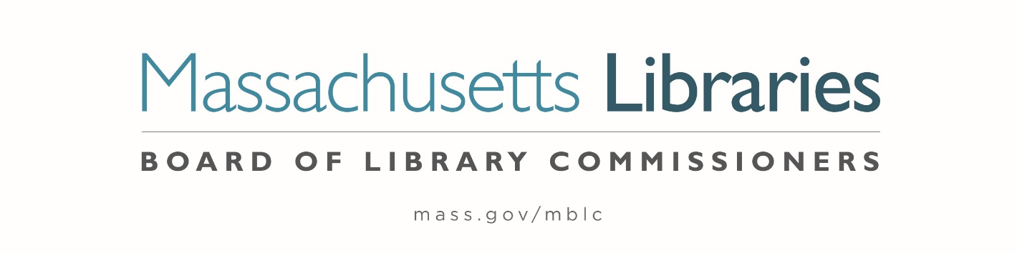

Welcome. Thank you for attending this meeting of the Massachusetts Board of Library Commissioners. Please remember that as part of the meeting agenda there is a time at the end of the meeting for public comment. Should you wish to address the Board during a particular item, please wait to be recognized by the chair.
Note: Agenda may include items not reasonably expected 48 hours before the meeting.
Thursday, June 6, 2024 10:00 A.M./ Refreshments 9:30 A.M.
Palmer Public Library
Zoom Meeting Information
https://us02web.zoom.us/j/89255863811?pwd=Zy9aQ0N4N1g5SExVVkMwa1QzaFlHUT09
Meeting ID: 892 5586 3811/ Passcode: June
Dial in number: (646) 558-8656/ Meeting ID: 892 5586 3811

Agenda- Regular Monthly Meeting
- Call to order

- Welcome

Speaker: Stephanie Maher, Library Director

- Roll Call of Commissioners

Speaker: Debby Conrad, Chair

- Approval of Minutes- May 2, 2024 Minutes (ACTION)

Speaker: Debby Conrad, Chair

- Chair’s Report

Speaker: Debby Conrad, Chair

- Commissioner Reports


Speaker: Debby Conrad, Chair
- Director’s Report

Speaker: James M. Lonergan, Director

- Legislative Report

Speaker: Rob Favini, Government Liaison

- Consideration of a FY2025 Grant Round for 7000-9506, Library Technology and Resource Sharing, including Telecommunications for Resource Sharing, Resource Sharing Program, Network Infrastructure, and Small Libraries in Networks (ACTION)

Speaker: Kate Butler, Library Information Systems Specialist

- Consideration of a FY2025 Grant Round for 7000-9506, LEA eContent grants (ACTION)

Speaker: Jaccavrie McNeely, Electronic Services Specialist

- Consideration of approval for a Deadline Extension Request from the Jones Library in Amherst (ACTION)

Speaker: Andrea Bono-Bunker, Library Building Consultant

- Report from Massachusetts Library System (MLS)

Speaker: Sarah Sogigian, Executive Director
Massachusetts Library System (MLS)

- Report from the Library for the Commonwealth (LFC)

- Public Comment

- Old Business

- Adjournment Debby Conrad, Chair
To review the Massachusetts Board of Library Commissioners current bylaws
(Organizations and Functions of the Board of Library Commissioners)
Visit https://mblc.state.ma.us/about-us/commissioners/index.php

