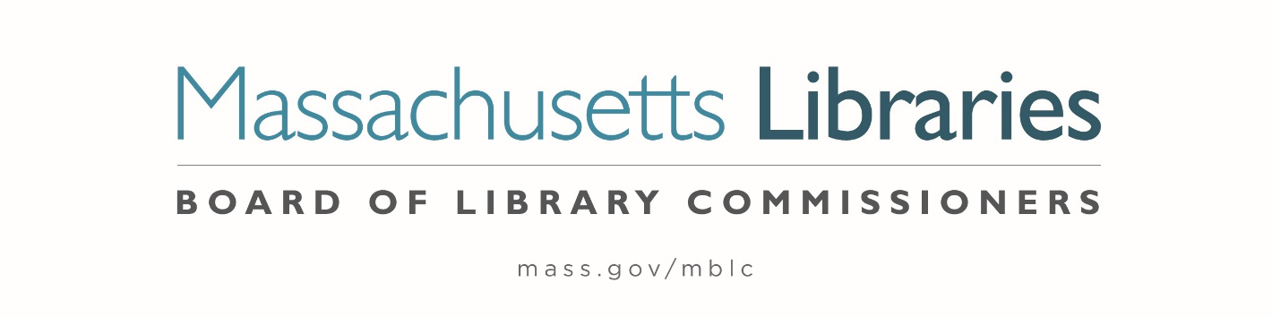

Welcome. Thank you for attending this meeting of the Massachusetts Board of Library Commissioners. Please remember that as part of the meeting agenda there is a time at the end of the meeting for public comment. Should you wish to address the Board during a particular item, please wait to be recognized by the chair.
Note: Agenda may include items not reasonably expected 48 hours before the meeting.
Thursday, July 13, 2023 1:00 P.M.
Fully Remote Meeting
Zoom Meeting Information
https://us02web.zoom.us/j/83930794789?pwd=dnluWXZTUTFVQ3pMZHdCL3FyaVdkUT09
Meeting ID: 839 3079 4789/ Passcode: July13
Dial in number: (646) 558-8656/ Meeting ID: 839 3079 4789

Agenda- Regular Monthly Meeting
- Call to order- Roll call Commissioners

Speaker: Debby Conrad, Chair

- Approval of Minutes- June 1, 2023 Minutes (ACTION)

Speaker: Debby Conrad, Chair

- Chair’s Report

Speaker: Debby Conrad, Chair

- Commissioner Reports

Speaker: Debby Conrad, Chair

- Director’s Report

Speaker: James M. Lonergan, Director

Posted: Friday, July 7, 2023 at 5:00 P.M.
:00 P.M.

- Legislative Report

Speaker: Mary Rose Quinn, Head of State Programs/ Government Liaison

- Massachusetts Public Library Construction Program Grant Awards Program

- Consideration of approval of provisional grant awards under the Massachusetts Public Library Construction Program (ACTION)
- Consideration of approval of a Library Green Incentive awards under the Massachusetts Public Library Construction program (ACTION)

Speaker: Andrea Bono-Bunker, Library Building Specialist
Lauren Stara, Library Building Specialist

- Consideration of approval of the FY2024 Library Services and Technology Act (LSTA) Grant Awards

- Access for All (ACTION)
- Archives Arrangement & Description (ACTION)
- At the Table (ACTION)
- Citizenship Corners (ACTION)
- Civic Hub (ACTION)
- Creative Communities (ACTION)
- Go Local (ACTION)
- Mind in the Making (ACTION)
- Open for Business (ACTION)

Speaker: Rob Favini, Head of Library Advisory and Development

- Discussion about the closure of library policy

Speaker: Mary Rose Quinn, Head of State Programs/ Government Liaison

- Report from Massachusetts Library System (MLS)

Speaker: Sarah Sogigian, Executive Director
Massachusetts Library System (MLS)

- Report from Library for the Commonwealth (LFC)

Speaker: Michael Colford, Director of Library Services
Boston Public Library (BPL)

- Election of Officers for FY2024 (ACTION)

Speaker: Stacy DeBole, Secretary

- Public Comment

- Old Business

- Adjournment Debby Conrad, Chair

To review the Massachusetts Board of Library Commissioners current bylaws
(Organizations and Functions of the Board of Library Commissioners)
Visit https://mblc.state.ma.us/about-us/commissioners/index.php

