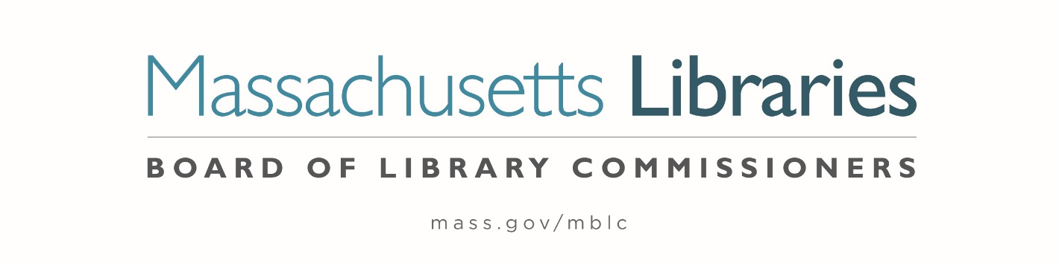

Welcome. Thank you for attending this meeting of the Massachusetts Board of Library Commissioners. Please remember that as part of the meeting agenda there is a time at the end of the meeting for public comment. Should you wish to address the Board during a particular item, please wait to be recognized by the chair.
Note: Agenda may include items not reasonably expected 48 hours before the meeting.
Thursday, January 4, 2024 10:00 A.M./ Refreshments 9:30 A.M.
MBLC Offices, Boston
Zoom Meeting Information
https://us02web.zoom.us/j/83709607727?pwd=eitZZHVtZWZkSnBha241N0diemhZZz09
Meeting ID: 837 0960 7727/Passcode: January
Dial in number: (646) 558-8656/ Meeting ID: 837 0960 7727

Agenda- Regular Monthly Meeting
- Call to order

- Welcome

- Roll Call of Commissioners

Speaker: Debby Conrad, Chair

- Approval of Minutes- December 7, 2023 Minutes (ACTION)

Speaker: Debby Conrad, Chair

- Chair’s Report

Speaker: Debby Conrad, Chair


Posted: Friday, December 29, 2023 at 5:00 P.M.
:00 P.M.
- Commissioner Reports

Speaker: Debby Conrad, Chair

- Director’s Report

Speaker: James M. Lonergan, Director

- Legislative Report

Speaker: Rob Favini, Government Liaison

- Consideration of approval to the Town of Lynnfield for an extension to accept their provisional grant award (ACTION)

Speaker: Andrea Bono-Bunker, Library Building Consultant

- Consideration of approval of municipalities meeting the requirements for the FY2024 State Aid to Public Libraries based on eligibility established in FY2024 for the Municipal Appropriation Requirement and in FY2023 for the minimum standards (ACTION)

Speaker: Jen Inglis, State Aid Specialist

- Review of municipalities requesting waivers for the FY2024 municipal appropriation requirement in the FY2024 State Aid to Public Libraries Program within the 5% threshold

Speaker: James Lonergan, Director

- Review and presentation of petition for a waiver of the municipal appropriation requirement for the FY2024 State Aid to Public Libraries Program above the 5% threshold

- Wayland -9.26%

Speaker: James Lonergan, Director

- Consideration of the Director Search Process

- Consideration of a charge to the Director Search Committee (ACTION)

Speaker: Chair Conrad

- Consideration of appointments to the Director Search Committee (ACTION)

Speaker: Chair Conrad
- Consideration of a timeline for the Director Search Committee (ACTION)

Speaker: Chair Conrad

- Presentation and discussion of the FY2025 Plan of Service and Program and Budget for the Massachusetts Center for the Book and Monthly Report

Speaker: Courtney Andree, Executive Director
Massachusetts Center for the Book

- Presentation and discussion pf the FY2025 Plan of Service and Program and Budget for the Massachusetts Library System (MLS) and Monthly Report

Speaker: Sarah Sogigian, Executive Director
Massachusetts Library System (MLS)

- Report from Library for the Commonwealth (LFC)

Speaker: Angela Veizaga, Director of Strategic Partnerships
Boston Public Library (BPL)

- Public Comment

- Old Business

- Adjournment Debby Conrad, Chair

To review the Massachusetts Board of Library Commissioners current bylaws
(Organizations and Functions of the Board of Library Commissioners)
Visit https://mblc.state.ma.us/about-us/commissioners/index.php

