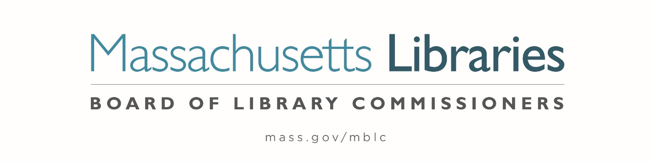

Welcome. Thank you for attending this meeting of the Massachusetts Board of Library Commissioners. Please remember that as part of the meeting agenda there is a time at the end of the meeting for public comment. Should you wish to address the Board during a particular item, please wait to be recognized by the chair.
Note: Agenda may include items not reasonably expected 48 hours before the meeting.
Thursday, February 1, 2024 10:00 A.M./ Refreshments 9:30 A.M.
MBLC Offices, Boston
Zoom Meeting Information
https://us02web.zoom.us/j/86786863782?pwd=bll0OWFCUHE5ZzliMFpCYUFQbDUrQT09
Meeting ID: 867 8686 3782/Passcode: February
Dial in number: (646) 558-8656/ Meeting ID: 867 8686 3782

Agenda- Regular Monthly Meeting
- Call to order

- Welcome

- Roll Call of Commissioners

Speaker: Debby Conrad, Chair

- Approval of Minutes- January 4, 2024 Minutes (ACTION)

Speaker: Debby Conrad, Chair

- Chair’s Report

Speaker: Debby Conrad, Chair


Posted: Thursday, January 25, 2024 at 5:00 P.M.
:00 P.M.
- Commissioner Reports

Speaker: Debby Conrad, Chair

- Director’s Report

Speaker: James M. Lonergan, Director

- Legislative Report

Speaker: Rob Favini, Government Liaison

- Report from Search Committee

Speaker: Vicky Biancolo, Search Committee Chair

- Consideration of approval of municipalities requesting waivers for the FY2024 municipal appropriation requirement in the FY2024 State Aid to Public Libraries Program within the 5% threshold (ACTION)

Speakers: Cate Merlin, Head of State Programs
James Lonergan, Director

- Consideration of approval of a petition for a waiver of the municipal appropriation requirement for the FY2024 State Aid to Public Libraries Program above the 5% threshold (ACTION)

- Wayland -9.26%

Speaker: Cate Merlin, Head of State Programs
James Lonergan, Director

- Consideration of approval of Joining Network Grants (ACTION)

Speaker: Kate Butler, Library Information System Specialist

- Consideration of approval of the FY2025 Plan of Service and Program and Budget for the Massachusetts Center for the Book (ACTION)

Speaker: Courtney Andree, Executive Director
Massachusetts Center for the Book

- Presentation and discussion of the FY2025 Plan of Service and Program and Budget for the Massachusetts Library System (MLS) and Monthly Report (ACTION)

Speaker: Sarah Sogigian, Executive Director
Massachusetts Library System (MLS)

- Presentation and discussion pf the FY2025 Plan of Service and Program and Budget for the Library for the Commonwealth (LFC) and Monthly Report

Speaker: Angela Veizaga, Director of Strategic Partnerships
Boston Public Library (BPL)

- Public Comment

- Old Business

- Adjournment Debby Conrad, Chair

To review the Massachusetts Board of Library Commissioners current bylaws
(Organizations and Functions of the Board of Library Commissioners)
Visit https://mblc.state.ma.us/about-us/commissioners/index.php

