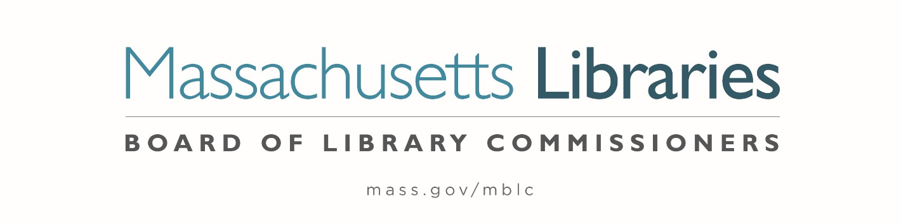

Welcome. Thank you for attending this meeting of the Massachusetts Board of Library Commissioners. Please remember that as part of the meeting agenda there is a time at the end of the meeting for public comment. Should you wish to address the Board during a particular item, please wait to be recognized by the chair.
Note: Agenda may include items not reasonably expected 48 hours before the meeting.
Thursday, December 7, 2023 10:00 A.M./ Refreshments 9:30 A.M.
MBLC Offices, Boston
Zoom Meeting Information
https://us02web.zoom.us/j/84433730266?pwd=MklrS1hGZVZDUXRtTDF0R2NtdjFvQT09
Meeting ID: 844 3373 0266/Passcode: 606554
Dial in number: (646) 558-8656/ Meeting ID: 844 3373 0266

Agenda- Regular Monthly Meeting
- Call to order

- Welcome

- Roll Call of Commissioners

Speaker: Debby Conrad, Chair

- Approval of Minutes- November 2, 2023 Minutes (ACTION)

Speaker: Debby Conrad, Chair

- Chair’s Report

Speaker: Debby Conrad, Chair


Posted: Friday, December 1, 2023 at 5:00 P.M.
:00 P.M.
- Commissioner Reports

Speaker: Debby Conrad, Chair

- Director’s Report

Speaker: James M. Lonergan, Director

- Legislative Report

Speaker: Rob Favini, Government Liaison

- Consideration of approval of municipalities meeting the requirements for the FY2024 State Aid to Public Libraries based on eligibility established in FY2024 for the Municipal Appropriation Requirement and in FY2023 for the minimum standards (ACTION)

Speaker: Jen Inglis, State Aid Specialist

- Consideration of appointment and reappointments to the Statewide PR Committee (ACTION)

Speaker: Celeste Bruno, Communications Director

- Report from Massachusetts Library System (MLS)

Speaker: Scott Kehoe, Senior Manager for Resource Sharing
Massachusetts Library System (MLS)

- Report from Library for the Commonwealth (LFC)

Speaker: Angela Veizaga, Director of Strategic Partnerships
Boston Public Library (BPL)

- Public Comment

- Old Business

- Adjournment Debby Conrad, Chair

To review the Massachusetts Board of Library Commissioners current bylaws
(Organizations and Functions of the Board of Library Commissioners)
Visit https://mblc.state.ma.us/about-us/commissioners/index.php

