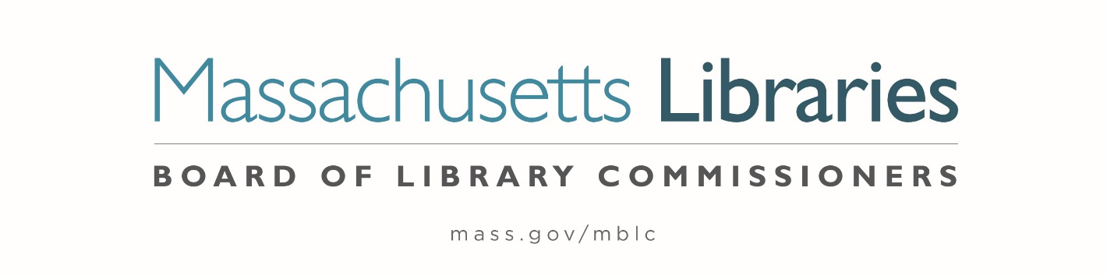

Welcome. Thank you for attending this meeting of the Massachusetts Board of Library Commissioners. Please remember that as part of the meeting agenda there is a time at the end of the meeting for public comment. Should you wish to address the Board during a particular item, please wait to be recognized by the chair.
Note: Agenda may include items not reasonably expected 48 hours before the meeting.
Thursday, April 4, 2024 10:00 A.M./ Refreshments 9:30 A.M.
Zoom Meeting
Zoom Meeting Information
https://us02web.zoom.us/j/83619629891?pwd=SXlkTnhTbzU2TGZWRGo1N2RwTXRWUT09
Meeting ID: 836 1962 9891 / Passcode: April
Dial in number: (646) 558-8656/ Meeting ID: 836 1962 9891

Agenda- Regular Monthly Meeting
- Call to order

- Roll Call of Commissioners

Speaker: Debby Conrad, Chair

- Approval of Minutes- March 7, 2024 Minutes (ACTION)

Speaker: Debby Conrad, Chair

- Chair’s Report

Speaker: Debby Conrad, Chair

- Commissioner Reports


Speaker: Debby Conrad, Chair

- Director’s Report

Speaker: James M. Lonergan, Director

- Legislative Report

Speaker: Rob Favini, Government Liaison

- Report from Director Search Committee

Speaker: Vicky Biancolo, Search Committee Chair

- Update on the 2023-2024 Massachusetts Public Library Construction Program (MPLCP) Grant Round and the bond bill

Speaker: Andrea Bono-Bunker, Library Building Consultant

- Quarterly Report from the Massachusetts Center for the Book

Speaker: Courtney Andree, Executive Director
Massachusetts Center for the Book

- Report from Massachusetts Library System (MLS)

Speaker: Bradley Schmidt, Executive Assistant
Massachusetts Library System (MLS)

- Report from Library for the Commonwealth

Speaker: Angela Veizaga, Director of Strategic Partnerships
Boston Public Library (BPL)

- Public Comment

- Old Business

- Adjournment Debby Conrad, Chair

To review the Massachusetts Board of Library Commissioners current bylaws
(Organizations and Functions of the Board of Library Commissioners)
Visit https://mblc.state.ma.us/about-us/commissioners/index.php

