MINUTES OF THE BOARD OF LIBRARY COMMISSIONERS SPECIAL MEETING

Date : Wednesday, April 17, 2024
Time : 9:45 A.M.

Place : Massachusetts Board of Library Commissioners Offices
Boston, MA

Board
Present : Debby Conrad, Chair; Vicky Biancolo, Vice Chair; Karen Traub, Secretary; Kate Chang; Timothy Cherubini; George Comeau, Esq.; Joyce Linehan; Jessica Vilas Novas

Staff Present:
Heather Backman, Library Building Specialist; Celeste Bruno, Communications Director;
Andrea Bono-Bunker, Library Building Consultant; Kate Butler, Library Information Systems Specialist; Terry D'Angelo, Administrative Assistant / Business Office; Tanesha Deane, Contract Specialist; Tracey Dimant, Head of Operations & Budget / Business Office; Ally Dowds, Consultant to Special Populations; Susan Faiella, Accountant; Rob Favini, Head of Library Advisory & Development / Government Liaison; Lyndsay Forbes, Project Manager & Grants Specialist; Jennifer Inglis, State Aid Specialist; James Lonergan, Director; Rachel Masse, Assistant to the Director; Jaccavrie McNeely, Electronic Services Specialist; Uechi Ng, Administrative Assistant / State Aid

Observers Present:
Clayton Cheever, Director, Morrill Memorial Library, Norwood; Mary Ann Cluggish, Former Commissioner; Debbie Froggatt, Retired Director of Library Services, Boston Public Schools; Esmé Green, Director, Goodnow Library, Sudbury; Kim Hewitt, Director, Watertown Free Public Library; Kathy Lussier, Network Administrator, North of Boston Library Exchange (NOBLE); Mary Rose Quinn, Former MBLC Staff

Meeting called to order by Chair Conrad
Chair Conrad called the meeting to order at 9:45 A.M.

Roll Call of Commissioners

 | Commissioner Cherubini- Present | Commissioner Linehan- Present
Commissioner Biancolo- Present | Commissioner Comeau- Present | Commissioner Traub- Present
Commissioner Chang- Present | Commissioner Conrad- Present | Commissioner Vilas Novas- Present

She stated that the purpose of this Special Meeting of the Board of Library Commissioners is to interview for the position of the Director. She relayed that when Director James Lonergan announced his retirement, the Board established a Search Committee to screen candidates for the position.

Commissioners Vicky Biancolo, Vice Chair of the Board and Chair of the Search Committee, Karen Traub, Secretary of the Board and Joyce Linehan, represented the Board on the Search Committee. Other members of the Search Committee and their affiliation include: Courtney Andree, Executive Director, Massachusetts Center for the Book; Kim Charlson, Executive Director, Perkins School Library; Ella Stocker, Massachusetts School Library Association; Tina McAndrew, Secretary, Massachusetts Library Association; Alex Reczkowski, Library Director, Berkshire Athenaeum, Pittsfield; David Slater, Network Administrator, Old Colony Library Network (OCLN); Sarah Sogigian, Executive Director, Massachusetts Library System; Celeste Bruno, Communications Director, MBLC Staff.

Interview session with Maria McCauley for the position of Director of the Massachusetts Board of Library

Chair Conrad welcomed candidate Maria McCauley for her interview. Following introductions the Commissioners asked Ms. McCauley the following questions:

- What are the skills, qualities, and characteristics that have helped you advance in your career?
- How do you envision your first 30 to 90 days in the role? When describing to us your approach, share which aspects are drawn from your past professional experiences and which aspects are specific to this role.
- What do you see as the MBLC’s role in informing and advising appointed and elected officials in the development of legislation, public policy, and programs? What will you do to cultivate a positive relationship with the library caucus, the members of the Ways & Means committees, and the Governor’s office specifically?
- The MBLC recently released a joint statement with library affiliates and partners in support of library staffs’ efforts to ensure free, equal, and open access to information, guaranteed to everyone regardless of age or citizenship status under the First Amendment of the US Constitution. Please describe the impacts of systemic inequities in libraries, and share some strategies you will employ as director of the MBLC to help dismantle the systems that perpetuate inequity.
- We are interested in how you will work with the Commissioners on the Board. Please tell us how you will work with Commissioners who may not agree, have relevant experience, or have a clear understanding of an issue. What will you do to educate and motivate everyone to reach consensus and work toward the same goals?
- What will you do to familiarize yourself with the libraries of the Commonwealth? With our diverse library landscape, how can the MBLC lead and support libraries to improve and expand library services to touch and improve life for every resident of the Commonwealth?
- Please tell us about a time you had to manage and resolve a conflict in a professional setting.
- What will you do to motivate and support staff, including those who may be more knowledgeable than you about their specific subject area? Please give specific examples.
- Please walk us through the steps you will take to develop a strategic plan for the MBLC, and what will you do to realize the initiatives articulated in it?
After responding to these questions, Ms. McCauley then presented a ten-minute prepared response to the following presentation question which was requested in advance by the Commissioners.

“Post pandemic, libraries are facing different–and greater–challenges and expectations than ever before. Censorship, social media pressure, changes in local demographics, global heating, denigration of the library profession, social injustices, and political divisiveness are just a few. Where does the MBLC fit in all of this? What will you do to position the MBLC to help libraries face these issues and those to come?”

Chair Conrad then offered the candidate an opportunity to ask questions of the Board.

Following Ms. McCauley’s presentation and question period, the Commissioners thanked her for interviewing for the position of Director of the Massachusetts Board of Library Commissioners.

Adjournment

There being no further business, Chair Conrad adjourned the first special meeting on April 17, 2024 of the Massachusetts Board of Library Commissioners at 11:12 A.M.

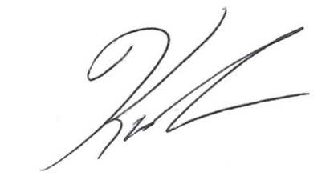

Karen Traub
Secretary
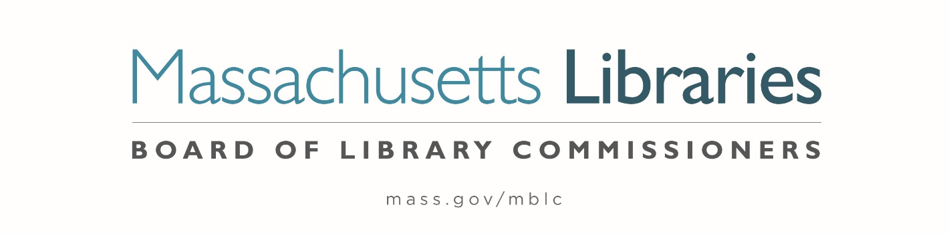

MINUTES OF THE BOARD OF LIBRARY COMMISSIONERS SPECIAL MEETING

Date : Wednesday, April 17, 2024
Time : 1:45 P.M.

Place : Massachusetts Board of Library Commissioners Offices
Boston, MA

Board
Present : Debby Conrad, Chair; Vicky Biancolo, Vice Chair; Karen Traub, Secretary; Kate Chang; Timothy Cherubini; George Comeau, Esq.; Joyce Linehan; Jessica Vilas Novas

Staff Present:
Heather Backman, Library Building Specialist; Celeste Bruno, Communications Director;
Andrea Bono-Bunker, Library Building Consultant; Kate Butler, Library Information Systems Specialist; Terry D'Angelo, Administrative Assistant / Business Office; Tanesha Deane, Contract Specialist; Tracey Dimant, Head of Operations & Budget / Business Office; Ally Dowds, Consultant to Special Populations; Susan Faiella, Accountant; Rob Favini, Head of Library Advisory & Development / Government Liaison; Lyndsay Forbes, Project Manager & Grants Specialist; Jennifer Inglis, State Aid Specialist; James Lonergan, Director; Rachel Masse, Assistant to the Director; Jaccavrie McNeely, Electronic Services Specialist; Uechi Ng, Administrative Assistant / State Aid

Observers Present:
Mary Ann Cluggish, Former Commissioner; Debbie Froggatt, Retired Director of Library Services, Boston Public Schools; Esmé Green, Director, Goodnow Library, Sudbury; Kim Hewitt, Director, Watertown Free Public Library; Scott Kehoe, Library Resource Director, Massachusetts Library System (MLS); Kathy Lussier, Network Administrator, North of Boston Library Exchange (NOBLE); Mary Rose Quinn, Former MBLC Staff

Meeting called to order by Chair Conrad
Chair Conrad called the meeting to order at 1:41 P.M.

Roll Call of Commissioners

 | Commissioner Cherubini- Present | Commissioner Linehan- Present
Commissioner Biancolo- Present | Commissioner Comeau- Present | Commissioner Traub- Present
Commissioner Chang- Present | Commissioner Conrad- Present | Commissioner Vilas Novas- Present

She stated that the purpose of this Special Meeting of the Board of Library Commissioners is to interview for the position of the Director. She relayed that when Director James Lonergan announced his retirement, the Board established a Search Committee to screen candidates for the position.

Commissioners Vicky Biancolo, Vice Chair of the Board and Chair of the Search Committee, Karen Traub, Secretary of the Board and Joyce Linehan, represented the Board on the Search Committee. Other members of the Search Committee and their affiliation include: Courtney Andree, Executive Director, Massachusetts Center for the Book; Kim Charlson, Executive Director, Perkins School Library; Ella Stocker, Massachusetts School Library Association; Tina McAndrew, Secretary, Massachusetts Library Association; Alex Reczkowski, Library Director, Berkshire Athenaeum, Pittsfield; David Slater, Network Administrator, Old Colony Library Network (OCLN); Sarah Sogigian, Executive Director, Massachusetts Library System; Celeste Bruno, Communications Director, MBLC Staff.

Interview session with Maureen Amyot for the position of Director of the Massachusetts Board of Library

Chair Conrad welcomed candidate Maureen Amyot for her interview. Following introductions the Commissioners asked Ms. Amyot the following questions:

- What are the skills, qualities, and characteristics that have helped you advance in your career?
- How do you envision your first 30 to 90 days in the role? When describing to us your approach, share which aspects are drawn from your past professional experiences and which aspects are specific to this role.
- What do you see as the MBLC’s role in informing and advising appointed and elected officials in the development of legislation, public policy, and programs? What will you do to cultivate a positive relationship with the library caucus, the members of the Ways & Means committees, and the Governor’s office specifically?
- The MBLC recently released a joint statement with library affiliates and partners in support of library staffs’ efforts to ensure free, equal, and open access to information, guaranteed to everyone regardless of age or citizenship status under the First Amendment of the US Constitution. Please describe the impacts of systemic inequities in libraries, and share some strategies you will employ as director of the MBLC to help dismantle the systems that perpetuate inequity.
- We are interested in how you will work with the Commissioners on the Board. Please tell us how you will work with Commissioners who may not agree, have relevant experience, or have a clear understanding of an issue. What will you do to educate and motivate everyone to reach consensus and work toward the same goals?
- What will you do to familiarize yourself with the libraries of the Commonwealth? With our diverse library landscape, how can the MBLC lead and support libraries to improve and expand library services to touch and improve life for every resident of the Commonwealth?
- Please tell us about a time you had to manage and resolve a conflict in a professional setting.
- What will you do to motivate and support staff, including those who may be more knowledgeable than you about their specific subject area? Please give specific examples.
- Please walk us through the steps you will take to develop a strategic plan for the MBLC, and what will you do to realize the initiatives articulated in it?
After responding to these questions, Ms. Amyot then presented a ten-minute prepared response to the following presentation question which was requested in advance by the Commissioners.

“Post pandemic, libraries are facing different–and greater–challenges and expectations than ever before. Censorship, social media pressure, changes in local demographics, global heating, denigration of the library profession, social injustices, and political divisiveness are just a few. Where does the MBLC fit in all of this? What will you do to position the MBLC to help libraries face these issues and those to come?”

Chair Conrad then offered the candidate an opportunity to ask questions of the Board.

Following Ms. Amyot’s presentation and question period, the Commissioners thanked her for interviewing for the position of Director of the Massachusetts Board of Library Commissioners.

Chair Conrad called a recess at 3:00 P.M.

Chair Conrad reconvened the meeting at 3:43 P.M.

Chair Conrad welcomed all attendees that returned. Chair Conrad noted that she and the Commissioners reviewed the notes/observations that were submitted to them by the staff after the interview.

The Commissioners engaged in discussion of both Ms. McCauley and Ms. Amyot’s responses to interview questions and their qualifications to become Director of the Board of Library Commissioners.

Following the discussion:

Commissioner Comeau moved and Commissioner Biancolo seconded that the Massachusetts Board of Library Commissioners offer the position of Director to Maureen Amyot.

Chair Conrad asked for a roll call of votes to appoint Ms. Amyot to the Director position.

 | Commissioner Cherubini- Yes | Commissioner Linehan- No
Commissioner Biancolo- Yes | Commissioner Comeau- Yes | Commissioner Traub- Yes
Commissioner Chang- No | Commissioner Conrad- Yes | Commissioner Vilas Novas- Yes

Ms. Amyot will be offered the position of next Director of the Massachusetts Board of Library Commissioners.

ADJOURNMENT

There being no further business, Chair Conrad adjourned the April 17, 2024 special meeting of the Massachusetts Board of Library Commissioners at 4:11 P.M.
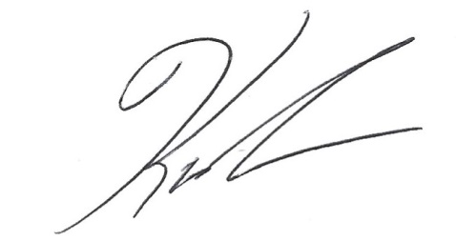

Karen Traub
Secretary

