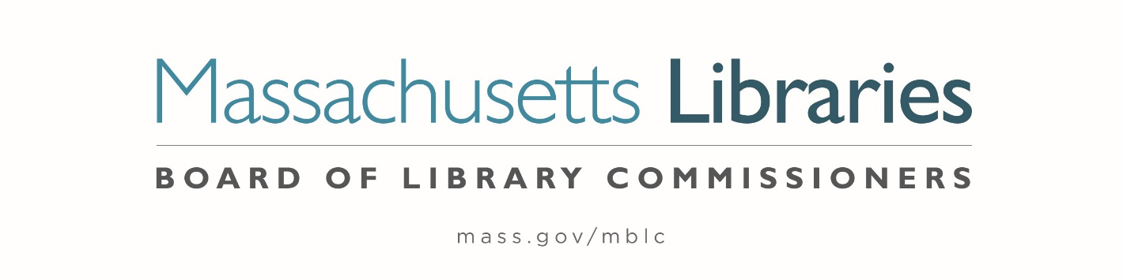

Welcome. Thank you for attending this meeting of the Massachusetts Board of Library Commissioners. Please remember that as part of the meeting agenda there is a time at the end of the meeting for public comment. Should you wish to address the Board during a particular item, please wait to be recognized by the chair.
Note: Agenda may include items not reasonably expected 48 hours before the meeting.
Thursday, September 1, 2022 10:00 A.M./ Refreshments 9:30 A.M.
Worcester Public Library, Worcester, MA
Zoom Meeting Information
https://us02web.zoom.us/j/85257973421?pwd=TklMOTZMc3pOUGo2ZTFIMXZMb0JOUT09
Meeting ID: 852 5797 3421/ Passcode: 530877
Dial in number: (646) 558-8656/ Meeting ID: 852 5797 3421

Agenda- Regular Monthly Meeting
- Call to order

- Welcome

Speaker: Jason Homer, Director of the Worcester Public Library

- Roll Call of Commissioners

Speaker: Debby Conrad, Chair

- Approval of Minutes- August 4, 2022 Minutes (ACTION)

Speaker: Debby Conrad, Chair

- Chair’s Report

Speaker: Debby Conrad, Chair


Posted: Friday, August 26, 2022 at 5:00 P.M.
:00 P.M.
- Commissioner Reports

Speaker: Debby Conrad, Chair

- Director’s Report

Speaker: James M. Lonergan, Director

- Legislative Report

Speaker: Mary Rose Quinn, Head of State Programs/ Government Liaison

- Discussion of the FY2024 Legislative Agenda (ACTION)

Speakers: James Lonergan, Director
Mary Rose Quinn, Head of State Programs/ Government Liaison

- Presenting a summary of the proposed changes to the Massachusetts Public Library Construction Program (MPLCP) Regulations in preparation for the next grant round

Speakers: Lauren Stara, Library Building Specialist
Andrea Bono-Bunker, Library Building Specialist

- Discussion/ review of policies for the FY2025 State Aid to Public Libraries Program

Speakers: Mary Rose Quinn, Head of State Programs/ Government Liaison
Jen Inglis, State Aid Specialist

- Discussion of EDI- Equity, Diversity and Inclusion Initiatives

Speaker: James Lonergan, Director

- Report from Massachusetts Library System (MLS)

Speaker: Sarah Sogigian, Executive Director
Massachusetts Library System (MLS)

- Public Comment

- Old Business

- Adjournment Debby Conrad, Chair

To review the Massachusetts Board of Library Commissioners current bylaws
(Organizations and Functions of the Board of Library Commissioners)
Visit https://mblc.state.ma.us/about-us/commissioners/index.php

