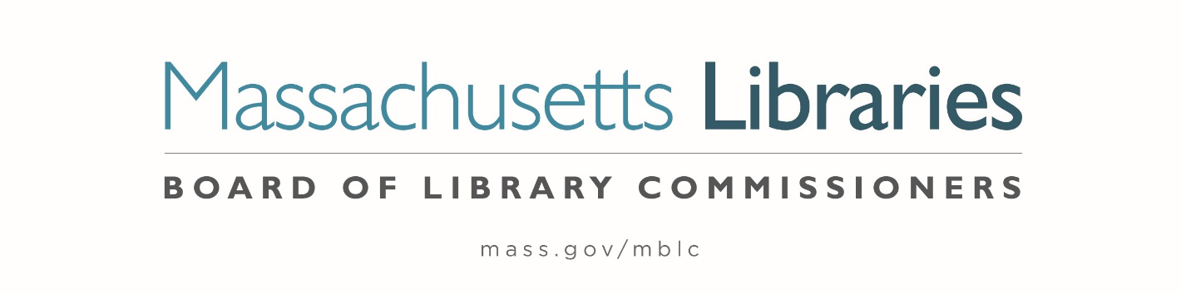

Welcome. Thank you for attending this meeting of the Massachusetts Board of Library Commissioners. Please remember that as part of the meeting agenda there is a time at the end of the meeting for public comment. Should you wish to address the Board during a particular item, please wait to be recognized by the chair.
Note: Agenda may include items not reasonably expected 48 hours before the meeting.
Thursday, October 6, 2022 10:00 A.M./ Refreshments 9:30 A.M.
Grafton Public Library, Grafton, MA
Zoom Meeting Information
https://us02web.zoom.us/j/85257973421?pwd=TklMOTZMc3pOUGo2ZTFIMXZMb0JOUT09
Meeting ID: 852 5797 3421/ Passcode: 530877
Dial in number: (646) 558-8656/ Meeting ID: 852 5797 3421

Agenda- Regular Monthly Meeting
- Call to order

- Welcome

Speaker: Beth Schreiber, Library Director

- Roll Call of Commissioners

Speaker: Debby Conrad, Chair

- Approval of Minutes- September 1, 2022 Minutes (ACTION)

Speaker: Debby Conrad, Chair

- Chair’s Report

Speaker: Debby Conrad, Chair


- Commissioner Reports

Speaker: Debby Conrad, Chair

- Director’s Report

Speaker: James M. Lonergan, Director

- Legislative Report

Speaker: Mary Rose Quinn, Head of State Programs/ Government Liaison

- Consideration of Network Grant Awards under account 7000-9506

- FY2023 Small Libraries in Networks Recommendation (ACTION)
- FY2023 Telecommunications for Resource Sharing Recommendation (ACTION)
- FY2023 Network Infrastructure Recommendation (ACTION)
- FY2023 Resource Sharing Program Recommendation (ACTION)

Speaker: Rob Favini, Head of Library Advisory & Development

- Consideration of approval for the Library eBooks and Audiobooks (LEA) Content Grants (ACTION)

Speaker: Kate Butler, Electronic Systems Specialist

- Consideration of appointments to the State Advisory Council on Libraries (SACL) Committee (ACTION)

Speaker: Rob Favini, Head of Library Advisory & Development

- Discussion/ review of policies for the FY2025 State Aid to Public Libraries Program

Speakers: Jen Inglis, State Aid Specialist

- Presentation of FY2023 MBLC Budget

Speaker: Tracey Dimant, Head of Operations and Budget

- Discussion of EDI- Equity, Diversity and Inclusion Initiatives

Speaker: James Lonergan, Director

- Report from Massachusetts Library System (MLS)

Speaker: Sarah Sogigian, Executive Director
Massachusetts Library System (MLS)

- Report from the Library for the Commonwealth (LFC)

Speaker: Michael Colford, Director of Library Services
Boston Public Library (BPL)

- Public Comment

- Old Business

- Adjournment Debby Conrad, Chair

To review the Massachusetts Board of Library Commissioners current bylaws
(Organizations and Functions of the Board of Library Commissioners)
Visit https://mblc.state.ma.us/about-us/commissioners/index.php

