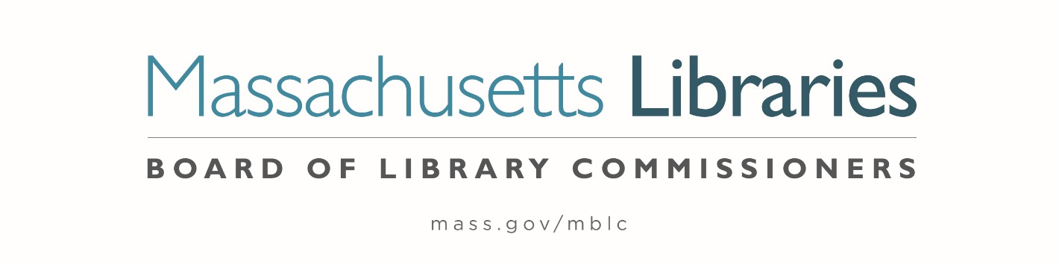

Welcome. Thank you for attending this meeting of the Massachusetts Board of Library Commissioners. Please remember that as part of the meeting agenda there is a time at the end of the meeting for public comment. Should you wish to address the Board during a particular item, please wait to be recognized by the chair.
Note: Agenda may include items not reasonably expected 48 hours before the meeting.
Thursday, November 3, 2022 10:00 A.M./ Refreshments 9:30 A.M.
East Forest Park Branch, Springfield City Library, Springfield, MA
Zoom Meeting Information
https://us02web.zoom.us/j/87061131913?pwd=OFRtS3ZvZWRiV3lXTzJLMldPMWtTdz09
Meeting ID: 870 6113 1913/ Passcode: 832893
Dial in number: (646) 558-8656/ Meeting ID: 870 6113 1913

Agenda- Regular Monthly Meeting
- Call to order

- Welcome

Speakers: Molly Fogarty, Library Director
Jean Canosa Albano, Assistant Director for Public Services

- Roll Call of Commissioners

Speaker: Debby Conrad, Chair

- Approval of Minutes- October 6, 2022 Minutes (ACTION)

Speaker: Debby Conrad, Chair

- Chair’s Report

Speaker: Debby Conrad, Chair


Posted: Friday, October 28, 2022 at 5:00 P.M.
:00 P.M.

- Commissioner Reports

Speaker: Debby Conrad, Chair

- Director’s Report

Speaker: James M. Lonergan, Director

- Legislative Report

Speaker: Mary Rose Quinn, Head of State Programs/ Government Liaison

- Consideration of approval of the municipalities meeting the requirements for the FY2023 State Aid to Public Libraries based on eligibility established in FY2023 for the Municipal Appropriation Requirement and in FY2022 for the minimum standards (ACTION)

Speaker: Jen Inglis, State Aid Specialist

- Consideration of approval of policies for the FY2025 State Aid to Public Libraries Program (ACTION)

Speaker: Jen Inglis, State Aid Specialist

- Consideration of approval of the FY2024 Library Services and Technology Act (LSTA) Direct Grant Round Program & Budget (ACTION)

Speaker: Rob Favini, Head of Library Advisory & Development

- Consideration of appointment to the State Advisory Council on Libraries (SACL) Committee (ACTION)

Speaker: Rob Favini, Head of Library Advisory & Development

- Adoption of State Advisory Council on Libraries (SACL) By-laws

Speaker: Rob Favini, Head of Library Advisory & Development

- Discussion of Statewide Public Relations Committee’s Equity Recommendations

Speaker: Celeste Bruno, Communications Director

- Update to the Construction Regulations Amendment Process

Speakers: Andrea Bono-Bunker, Library Building Specialist
Lauren Stara, Library Building Specialist

- Report from Massachusetts Library System (MLS)

Speaker: Sarah Sogigian, Executive Director
Massachusetts Library System (MLS)

- Report from the Library for the Commonwealth (LFC)

Speaker: Michael Colford, Director of Library Services
Boston Public Library (BPL)

- Public Comment

- Old Business

- Adjournment Debby Conrad, Chair

To review the Massachusetts Board of Library Commissioners current bylaws
(Organizations and Functions of the Board of Library Commissioners)
Visit https://mblc.state.ma.us/about-us/commissioners/index.php

