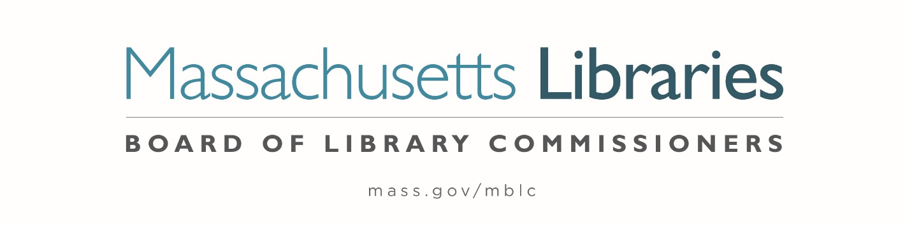

Welcome. Thank you for attending this meeting of the Massachusetts Board of Library Commissioners. Please remember that as part of the meeting agenda there is a time at the end of the meeting for public comment. Should you wish to address the Board during a particular item, please wait to be recognized by the chair.
Note: Agenda may include items not reasonably expected 48 hours before the meeting.
Thursday, May 4, 2023 11:00 A.M./ Refreshments 10:30 A.M.
Monterey Library, Monterey, MA
Zoom Meeting Information
https://us02web.zoom.us/j/81128121805?pwd=OU56bzJjb3M0T2tTMGRxOWcrTldkUT09
Meeting ID: 811 2812 1805/ Passcode: 047823
Dial in number: (646) 558-8656/ Meeting ID: 811 2812 1805

Agenda- Regular Monthly Meeting
- Call to order

- Welcome

Speaker: Mark Makuc, Library Director

- Roll Call of Commissioners

Speaker: Debby Conrad, Chair

- Approval of Minutes-

- March 2, 2023 Minutes (ACTION)
- April 6, 2023 Minutes (ACTION)

Speaker: Debby Conrad, Chair

- Chair’s Report


Speaker: Debby Conrad, Chair
Posted: Thursday, April 27, 2023 at 4:00 P.M.

- Commissioner Reports
Speaker: Debby Conrad, Chair

- Director’s Report

Speaker: James M. Lonergan, Director

- Legislative Report

Speaker: Mary Rose Quinn, Head of State Programs/ Government Liaison

- Consideration of a FY2024 Grant Round for 7000-9506, Library Technology and Resource Sharing, including Telecommunications for Resource Sharing, Resource Sharing Program, Network Infrastructure, and Small Libraries in Networks (ACTION)

Speaker: Paul Kissman, Library Information Systems Specialist

- Consideration of approval of three Massachusetts Public Library Construction Program (MPLCP) Partial Provisional Grant Awards (ACTION)

Speaker: Andrea Bono-Bunker, Library Building Specialist
Lauren Stara, Library Building Specialist

- Update on the Small Library Pilot Project

Speaker: Andrea Bono-Bunker, Library Building Specialist
Lauren Stara, Library Building Specialist

- Report from Massachusetts Library System (MLS)

Speaker: Sarah Sogigian, Executive Director
Massachusetts Library System (MLS)

- Report from Library for the Commonwealth (LFC)

Speaker: Michael Colford, Director of Library Services

- Public Comment

- Old Business

- Adjournment Debby Conrad, Chair

Tour of the library.

To review the Massachusetts Board of Library Commissioners current bylaws
(Organizations and Functions of the Board of Library Commissioners)
Visit https://mblc.state.ma.us/about-us/commissioners/index.php

