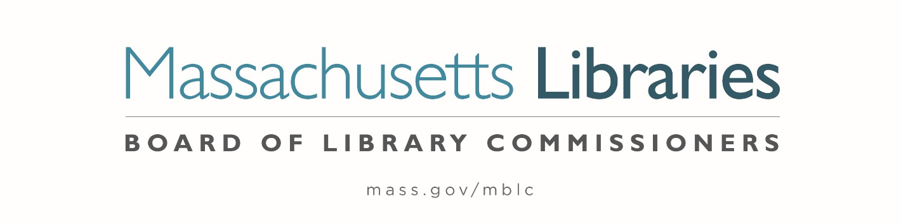

Welcome. Thank you for attending this meeting of the Massachusetts Board of Library Commissioners. Please remember that as part of the meeting agenda there is a time at the end of the meeting for public comment. Should you wish to address the Board during a particular item, please wait to be recognized by the chair.
Note: Agenda may include items not reasonably expected 48 hours before the meeting.
Thursday, June 1, 2023 10:00 A.M./ Refreshments 9:30 A.M.
Woburn Public Library, Woburn, MA
Zoom Meeting Information
https://us02web.zoom.us/j/83517201713?pwd=TFVuQ0NCNWY5anM1LzAxdk9QdE5OZz09
Meeting ID: 835 1720 1713/ Passcode: 349440
Dial in number: (646) 558-8656/ Meeting ID: 835 1720 1713

Agenda- Regular Monthly Meeting
- Call to order

- Welcome

Speaker: Hermayne Gordon, Library Director

- Roll Call of Commissioners

Speaker: Debby Conrad, Chair

- Approval of Minutes-

- May 4, 2023 Minutes (ACTION)

Speaker: Debby Conrad, Chair

- Chair’s Report


Speaker: Debby Conrad, Chair
Posted: Friday, May 26, 2023 at 4:00 P.M.
- Commissioner Reports
Speaker: Debby Conrad, Chair

- Director’s Report

Speaker: James M. Lonergan, Director

- Legislative Report

Speaker: Mary Rose Quinn, Head of State Programs/ Government Liaison

- Consideration of approval for a Deadline Extension Request from the Sharon Public Library (ACTION)

Speaker: Andrea Bono-Bunker, Library Building Specialist

- Consideration of approval of proposal to add additional escalation to select 2016-2017 MPLCP grant awards (ACTION)

Speaker: James Lonergan, Director
Mary Rose Quinn, Head of State Programs/ Government Liaison
Lauren Stara, Library Building Consultant
Andrea Bono-Bunker, Library Building Specialist

- Consideration of a FY2024 Grant Round for 7000-9506, LEA eContent grants (ACTION)

Speaker: Kate Butler, Electronic Services Specialist

- Consideration of approval of joint statement from Massachusetts library organizations against censorship and intolerance (ACTION)

Speaker: James Lonergan, Director
Celeste Bruno, Communications Director

- Report from the Massachusetts Library System (MLS)

Speaker: Sarah Sogigian, Executive Director
Massachusetts Library System (MLS)

- Report from Library for the Commonwealth (LFC)

Speaker: Michael Colford, Director of Library Services
Boston Public Library

- Public Comment

- Old Business

- Adjournment Debby Conrad, Chair

Tour of the new library building.

To review the Massachusetts Board of Library Commissioners current bylaws
(Organizations and Functions of the Board of Library Commissioners)
Visit https://mblc.state.ma.us/about-us/commissioners/index.php

