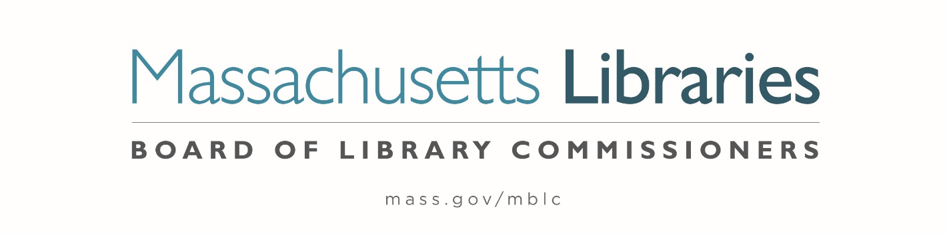

Welcome. Thank you for attending this meeting of the Massachusetts Board of Library Commissioners. Please remember that as part of the meeting agenda there is a time at the end of the meeting for public comment. Should you wish to address the Board during a particular item, please wait to be recognized by the chair.
Note: Agenda may include items not reasonably expected 48 hours before the meeting.
Thursday, July 7, 2022 10:00 A.M.
Massachusetts Board of Library Commissioners Offices/ Hybrid Meeting
Zoom Meeting Information
https://us02web.zoom.us/j/81324630688?pwd=RktRaVlMRDVyd09GUkRrbm1MU1huUT09
Meeting ID: 813 2463 0688 / Passcode: 390525
Dial in number: (646) 558-8656/ Meeting ID: 813 2463 0688

Agenda- Regular Monthly Meeting
- Call to order- Roll call Commissioners

Speaker: Mary Ann Cluggish, Chair

- Approval of Minutes- June 2, 2022 Minutes (ACTION)

Speaker: Mary Ann Cluggish, Chair

- Chair’s Report

Speaker: Mary Ann Cluggish, Chair

- Commissioner Reports

Speaker: Mary Ann Cluggish, Chair


Posted: Friday, July 1, 2022 at 5:00 P.M.
:00 P.M.

- Director’s Report

Speaker: James M. Lonergan, Director

- Legislative Report

Speaker: Mary Rose Quinn, Head of State Programs/ Government Liaison

- Consideration of approval of the FY2023 Library Services and Technology Act (LSTA) Grant Awards

- Access for All (ACTION)
- Anytime STEM Learning (ACTION)
- At the Table (ACTION)
- Citizenship Corners & Expanded English Language Services (ACTION)
- Dig In (ACTION)
- Go Local (ACTION)
- Managing Fine and Decorative Arts (ACTION)
- Mind in the Making (ACTION)
- Open (ACTION)
- Open for Business (ACTION)
- Protecting Priority Collections (ACTION)
- Strength in Families (ACTION)

Speaker: Rob Favini, Head of Library Advisory and Development

- Massachusetts Public Library Construction Program Grant Awards

- Consideration of approval of provisional grant awards under the Massachusetts Public Library Construction Program (ACTION)
- Consideration of approval of a Library Green Incentive awards under the Massachusetts Public Library Construction program (ACTION)

Speaker: Lauren Stara, Library Building Specialist

- Report from Massachusetts Library System (MLS)

Speaker: Sarah Sogigan, Executive Director
Massachusetts Library System (MLS)

- Report from Library for the Commonwealth (LFC)

Speaker: Angela Veizaga, Director of Strategic Partnerships
Boston Public Library (BPL)

- Election of Officers for FY2023 (ACTION)

Speaker: Deb Abraham

- Public Comment

- Old Business

- Adjournment Mary Ann Cluggish, Chair

To review the Massachusetts Board of Library Commissioners current bylaws
(Organizations and Functions of the Board of Library Commissioners)
Visit https://mblc.state.ma.us/about-us/commissioners/index.php

