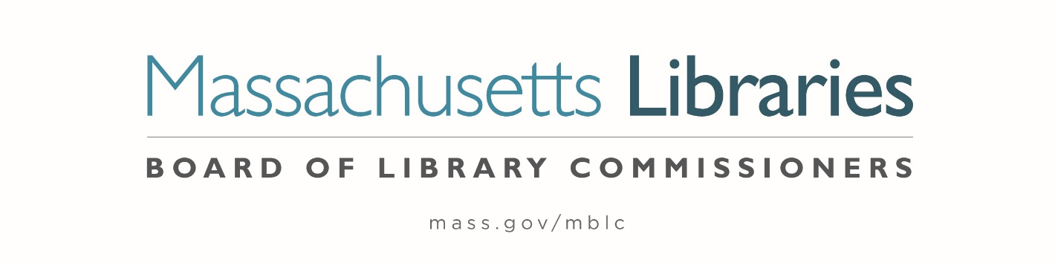

Welcome. Thank you for attending this meeting of the Massachusetts Board of Library Commissioners. Please remember that as part of the meeting agenda there is a time at the end of the meeting for public comment. Should you wish to address the Board during a particular item, please wait to be recognized by the chair.
Note: Agenda may include items not reasonably expected 48 hours before the meeting.
Thursday, January 5, 2023 10:00 A.M./ Refreshments 9:30 A.M.
MBLC Offices, Boston, MA
Zoom Meeting Information
https://us02web.zoom.us/j/87592314492?pwd=YUNWNUg3eU0vKytDeG9sZ1NTQjJVUT09
Meeting ID: 875 9231 4492/ Passcode: 566176
Dial in number: (646) 558-8656/ Meeting ID: 875 9231 4492

Agenda- Regular Monthly Meeting
- Call to order

- Welcome

- Roll Call of Commissioners

Speaker: Debby Conrad, Chair

- Approval of Minutes- December 1, 2022 Minutes (ACTION)

Speaker: Debby Conrad, Chair

- Chair’s Report

Speaker: Debby Conrad, Chair

- Commissioner Reports

Speaker: Debby Conrad, Chair
Posted: Friday, December 30, 2022 at 5:00 P.M.
:00 P.M.
- Director’s Report

Speaker: James M. Lonergan, Director

- Legislative Report

Speaker: Mary Rose Quinn, Head of State Programs/ Government Liaison

- Consideration of appointment to the State Advisory Council on Libraries (SACL) Committee (ACTION)

Speaker: Rob Favini, Head of Library Advisory & Development

- Consideration of approval of the municipalities meeting the requirements for the FY2023 State Aid to Public Libraries based on eligibility established in FY2023 for the Municipal Appropriation Requirement and in FY2022 for the minimum standards (ACTION)

Speaker: Jen Inglis, State Aid Specialist

- Review of municipalities requesting waivers for the FY2023 municipal appropriation requirement in the FY2023 State Aid to Public Libraries Program within the 5% threshold

Speaker: Mary Rose Quinn, Head of State Programs/ Government Liaison

- Presentation and discussion of the FY2024 Plan of Service and Program and Budget for the Massachusetts Library System and Monthly Report

Speaker: Sarah Sogigian, Executive Director
Massachusetts Library System (MLS)

- Report from the Library for the Commonwealth (LFC)

Speaker: Michael Colford, Director of Library Services
Boston Public Library (BPL)

- Public Comment

- Old Business

- Adjournment Debby Conrad, Chair

To review the Massachusetts Board of Library Commissioners current bylaws
(Organizations and Functions of the Board of Library Commissioners)
Visit https://mblc.state.ma.us/about-us/commissioners/index.php

