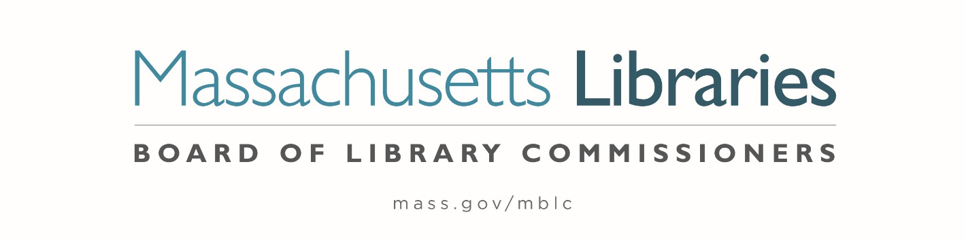

Welcome. Thank you for attending this meeting of the Massachusetts Board of Library Commissioners. Please remember that as part of the meeting agenda there is a time at the end of the meeting for public comment. Should you wish to address the Board during a particular item, please wait to be recognized by the chair.
Note: Agenda may include items not reasonably expected 48 hours before the meeting.
Thursday, February 2, 2023 10:00 A.M./ Refreshments 9:30 A.M.
MBLC Offices, Boston, MA
Zoom Meeting Information
https://us02web.zoom.us/j/89070596003?pwd=R2VhMEpqSFMwYlkzWHBMSk1qb2JFUT09
Meeting ID: 890 7059 6003 / Passcode: 730469
Dial in number: (646) 558-8656/ Meeting ID: 890 7059 6003

Agenda- Regular Monthly Meeting
- Call to order

- Welcome

- Roll Call of Commissioners

Speaker: Debby Conrad, Chair

- Approval of Minutes- January 5, 2023 Minutes (ACTION)

Speaker: Debby Conrad, Chair

- Chair’s Report

Speaker: Debby Conrad, Chair

- Commissioner Reports

Speaker: Debby Conrad, Chair

- Director’s Report

Speaker: James M. Lonergan, Director

- Legislative Report

Speaker: Mary Rose Quinn, Head of State Programs/ Government Liaison

- Consideration of approval of municipalities requesting waivers for the FY2023 municipal appropriation requirement in the FY2023 State Aid to Public Libraries Program within the 5% threshold (ACTION)

Speaker: Mary Rose Quinn, Head of State Programs/ Government Liaison

- Consideration of approval of the FY2024 Plan of Service and Program and Budget for the Massachusetts Library System (ACTION)

Speaker: Sarah Sogigian, Executive Director
Massachusetts Library System (MLS)

- Presentation and discussion of the FY2024 Plan of Service and Program and Budget for the Library for the Commonwealth and Monthly Report

Speaker: Michael Colford, Director of Library Services
Boston Public Library (BPL)

- Presentation and discussion of the FY2024 Plan of Service and Program and Budget for the Massachusetts Center for the Book and Monthly Report

Speaker: Sharon Shaloo, Executive Director
Massachusetts Center for the Book

- Consideration of approval of the 2023-2024 MPLCP Construction Grant Round (ACTION)

Speaker: Andrea Bono-Bunker, Library Building Specialist
Lauren Stara, Library Building Specialist

- Report from Massachusetts Library System (MLS)

Speaker: Sarah Sogigian, Executive Director
Massachusetts Library System (MLS)

- Public Comment

- Old Business

- Adjournment Debby Conrad, Chair

To review the Massachusetts Board of Library Commissioners current bylaws
(Organizations and Functions of the Board of Library Commissioners)
Visit https://mblc.state.ma.us/about-us/commissioners/index.php

