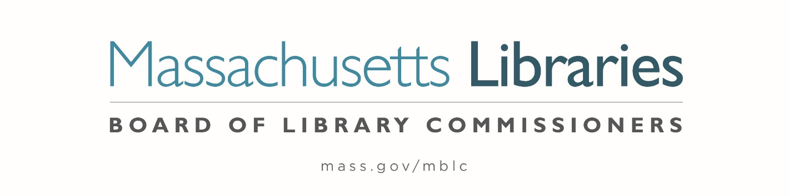
MINUTES OF THE BOARD OF LIBRARY COMMISSIONERS monthly regular meeting

Date : Thursday, February 2, 2023

Time : 10:12 A.M.

Place : Massachusetts Board of Library Commissioners Offices
Boston, MA

Present : Debby Conrad, Chair; Les Ball; Mary Ann Cluggish; Karen Traub

Zoom : Deb Abraham, Vice Chair; Stacy DeBole, Secretary; Vicky Biancolo; Jessica Vilas Novas

Absent : George Comeau, Esq.

Staff Present:
James Lonergan, Director; Celeste Bruno, Communications Director; Maura Deedy, Library Advisory Specialist; Tracey Dimant, Head of Operations & Budget; Rob Favini, Head of Library Advisory and Development; Paul Kissman, Library Information Systems Specialist; Rachel Massse, Assistant to the Director; Mary Rose Quinn, Head of State Programs; June Thammasnong, Communications Specialist

Staff Zoom:
Andrea Bono-Bunker, Library Building Specialist; Kate Butler, Electronic Services Specialist; Jen Inglis, State Aid Specialist; Uechi Ng, Administrative Assistant; Lauren Stara, Library Building Specialist; Lilli Sutton, Administrative Assistant

Observers Present:
Sharon Shaloo, Executive Director, Massachusetts Center for the Book

Observers Zoom:
Eileen Chandler, Network Administrator, Cape Libraries Automated Materials Sharing, Inc. (CLAMS); Anna Fahey-Flynn, Manager of the Central Library, Boston Public Library; Ron Gagnon, Network Administrator, North of Boston Library Exchange (NOBLE); Phil McNulty, Executive Director, Minuteman Library Network; David Slater, Network Administrator, Old Colony Library Network (OCLN); Sarah Sogigian, Executive Director, Massachusetts Library System (MLS)

Meeting called to order by Chair Conrad
Chair Conrad called the meeting to order at 10:12 A.M. due to some technology issues.

Roll Call of Commissioners

Chair Conrad stated that she is required to take a roll call of Commissioners to comply with the Open Meeting Law for hybrid meetings.
Commissioner Abraham- Present Zoom | Commissioner Cluggish- Present | Commissioner DeBole- Absent
Commissioner Ball- Present | Commissioner Comeau- Absent | Commissioner Traub- Present
Commissioner Biancolo- Present Zoom | Commissioner Conrad- Present | Commissioner Vilas Novas- Present Zoom

Chair Conrad explained that she would be making a motion to comply with a consent agenda. A consent agenda is a board meeting practice that groups routine motions into the consent agenda. If there are no objections, the Chair can declare a motion passed, rather than counting votes for each motion separately.

Chair Conrad moved to adopt a consent agenda for agenda items #2- Approval of Minutes- January 5, 2023 Minutes; #7- Consideration of approval of municipalities requesting waivers for the FY2023 municipal appropriation requirement in the FY2023 State Aid to Public Libraries Program within the 5% threshold ; #8- Consideration of approval of the FY2024 Plan of Service and Program and Budget for the Massachusetts Library System; #11- Consideration of approval of the 2023-2024 MPLCP Construction Grant Round; #15 Adjournment.
Commissioner Ball seconded.

Chair Conrad asked for a roll call vote of the Commissioners for this motion.

Commissioner Abraham- Yes | Commissioner Cluggish- Yes | Commissioner DeBole- Absent
Commissioner Ball- Yes | Commissioner Comeau- Absent | Commissioner Traub- Yes
Commissioner Biancolo- Yes | Commissioner Conrad- Yes | Commissioner Vilas Novas- Yes

The motion passed.

Approval of Minutes from the regular monthly meeting:

January 5, 2023

Chair Conrad asked for a motion to approve the minutes from the January 5, 2023 Monthly Meeting.

Commissioner Traub moved and Commissioner Ball seconded to approve the minutes from the January 5, 2023, Regular Monthly Meeting.

Hearing no objection, Chair Conrad declared the motion passed under the consent agenda.

Chair’s Report

Chair Conrad presented the following report:

The new legislative session began in January and there have been many opportunities to advocate for the FY2024 Legislative Agenda and MBLC programs. On January 10, I attended the quarterly board meeting of the Massachusetts Center for the Book and then I was able to attend the Center’s Three Years of Massachusetts Book Awards program at the State House on January 18. It was wonderful to visit the State House again and to hear the authors speak about their works and inspirations. The MLA Committee responsible for planning the State House Legislative Day event met on January 13. If you haven’t received the email with registration information for the March 15th event, please let me know and I will forward that to you. Invitations are being sent to the Senators and Representatives, but I have found that sending a personal invitation to my elected representatives is very effective – even when I have been unable to attend the event in person. On January 20 I spoke at the Southeast Legislative Breakfast at the Somerset Public Library – a well-attended and inspirational event which gave me an opportunity to speak to a number of elected officials from that part of the Commonwealth. On the same day I attended the Mass Municipal Conference in the exhibitors’ area – a first time for me. On January 24 I attended the Board Executive Committee meeting and sat in on a meeting with Senator Michael Rodrigues and Senator Comerford regarding additional funding for outstanding construction projects. We will be talking about that discussion later. In addition to my own activities, I know several commissioners have attended legislative events in the Commonwealth and Representative Basler has filed the eBook legislation. We will have many topics for discussion over the next several months.

Commmissioner DeBole Jpoined the Meeting at 10:20 A.M.

Commissioner Activities

Commissioner Abraham
- January 24- Participated in the Executive Board Meeting
- Joined a database webinar
- Wrote letters to Senators & Representatives

Commissioner Ball
- January 21- Attended MMA At the Hynes
- Met with Westford about their funding.
- Met with Scituate Library

Commissioner Biancolo
- January 11: Attended WMLA board meeting, virtual
- January 18: Attended the Mass Book Awards celebration from the Mass Center for the Book at the State House
- January 19: Attended CMLA board meeting, virtual
- January 20: Attended Legislative Breakfast at Somerset
- January 21: Attended MMA Conference in Boston
- January 27: Spoke at the Berkshire Legislative Breakfast Bard College at Simon’s Rock
- January 31: Attended the January Reading Challenge Shout & Share from the Mass Center for the Book, virtual

Commissioner Cluggish
- January 26- Attended PR Committee Meeting, virtual
- Attended MLA Legislative Committee Meeting
- January 11, 2023- Spoke at the Melrose Public Library Groundbreaking

Commissioner Traub
- January 10- Library Foundation Forum (virtual)
- January 11- Youth Services Community Chat (virtual)
- January 11- Western Mass Library Advocates (virtual)
- January 18- Mass Book awards State House Boston
- January 20- Mass Municipal Association Trade show Hynes Auditorium
- January 25- Trustee Deep Dive (virtual)
- January 26- MBLC PR Committee (virtual)

Commissioner Vilas Novas
- January 25- Meeting at Pollard Memorial Library, Lowell
- January 31- Get together with Commissioner Biancolo in hopes of getting to know each other better.

DIRECTOR’S REPORT

Director Lonergan presented the following report:

Meetings/activities highlights since the last monthly Board meeting:

- January 9—MLS Executive Board Meeting, virtual
- January 10—Mass. Center for the Book Quarterly Board Meeting, virtual
- January 11—Melrose Public Library Groundbreaking
- January 11—Webjunction Webinar: “Practical Strategies for Engaging Veteran and Military-Affiliated Patrons at Your Library”
- January 18—MCB Massachusetts Book Awards Ceremony, State House
- January 20—SAILS Legislative Breakfast, Somerset Public Library
- January 20—MLA Legislative Committee meeting, virtual
- January 24—Meeting with Senators Comerford and Rodrigues to discuss MPLCP, virtual
- January 25—Call with Jonathan Torcia, new deputy director of Office of Boards and Commissions
- January 26—Meeting with Natalie Albanese, our new House Ways and Means analyst, virtual
- January 30—MLS/MBLC/MLA/MSLA Intellectual Freedom working group meeting, virtual

MPLCP Bond Authorization: The Executive Office of Administration and Finance (A&F) let us know that they are splitting our $150 million bond authorization request for our next construction grant round into two parts—$25 million is included in Governor Healey’s “Immediate Needs” bond bill, announced on 1/19/23, and the remaining $125 million will be included in an economic development bond bill that will be filed in March.

MPLCP Legislative Meeting: Senator Comerford requested a follow-up meeting to our September 21 meeting to discuss library building projects and increased construction costs. Chair Conrad, Mary Rose, Lauren, Andrea, Tracey, and I met with Sen. Comerford and Senator Rodrigues, the Senate Ways & Means chair, and some of their staff members, on January 24.

We were asked what the MBLC could do to further support these projects and told that “pothole” funding (whether ARPA or other state funds), initially proposed by Sen. Tarr in the 9/21 meeting, would not be available to supplement our awards.

Sen. Rodrigues mentioned the $25 million in the “Immediate Needs” bond bill and asked if it could be used to support supplemental funding to the communities seeking additional construction funds. We explained that the $25 million is part of our $150 million request for our next grant round. He mentioned what a strong supporter he has been of our budget lines, particularly over the last few years when we have seen significant increases. He also mentioned that the Mass. School Building Authority paused their program at one point for three years (for further details, see the history section at: https://en.wikipedia.org/wiki/Massachusetts_School_Building_Authority)

We discussed the limits in our current regulations regarding increasing construction grant awards and our current bond authorization and annual cap but said we would investigate what we could possibly do to help. While we are concerned about setting a precedent, we are investigating the possibility of increasing the funding to 15 projects that were potentially impacted by cost increases during the pandemic by adding to the three years of escalation already included for projects in the FY2016/2017 grant round.

Library Legislative Caucus: Rep. Higgins has informed us that Senator Susan Moran (Plymouth and Barnstable) is the new caucus co-chair for the Senate, replacing Sen. Lesser.

EDI Audit: In her inauguration speech, Governor Healey announced that she would direct each agency under her administration to conduct a full equity audit. She recently announced that she plans to sign an executive order soon to "create an interagency council task force that is going to look at equity across the board, across all of our commissions and departments, and across the secretariats.” We were preparing an RFP to contract with a consultant to assist the agency with both an EDI audit and additional work, but we have paused these efforts until we get further details on the Healey/Driscoll administration’s guidelines for an equity audit.

Agency Audit: The Office of the State Auditor shared a draft audit report with us on January 20 and let us know that there were no findings to report. The audit covered the period of July 1, 2020 to March 31, 2022 and was primarily focused on our use of IMLS CARES Act funds, follow up from the last audit regarding the MPLCP, and updates to our internal control plan in accordance with pandemic-related guidance. Chair Conrad and managers reviewed the draft report and Chair Conrad approved it. Given there were no findings, we will not need to attend an exit interview. We should receive the final report in the coming weeks and will share it with commissioners, staff, and the Institute of Museums and Library Services (IMLS).
IMLS State Program Report (SPR): We filed the annual SPR with IMLS on 1/30, including 57 reports on statewide Library Services and Technology Act (LSTA) projects, direct LSTA grants (some reports bundled awards to several grantees for similar project types, for example, preservation assessments), and projects supported with American Rescue Plan Act (ARPA) funds. This substantial agency-wide effort involved staff from all units and resulted in both a narrative and financial accounting of funds spent. The narrative described the work done by MBLC staff and grant recipients representing libraries across the Commonwealth who delivered outstanding programs to their communities. IMLS staff often highlight our statewide and direct grant programs for being innovative and effective.

LSTA Grant Round Update: 36 LSTA FY2024 Direct Grant letters of intent were submitted by the December 6 deadline, for a total request of $739,000. The letters provided intended grant programs and amount of funding that potential grant applicants are seeking. This is the first grant round that the application process will be managed though our Amplifund grant management system. It is also the first round since the increased amount of available funds per category has been offered. Traditionally not all letters of intent translate to final applications. But this strong initial total funding ask indicates that it will be a competitive grant round, given we budget for $500,000 in direct grants.

Draft applications are due on February 23, 20023, with final applications due on April 11, 2023. More information about the application process can be found on the MBLC’s LSTA Grants Application LibGuide: https://guides.mblc.state.ma.us/c.php?g=1291442

Intellectual Freedom/Library Challenge update: Rob Favini attended the January 19th MLA Intellectual Freedom/Social Responsibility Committee meeting. At the meeting committee members reported on continuing library support activities. The committee’s slate of MLA Annual Conference programs was announced including a keynote from Jonathan Friedman of PEN America titled “Book Challenges in Your Library: Tips for Librarians Facing Harassment and Threats.” Additional programs include “Using Creative Freedom to Build Justice Through Empathy,” and programs focused on the Access to Justice Initiative, privacy and reproductive rights, trans identity, and library social work (featuring MBLC's Shelley Quezada and MLS's Michele Eberle.)

On January 30 staff members from the MLS, MBLC, Massachusetts Library Association, and the Massachusetts School Library Association met to discuss data around tracking challenges, upcoming training series at both the MLS and MBLC, MBLC fact sheets for legislators, MBLC’s Collection Development Compliance Project, and partnerships with the Mass Commission on LGBTQ Youth.

Legal Issues for Librarians Series: Maura Deedy announced two upcoming webinars on Library Legal Issues presented by Dr. Tomas Lipinski: Library Meeting Spaces and Library Collections. Each topic will be presented twice, and will have time for Q&A.
These sessions will provide information on the framework courts use to determine the constitutionality of a government policies and regulations. Library Meeting Spaces will focus on library cases involving the use of meeting rooms by patrons. Library Collections will focus on the law relating to content objections in libraries, both physical and online collections, and the immunity for online content when the library is a qualifying service provider under federal law.
Full Schedule of Sessions:
- Library Meeting Spaces on Tuesday, February 7 at 2PM EST
More Information & Registration
- Library Meeting Spaces on Tuesday, February 7 at 6PM EST
More Information & Registration
- Library Collections on Tuesday, February 28 at 2PM EST
More Information & Registration
- Library Collections on Wednesday, March 1 at 6PM EST
More Information & Registration

Paul Kissman has published the FY2022 Network Annual Report: https://public.tableau.com/app/profile/mblc/viz/FY22NetworkAnnualReport/LandingPage

The Automated Resource Sharing Networks Report FY2022 displays data submitted by nine automated resource sharing networks serving libraries in Massachusetts and presents data relating to all aspects of Network operations, services, membership and expenditures.

On January 25, Shelley Quezada took part in the Substance Abuse and Mental Health Services Administration (SAMHSA)’s Diversity and Inclusion Project Showcase (DIPS): Deaf Awareness and Supporting the Mental Health of Deaf and Hard of Hearing Populations. The event attracted state, federal, nonprofit organizations, and community members to amplify the work of community-based organizations in the New England region supporting mental health and advancing substance use prevention, treatment, and recovery for those who are deaf/hard of hearing.

The Communications Team has been working closely with the crisis communications trainer and members from the inter-agency intellectual freedom group to develop the upcoming trainings. They are scheduled for March 16 and March 29, (9am to 12pm). They will cover:

- Principles of crisis communication
- Messaging and narrative
- Developing a crisis communication plan
- Qualities of an effective spokesperson
- Building community support
- Managing online engagement
- Harnessing attention to promote the value of the library

The team has also developed an Intellectual Freedom Fact sheet that can be used with local officials, state legislators, and school committees. It frames the issue from the library point of view and is a useful tool for giving officials background and context on the issue so that when they are faced with a challenge, they already have some understanding.
The team developed the materials used at MMA as well as the MMA webpage. This included the new construction fact sheet that addresses the need for a new bond. These, along with the legislative agendas, were sent to all legislative breakfast locations.
The team is also expanding the partnership with the Office of Economic Empowerment, developing a month-by-month plan that highlights activities and resources for patrons.

#LibraryLovers campaign is back. This is a fun and easy way that library users can let legislators and local officials know how much they value libraries. This year the option for paper valentines is back but the website https://www.lovemasslibraries.com/ is an easy way for anyone to upload a valentine. At the beginning of March any paper valentines the MBLC receives will be given to legislators.
The Boston Bruins PJ Drive runs through March 15. The MBLC provides the toolkit, posters, and stickers for participating libraries. It’s a fun way to support our summer partners who are currently ranked #1.

The PJ Celebration will be held at Rockland Library on February 23 at 2:30.

Legislative Report

Mary Rose Quinn, Head of State Programs presented the following report:

As a reminder, the online version of the Legislative Agenda can be accessed at https://www.mblclegislativeagenda.com/. The theme for this year’s Agenda is: Ensuring Your Right to Read. Initiatives include eBook legislation, freedom from censorship, digital equity through automated networks, and accessibility for all. The Affiliate sheets and more detailed information about the Agenda Topics are available through the Agenda lines/links (top right).

The new Construction page rolled out just in time for MMA. https://mblc.state.ma.us/programs-and-support/construction/index.php.
Total Tax collections for the month-to-date period were $1.470 billion, virtually equal
to the collections during the same period in January 2022. Although revenues remain steady and at or above benchmark and ARPA and other additional state and federal funds are still high, the FY 2024 budget is predicated on a consensus revenue figure that is expected to increase only 1.6% over current fiscal year projections. These figures do not include any revenue generated from the Millionaires Tax receipts. The Consensus Budget Hearing was hosted by The House and Senate Ways and Means Chairs on January 24, 2023 at 11:00 am. Access to the full recording is available on the Legislature’s website at: https://malegislature.gov/Events/SpecialEvents/Detail/403/Video1#.
The final two contested House seats have been decided and newly elected Margaret Scarsdale (D-Pepperell), and Kristen Kassner (D-Hamilton) have been sworn in as Representatives in the 193rd General Court.
Senator Susan Moran from Bourne is the new Senate Chair of the Legislative Library Caucus. Senator Eric Lesser, the most recent Chair, gave up his Senate seat in his run for Lieutenant Governor. Senator Moran is scheduled to attend the CLAMS virtual Legislative Luncheon on February 3.
Legislative Breakfasts have taken place in Sommerset and Great Barrington to date.
Upcoming Library Outreach and Advocacy Events:
February 3, 2023, CLAMS Virtual “Luncheon”
FROM THE INVITATION:
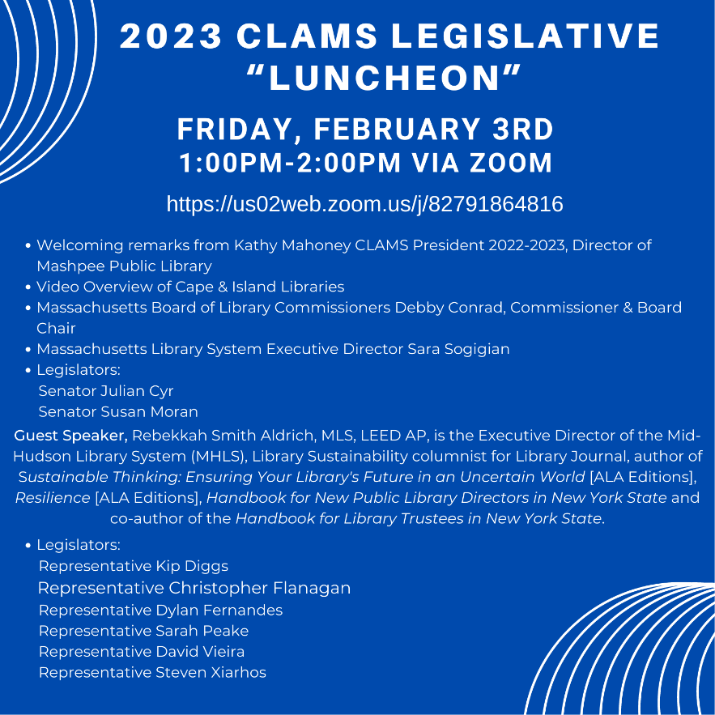
Topic: CLAMS Legislative Luncheon
Time: Feb 3, 2023 01:00 PM Eastern Time (US and Canada)
Join Zoom Meeting
https://us02web.zoom.us/j/82791864816
Meeting ID: 827 9186 4816
One tap mobile
+13017158592,,82791864816# US (Washington DC)
+13052241968,,82791864816# US
February 10, 2023, 7:30 am Worcester Public Library
FROM THE INVITATION:
The Worcester Public Library is hosting a Legislative Breakfast in conjunction with CMLA, MLA, and MBLC

We have a very exciting legislative lineup with national names currently expected to attend. The invite will reflect that closer to the date with the run of show. Register here!

Link address: https://www.eventbrite.com/e/legislative-breakfast-worcester-tickets-525088803747

Our emphasis is in person, but we are streaming it live, so when you get your tickets, select either in-person or online. The zoom link for online will be send out 3 days prior!

Look forward to an awesome event!



February 17, 2023, 8 am Legislative Breakfast, Peabody Public Library Contact: Al Hyden, hayden@noblenet.org
February 17, 2023 8 am Legislative Breakfast Thayer Memorial Library,
Lancaster, Contact: Joe Mulé, jmule@cwmars.org
March 8, 2023, Virtual Legislative Day Event
Virtual New Library Directors' Legislative Information Session
Virtual New Directors' Legislative Day Information Session: 10 am - 10:40 am
New library directors, new assistant directors, and first time attendees, are invited to attend this session to learn the basics about this year's Library Legislative Agenda and how you can advocate to your local legislators for these priorities that help serve your community.
Virtual MLA/MSLA Library Legislative Day, 11:00 am
Can't make it to in-person Library Legislative Day on March 15? Join MLA and MSLA for our online version of Legislative Day.
In-person Legislative Day at the MA State House date: 3/15/2023
CONTACT: Will Adamczyk/Eileen Dyer legislative@masslib.org

May 8 and 9, 2023 MLA’s Annual Conference, “Making Waves”, in Falmouth.

Thank you to staff members Andrea Bono-Bunker, Lauren Stara, Maura Deedy, Jen Inglis, Celeste Bruno, Rachel Masse, and June Thammasnong and Commissioners Debby Conrad, Karen Traub, Vicky Biancolo, and Les Ball for making our booth at the MMA Trade Show and Annual Meeting such a huge success.

Representative Ruth Balser has filed a new eBook bill this session, HD.3425, An Act empowering library access to electronic books and digital audiobooks. The new language in
focuses on consumer protections for libraries. Commissioners will be notified when the bill is scheduled for a hearing.

Consideration of approval of municipalities requesting waivers for the FY2023 municipal appropriation requirement in the FY2023 State Aid to Public Libraries Program within the 5% threshold

Mary Rose Quinn, Head of State Programs/ Government Liaison presented the 8 libraries that were petitioning the Board for a Waiver of the MAR that were below the five percent threshold set by the Board at the January Board Meeting for not being disproportionately cut in relationship to other departments within their municipality.

State Aid to Public Libraries Program – 5 Year Waiver Plan – Year 2
In the FY 2023 State Aid to Public Libraries Program cycle, three hundred and thirty nine of the three hundred forty seven municipalities that applied for certification this year funded their public libraries at or above the Municipal Appropriation Requirement (MAR). This support is a credit to the great work that libraries do to serve their communities every day, but especially during times of unprecedented challenges. This ongoing fiscal support will be crucial moving forward as libraries provide critical and essential services, opportunities, and resources to help their communities and residents.
Of the 351 municipalities in Massachusetts, 350 provide public library services. Only New Ashford has no library and no library services (population 250). Three other municipalities do not traditionally apply to the State Aid to Public Libraries Program; Alford last applied in 1988 and Monroe and Savoy have never applied. The sixteen million dollars in the current State Aid to Public Libraries Program is being distributed in two payments based on the Department of Revenue’s population figures of 7,029,917.
Of the 347 applicants:
- 339 met the MAR and have already been certified.
- 8 municipalities funded their libraries at levels below the MAR and needed to apply for waivers. Of waiver applicants:
  - 7 provided increases to the libraries’ budgets.
  - Only 1 library budget received a small reduction but was not disproportionately cut.
- There is only one new applicant for a Waiver in this grant cycle.
- 6 of the waivers applicants submitted Year 2 Waiver Reports*.
*The Task Force that developed the 5-year Waiver Plan was an offshoot of the last complete State Aid Review Committee. The goal of the Task Force was to develop a program or process that would encourage municipalities and their libraries to reverse the funding cuts and restore library funding to meet the MAR incrementally over 5 years. Through the regulatory hearing comments and over a series of community engagement and listening sessions, the Committee, Task Force, and State Aid staff heard from directors and others that greater involvement and guidance was needed from the MBLC for the libraries to be successful in meeting the MAR, especially after disproportionate cuts or a long series of waivers.

The 5-year plan was designed to help municipalities and their libraries meet the Municipal Appropriation Requirement after being granted a waiver. It went into effect FY2020. (July 1, 2019). All libraries requesting waivers, regardless of the number of waivers received in prior years, will be considered “Year 1” filers. The financial plans require the municipality to provide additional information to the MBLC and includes additional information from the MBLC to the municipal officials.

The MBLC kept the Plan at Year 1 through 2020-2022 due to the pandemic. The historical data (pre-Year 1), for those municipalities with waivers going back a decade or more, was provided so that municipal officials could see the calculations and formulas used over time to achieve the current MAR calculation.
Year 2
Standard MAR waiver application. The municipality must submit a financial plan written in conjunction with library trustees and director. The plan must be signed by the Library Director, Trustee Chairperson, and Senior Municipal Official. At the discretion of the Board, the library and municipality may need to appear at the January Board Meeting. (605 CMR 4.00) This is true for all subsequent years.

The 8 municipalities seeking a waiver are Duxbury, Fairhaven, Hanover, Lawrence, Stoughton, Walpole, Ware, and Woburn.

Commissioner Cluggish moved and Commissioner Ball seconded that the Massachusetts Board of Library Commissioners grants a waiver of the FY23 Municipal Appropriation Requirement (MAR) and certifies that the communities on the attached list have met minimum standards of free public library service and awards each a FY2023 Library Incentive Grant (LIG), a FY2023 Municipal Equalization Grant (MEG)and a FY2023 Nonresident Circulation (NRC) offset in the indicated amounts, totaling $ 305,253.48, and authorizes any additional FY2023 State Aid to Public Libraries disbursements that may be possible toward the end of the grant cycle.

Hearing no objection, Chair Conrad declared the motion passed under the consent agenda.

Consideration of approval of the FY2024 Plan of Service and Program and Budget for the Massachusetts Library System
Sarah Sogigian, Executive Director, Massachusetts Library System (MLS) presented the FY2024 Plan of Service and Program and Budget.

The MLS Executive Board unanimously approved the FY2024 Plan of Service and Program and Budget at its September 12, 2022 meeting and the MLS Council of Members approved it unanimously on November 22, 2022.

The budget is based on our current annual budget figure: $10,787,000.

MLS is incredibly honored and grateful for the strong support from the Legislature over the past few years, and has applied the funding to ensure continued and sustained services. This document will be complemented by our annual Action Plan. Our current Action Plan can be found on our website. Our new one will be shared prior to July 1, 2023. The Plan of Service will present our service list for upcoming fiscal year and the Action Plan will address how we will focus on our strategic initiatives.

Commissioner Ball moved and Commissioner Traub seconded that the Massachusetts Board of Library Commissioners approves the FY2024 Plan of Service and Program and Budget filed on January 5, 2023 for the Massachusetts Library System, with a bottom line of $10,787,000.

Hearing no objection, Chair Conrad declared the motion passed under the consent agenda.

Presentation and discussion of the FY2024 Plan of Service and Program and Budget for the Library for the Commonwealth and Monthly Report

Anna Fahey Flynn, Manager of the Central Branch spoke about the LFC FY2024 Program and Budget that was submitted on February 2, 2023. As the Library for the Commonwealth, the Boston Public Library (BPL) will continue to expand access to library services to residents across the Commonwealth. Our staff is committed to delivering excellent reference and research assistance, creating and supporting educational activities, facilitating pursuits of personal interest and growth, and enhancing the discovery of our shared cultural heritage through the development and maintenance of unique print and digital collections.

The BPL’s e-card program allows Massachusetts residents to remotely and instantly access a wealth of online resources, including e-books, audiobooks, music, television, movies, graphic novels, and newspapers and magazines from around the world. The e-card program has grown steadily and extensively every year since its inception and is now in need to serious attention. Our extensive collection of subscription databases and e-resources provide sound, authoritative information from trusted sources. Through remote reference, the creation of research guides and online tutorials, our subject specialists can assist patrons in the use of these tools from nearly anywhere and at any time.

The budget has a bottom line of $3,629,000.

The Board will vote on the FY2024 LFC Plan of Service and Program and Budget at the March 2, 2023 Monthly Board Meeting.

Presentation and discussion of the FY2024 Plan of Service and Program and Budget for the Massachusetts Center for the Book and Monthly Report

Sharon Shaloo, Executive Director of the MCB Presented the FY2024 Program and Budget.

The plan of service that was submitted on February 2, 2023 assumes level funding and thus represents, given inflationary pressures and the need to meet increased personnel and overhead costs, a cut in direct program expenses. Of course, we hope the reductions will not be necessary if we succeed in securing the 10% increase in our line-item funding.

We continue to support the following programming that I will expand upon in my presentation:
- Massachusetts Book Awards
- Letters About Literature
- Reading Challenge
- National Book Festival/Great Reads from Great Places
- Mass Book Trails
- Family Literacy -- Gateways to Reading
- Travelling Exhibits Initiative -- Fall Launch

We also will be managing a leadership transition as the founding director of the Center retires and a new director comes on board to lead MCB into its next phase of growth.

The Board will vote on the FY2024 LFC Plan of Service and Program and Budget at the March 2, 2023 Monthly Board Meeting.

Consideration of approval of the 2023-2024 MPLCP Construction Grant Round

Library Building Consultants Andrea Bono-Bunker and Lauren Stara presented the Board with the new grant round.

The MPLCP provides grants that help pay for major capital improvement projects such as new construction, addition or renovation of an existing library, as well as conversions of another building into a library space.

The new grant round will be governed by construction regulations 605 CMR 6.00 approved at the MBLC’s December 2022 meeting. It will be more competitive and streamlined, requiring only one application, significantly reducing the cost for municipalities to apply. The single application has two phases: a planning and design phase and a construction phase. Each phase will undergo evaluation by an independent review team. This eliminates two years of the previous grant process, thereby reducing escalation costs. Initial costs are further reduced by no upfront design requirements.
In an effort to provide more assistance to municipalities with smaller populations and capacity, this grant round features two grant types: Standard Grants for municipal populations of 2, 500 and over; or Small Population Grants for municipal populations less than 2,500. Program notices for each provide specific information including eligibility, application components, the Green Library Incentive, and funding formulas for each phase. Construction grant awards will be based on eligible project costs determined at the close of the planning and design phase and include a need factor specific to each community.

To apply, eligible libraries must submit a Letter of Intent by April 28, 2023 through Amplifund. Libraries will have an entire year to complete the application process with MBLC Library Building Specialists Andrea Bono-Bunker and Lauren Stara guiding each municipality and library. Final applications are due May 31, 2024. Grant recipients will be announced in the Fall of 2024.

Three information sessions in February will provide library and municipal attendees an opportunity to ask questions and learn more about the requirements and application process. Information sessions begin on February 7, with two more scheduled on February 9 and February 15. Registration is through the MBLC events calendar online.

The MPLCP was first funded by a state bond authorization in 1987. Since then, it has helped more than 250 communities plan, build, renovate and/or expand their public libraries. The MPLCP is currently seeking a new $150 million bond authorization to support upcoming grant rounds. MPLCP projects are underway in the following communities: Amherst, Deerfield, Gloucester, Marlborough, Melrose, Sharon, Shutesbury and Westford. Learn more about the program on the MBLC website and the Building Literacy podcast.
*eligible project costs are not the same as total project cost. MPLCP construction grant funds pay for a percentage of eligible costs based on a funding formula. Eligible costs include: acquisition of land, planning, design, and engineering services, project management services. Grant funds do not pay for furniture, computers, landscaping, paving, and other ineligible costs as defined in 605 CMR 6.00.

Commissioner Ball moved and Commissioner Cluggish seconded that the Massachusetts Board of Library Commissioners approve the February 2023 – May 2024 Standard General Construction Projects Application Round and Small Population General Construction Projects Application Round Materials for the Public Library Construction Program, including the Timeline, the Program Notices, and the Economic Need Factor as established using data compiled by the Department of Revenue for the FY2023 Cherry Sheet.

Hearing no objection, Chair Conrad declared the motion passed under the consent agenda.

PUBLIC COMMENT
There was no public comment.

OLD BUSINESS

There was no old business.

List of documents for the February 2, 2023, Regular Monthly Board Meeting:

- Agenda for the February 2, 2023, Regular Monthly Board Meeting
- Draft Minutes from the January 5, 2023 Regular Monthly Board Meeting
- #7- Consideration of approval of municipalities requesting waivers for the FY2023 municipal appropriation requirement in the FY2023 State Aid to Public Libraries Program within the 5% threshold
- #8- Consideration of approval of the FY2024 Plan of Service and Program and Budget for the Massachusetts Library System
- #9- Presentation and discussion of the FY2024 Plan of Service and Program and Budget for the Library for the Commonwealth and Monthly Report
- #10- Presentation and discussion of the FY2024 Plan of Service and Program and Budget for the Massachusetts Center for the Book and Monthly Report
- #11- Consideration of approval of the 2023-2024 MPLCP Construction Grant Round

ADJOURNMENT

The meeting adjourned at 12:26 P.M.

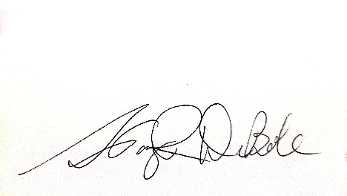

Stacy DeBole
Secretary

