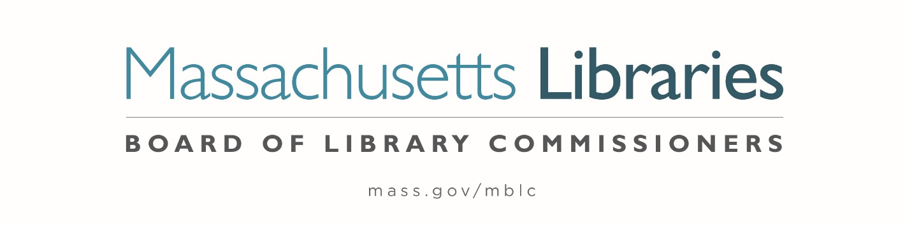

Welcome. Thank you for attending this meeting of the Massachusetts Board of Library Commissioners. Please remember that as part of the meeting agenda there is a time at the end of the meeting for public comment. Should you wish to address the Board during a particular item, please wait to be recognized by the chair.
Note: Agenda may include items not reasonably expected 48 hours before the meeting.
Thursday, December 1, 2022 10:00 A.M./ Refreshments 9:30 A.M.
MBLC Offices, Boston, MA
Zoom Meeting Information
https://us02web.zoom.us/j/87061131913?pwd=OFRtS3ZvZWRiV3lXTzJLMldPMWtTdz09
Meeting ID: 870 6113 1913/ Passcode: 832893
Dial in number: (646) 558-8656/ Meeting ID: 870 6113 1913

Agenda- Regular Monthly Meeting
- Call to order

- Welcome

- Roll Call of Commissioners

Speaker: Debby Conrad, Chair

- Approval of Minutes- November 3, 2022 Minutes (ACTION)

Speaker: Debby Conrad, Chair

- Chair’s Report

Speaker: Debby Conrad, Chair

- Commissioner Reports

Speaker: Debby Conrad, Chair
Posted: Friday, November 25, 2022 at 5:00 P.M.
:00 P.M.
- Director’s Report

Speaker: James M. Lonergan, Director

- Legislative Report

Speaker: Mary Rose Quinn, Head of State Programs/ Government Liaison

- Consideration of approval of the changes to the 605 CMR 6.00, Library Improvement Program (ACTION)

Speakers: Andrea Bono-Bunker, Library Building Specialist
Lauren Stara, Library Building Specialist

- Consideration of approval for requests from libraries for an extension of time to confirm local funding and accept its provisional grant award in the Massachusetts Public Library Construction Program

- Tilton Library, Deerfield (ACTION)
- Wheeler Memorial Library, Orange (ACTION)
- Seekonk Public Library (ACTION)

Speakers: Andrea Bono-Bunker, Library Building Specialist
Lauren Stara, Library Building Specialist

- Consideration of approval of the municipalities meeting the requirements for the FY2023 State Aid to Public Libraries based on eligibility established in FY2023 for the Municipal Appropriation Requirement and in FY2022 for the minimum standards (ACTION)

Speaker: Jen Inglis, State Aid Specialist

- Consideration of State Advisory Council on Libraries (SACL) By-laws (ACTION)

Speaker: Rob Favini, Head of Library Advisory & Development

- Overview of the State Aid to Public Libraries Waivers Process

Speaker: Mary Rose Quinn, Head of State Programs/ Government Liaison

- Report from Massachusetts Library System (MLS)

Speaker: Scott Kehoe, Library Resources Director
Massachusetts Library System (MLS)

- Report from the Library for the Commonwealth (LFC)

Speaker: Michael Colford, Director of Library Services
Boston Public Library (BPL)

- Public Comment

- Old Business

- MBLC Years of Services Pins

- Terry D’Angelo, 40 Years
- Celeste Bruno, 15 Years
- James Lonergan, 10 Years
- Tracey Dimant, 5 Years
- Lyndsay Forbes, 5 Years

- Adjournment Debby Conrad, Chair

To review the Massachusetts Board of Library Commissioners current bylaws
(Organizations and Functions of the Board of Library Commissioners)
Visit https://mblc.state.ma.us/about-us/commissioners/index.php

