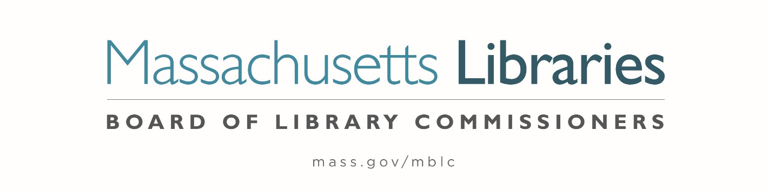

Welcome. Thank you for attending this meeting of the Massachusetts Board of Library Commissioners. Please remember that as part of the meeting agenda there is a time at the end of the meeting for public comment. Should you wish to address the Board during a particular item, please wait to be recognized by the chair.
Note: Agenda may include items not reasonably expected 48 hours before the meeting.
Thursday, August 4, 2022 10:00 A.M.
Perkins School, Grousbeck Center, Watertown, MA
Zoom Meeting Information
https://us02web.zoom.us/j/89697298056?pwd=N3lzQktxOWtpaW4wSzBRTlFFY0plUT09
Meeting ID: 896 9729 8056/ Passcode: 873932
Dial in number: (646) 558-8656/ Meeting ID: 896 9729 8056

Agenda- Regular Monthly Meeting
- Call to order- Roll call Commissioners

Speaker: Debby Conrad, Chair

- Approval of Minutes- July 7, 2022 Minutes (ACTION)

Speaker: Debby Conrad, Chair

- Chair’s Report

Speaker: Debby Conrad, Chair

- Commissioner Reports

Speaker: Debby Conrad, Chair

- Director’s Report


Speaker: James M. Lonergan, Director
Posted: Friday, July 29, 2022 at 5:00 P.M.
:00 P.M.

- Perkins Report

Speaker: Kim Charlson, Executive Director
Perkins School Library

- Legislative Report

Speaker: Mary Rose Quinn, Head of State Programs/ Government Liaison

- Consideration of reappointments to the Public Relations Committee (ACTION)

Speaker: Celeste Bruno, Communications Director

- Preliminary discussion of the FY2024 Legislative Agenda

Speakers: James M. Lonergan, Director
Mary Rose Quinn, Head of State Programs/ Government Liaison

- Report from Massachusetts Library System (MLS)

Speaker: Sarah Sogigian, Executive Director
Massachusetts Library System (MLS)

- Report from Library for the Commonwealth (LFC)

Speaker: Angela Veizaga, Director of Strategic Partnerships
Boston Public Library (BPL)

- Public Comment

- Old Business

- Adjournment Debby Conrad, Chair

To review the Massachusetts Board of Library Commissioners current bylaws
(Organizations and Functions of the Board of Library Commissioners)
Visit https://mblc.state.ma.us/about-us/commissioners/index.php

