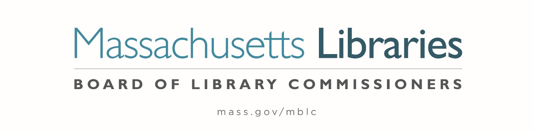

Welcome. Thank you for attending this meeting of the Massachusetts Board of Library Commissioners. Please remember that as part of the meeting agenda there is a time at the end of the meeting for public comment. Should you wish to address the Board during a particular item, please wait to be recognized by the chair.
Note: Agenda may include items not reasonably expected 48 hours before the meeting.
Thursday, April 6, 2023 10:00 A.M./ Refreshments 9:30 A.M.
Turner Free Public Library, Randolph, MA
Zoom Meeting Information
https://us02web.zoom.us/j/87137584969?pwd=Q0o0SlNLZG5mNWFHOHkwYU9NNVl5QT09
Meeting ID: 871 3758 4969/ Passcode: 868889
Dial in number: (646) 558-8656/ Meeting ID: 871 3758 4969

Agenda- Regular Monthly Meeting
- Call to order

- Welcome

Speaker: Sharon Parrington Wright, Library Director

- Roll Call of Commissioners

Speaker: Debby Conrad, Chair

- Approval of Minutes- March 2, 2023 Minutes (ACTION)

Speaker: Debby Conrad, Chair

- Chair’s Report

Speaker: Debby Conrad, Chair

- Commissioner Reports

Speaker: Debby Conrad, Chair
Posted: Thursday, March 22, 2023 at 5:00 P.M.

- Director’s Report

Speaker: James M. Lonergan, Director

- Legislative Report

Speaker: Mary Rose Quinn, Head of State Programs/ Government Liaison

- Consideration of approval of three Massachusetts Public Library Construction Program (MPLCP) Partial Provisional Grant Awards (ACTION)

Speaker: Andrea Bono-Bunker, Library Building Specialist

- Consideration of appointments to the Perkins’s Braille and Talking Book Library Consumer Advisory Board (ACTION)

Speakers: Mary Rose Quinn, Head of State Programs/ Government Liaison
Kim Charlson, Library Director, Perkins School

- Consideration of approval of revised budget 2 for Massachusetts Library System (MLS) (ACTION)

Speaker: Sarah Sogigian, Executive Director
Massachusetts Library System (MLS)

- Report from Massachusetts Library System (MLS)

Speaker: Sarah Sogigian, Executive Director
Massachusetts Library System (MLS)

- Report from Library for the Commonwealth (LFC)

Speaker: Michael Colford, Director of Library Services

- Public Comment

- Old Business

- Adjournment Debby Conrad, Chair

To review the Massachusetts Board of Library Commissioners current bylaws
(Organizations and Functions of the Board of Library Commissioners)
Visit https://mblc.state.ma.us/about-us/commissioners/index.php

