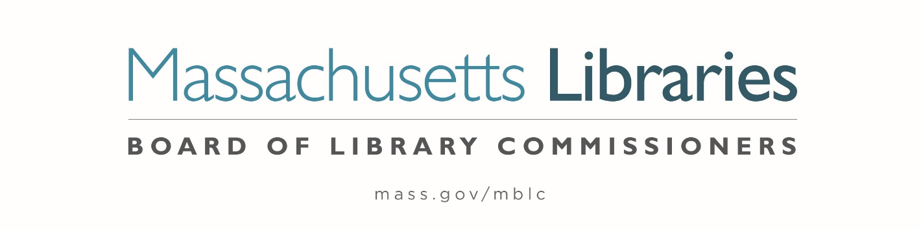

Welcome. Thank you for attending this meeting of the Massachusetts Board of Library Commissioners. Please remember that as part of the meeting agenda there is a time at the end of the meeting for public comment. Should you wish to address the Board during a particular item, please wait to be recognized by the chair.
Note: Agenda may include items not reasonably expected 48 hours before the meeting.
Thursday, September 2, 2021 10:00 A.M.
Zoom Meeting Information

https://us02web.zoom.us/j/85895097477?pwd=SVJNdG9OaXMxS2pCT2VWMko3Wkl3QT09

Meeting ID: 858 9509 7477 ∙ Passcode: 315452

Dial in number: (646) 558-8656/ Meeting ID: 858 9509 7477

Agenda- Regular Monthly Meeting
- Call to Order- Roll Call of Commissioners
10:00- 10:02 A.M.
Speaker: Mary Ann Cluggish, Chair

- Approval of Minutes- August 5, 2021 Minutes (ACTION)
10:03 - 10:08 A.M.
Speaker: Mary Ann Cluggish, Chair

- Chair’s Report
10:09- 10:14 A.M.
Speaker: Mary Ann Cluggish, Chair

- Commissioner Reports
10:15- 10:25 A.M.
Speaker: Mary Ann Cluggish, Chair

- Director’s Report
10:26- 10:36 A.M.

Speaker: James M. Lonergan, Director
Posted: Thursday, August 26, 2021 at 5:00 P.M.

- Legislative Report
10:37- 10:42 A.M.

Speakers: Mary Rose Quinn, Head of State Programs/ Government Liaison

- Discussion/ review of policies for the State Aid to Public Libraries Program
10:43- 10:53 A.M.

Speaker: Liz Babbitt, State Aid Specialist
- Discussion of the FY2023 Legislative Agenda (ACTION)
10:54- 11:30 A.M.

Speakers: James Lonergan, Director
Mary Rose Quinn, Head of State Programs/ Government Liaison

- Report from Massachusetts Library System (MLS)
11:30- 11:35 A.M.
Speaker: Sarah Sogigian, Executive Director
Massachusetts Library System (MLS)

- Report from the Library for the Commonwealth (LFC)
11:36- 11:41 A.M.
Speaker: Anna Fahey-Flynn, Central Library Manager
Boston Public Library (BPL)

- Libraries and COVID-19 Discussion
11:42- 11:47 A.M.
Speakers: James Lonergan, Director
Rob Favini, Head of Library Advisory and Development

- Public Comment 11:48- 11:53 A.M.

- Old Business

- Adjournment Mary Ann Cluggish, Chair

To review the Massachusetts Board of Library Commissioners current bylaws
(Organizations and Functions of the Board of Library Commissioners)
Visit https://mblc.state.ma.us/about-us/commissioners/index.php

