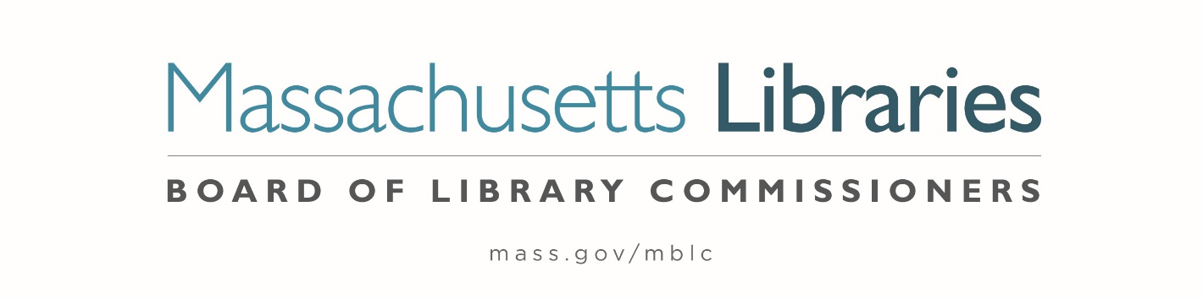

Welcome. Thank you for attending this meeting of the Massachusetts Board of Library Commissioners. Please remember that as part of the meeting agenda there is a time at the end of the meeting for public comment. Should you wish to address the Board during a particular item, please wait to be recognized by the chair.
Note: Agenda may include items not reasonably expected 48 hours before the meeting.
Thursday, October 7, 2021 10:00 A.M.
Zoom Meeting Information

https://us02web.zoom.us/j/84508279687?pwd=NHJRWjhuS1EycVRvV2VFK2Y2Yi9OZz09

Meeting ID: 845 0827 9687 ∙ Passcode: 399956

Dial in number: (646) 558-8656/ Meeting ID: 845 0827 9687

Agenda- Regular Monthly Meeting
- Call to Order- Roll Call of Commissioners
10:00- 10:02 A.M.
Speaker: Mary Ann Cluggish, Chair

- Approval of Minutes- September 2, 2021 Minutes (ACTION)
10:03 - 10:08 A.M.
Speaker: Mary Ann Cluggish, Chair

- Chair’s Report
10:09- 10:14 A.M.
Speaker: Mary Ann Cluggish, Chair

- Commissioner Reports
10:15- 10:25 A.M.
Speaker: Mary Ann Cluggish, Chair

- Director’s Report
10:26- 10:36 A.M.

Speaker: James M. Lonergan, Director
Posted: Thursday, September 30, 2021 at 5:00 P.M.
- Legislative Report
10:37- 10:42 A.M.

Speakers: Mary Rose Quinn, Head of State Programs/ Government Liaison

- MLS FY2022 Budget Revision 2 approval request (ACTION) 10:43-10:53 A.M.

Speaker: Sarah Sogigian, Executive Director
Massachusetts Library System (MLS)

- Consideration of approval of policies for the FY2024 State Aid to Public Libraries Program 10:54- 11:09 A.M.

- Extending a Grace Period for Increased Population-Based Minimum Standards (ACTION)
- Minimum Standards of Hours of Service for Public Libraries (ACTION)
- Minimum Materials Expenditure Standard Calculation (ACTION)
- Materials Expenditure and Hours Open Accommodation Policy (ACTION)
- Municipal Appropriation Requirement Calculation (ACTION)
- Determining Eligibility for a Waiver for the FY2024 Municipal Appropriation Requirement (ACTION)
- The Closure of a Public Library (ACTION)
- Five Year Waiver Plan Policy (ACTION)

Speaker: Liz Babbitt, State Aid Specialist

- Consideration of Network Grant Awards under account 7000-9506 11:10-11:25 A.M.

- FY2022 Small Libraries in Networks Recommendation (ACTION)
- FY2022 Telecommunications for Resource Sharing Recommendation (ACTION)
- FY2022 Network Infrastructure Recommendation (ACTION)
- FY2022 Resource Sharing Program Recommendation (ACTION)

Speaker: Paul Kissman, Library Information System Specialist

- Consideration of approval for the Library eBooks and Audiobooks (LEA) Content Grants (ACTION) 11:26- 11:41 A.M.

Speaker: Kate Butler, Electronic Systems Specialist

- Consideration of appointments to the State Advisory Council on Libraries (SACL) (ACTION) 11:42- 11:47 A.M.

Speaker: Rob Favini, Head of Library Advisory & Development

- Consideration of re-appointments to the Public Relations Committee (ACTION)
11:48- 11:53 A.M.
Speaker: Celeste Bruno, Communications Director

****10 Minute Break****

- Update on the Small Library Pilot project 12:05-12:15 P.M.

Speaker: Lauren Stara, Library Building Specialist

- Update on the databases RFR 12:16-12:26 P.M.

Speaker: Kate Butler, Electronic Systems Specialist

- Report from Massachusetts Library System (MLS)
12:27-12:32 P.M.
Speaker: Sarah Sogigian, Executive Director
Massachusetts Library System (MLS)

- Report from the Library for the Commonwealth (LFC)
12:33-12:38 P.M.
Speaker: Catherine Halpin, Collaborative Library Services Coordinator
Boston Public Library (BPL)

- Libraries and COVID-19 Discussion
12:39- 12:44 P.M.
Speakers: James Lonergan, Director
Rob Favini, Head of Library Advisory and Development

- Public Comment 12:45-12:50 P.M.

- Old Business

- Adjournment Mary Ann Cluggish, Chair

To review the Massachusetts Board of Library Commissioners current bylaws
(Organizations and Functions of the Board of Library Commissioners)
Visit https://mblc.state.ma.us/about-us/commissioners/index.php

