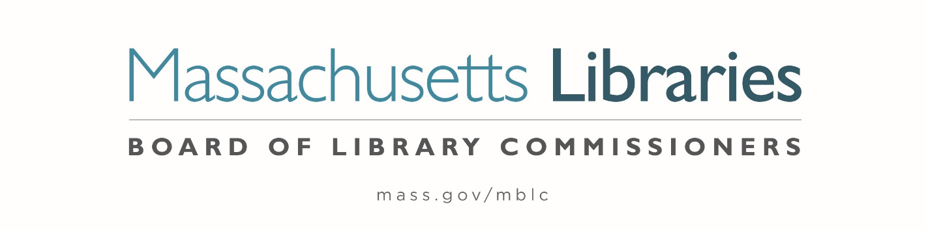

Welcome. Thank you for attending this meeting of the Massachusetts Board of Library Commissioners. Please remember that as part of the meeting agenda there is a time at the end of the meeting for public comment. Should you wish to address the Board during a particular item, please wait to be recognized by the chair.
Note: Agenda may include items not reasonably expected 48 hours before the meeting.
Thursday, November 4, 2021 10:00 A.M.
Zoom Meeting Information

https://us02web.zoom.us/j/82317687181?pwd=dDZ3TGVHUkI1MW5ZK2tNR0FDK0tHQT09

Meeting ID: 823 1768 7181 ∙ Passcode: 971814

Dial in number: (646) 558-8656/ Meeting ID: 823 1768 7181

Agenda- Regular Monthly Meeting
- Call to Order- Roll Call of Commissioners

Speaker: Mary Ann Cluggish, Chair

- Approval of Minutes- October 7, 2021 Minutes (ACTION)

Speaker: Mary Ann Cluggish, Chair

- Chair’s Report

Speaker: Mary Ann Cluggish, Chair

- Commissioner Reports

Speaker: Mary Ann Cluggish, Chair

- Director’s Report


Speaker: James M. Lonergan, Director
Posted: Thursday, October 28, 2021 at 4:00 P.M.
:00 P.M.
- Legislative Report

Speakers: Mary Rose Quinn, Head of State Programs/ Government Liaison

- Consideration of approval of the FY2023 Library Services and Technology Act (LSTA) Direct Grant Round Program & Budget (ACTION)

Speaker: Rob Favini, Head of Library Advisory & Development

- Consideration of approval of the municipalities meeting the requirements for the FY2022 State Aid to Public Libraries based on eligibility established in FY2022 for the Municipal Appropriation Requirement and in FY2021 for the minimum standards (ACTION)

Speaker: Liz Babbitt, State Aid Specialist

- Update on the State Aid Applications and Waivers

Speaker: Liz Babbitt, State Aid Specialist

- Presentation of FY2022 MBLC Budget

Speaker: Tracey Dimant, Head of Operations and Budget

- Discussion of MBLC Bylaws Revisions

Speakers: Mary Ann Cluggish, Chair
James Lonergan, Director

- Report from Massachusetts Library System (MLS)

Speaker: Sarah Sogigian, Executive Director
Massachusetts Library System (MLS)

- Report from the Library for the Commonwealth (LFC)

Speaker: Catherine Halpin, Collaborative Library Services Coordinator
Boston Public Library (BPL)

- Libraries and COVID-19 Discussion

Speakers: James Lonergan, Director
Rob Favini, Head of Library Advisory and Development

- Public Comment

- Old Business

- Adjournment Mary Ann Cluggish, Chair

To review the Massachusetts Board of Library Commissioners current bylaws
(Organizations and Functions of the Board of Library Commissioners)
Visit https://mblc.state.ma.us/about-us/commissioners/index.php

