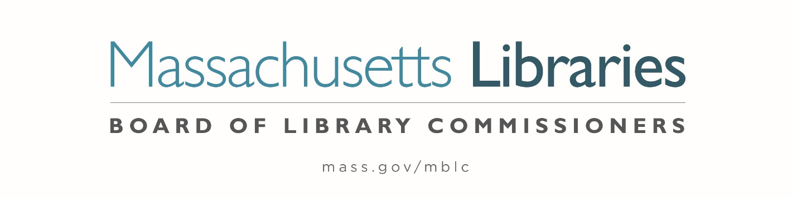

Welcome. Thank you for attending this meeting of the Massachusetts Board of Library Commissioners. Please remember that as part of the meeting agenda there is a time at the end of the meeting for public comment. Should you wish to address the Board during a particular item, please wait to be recognized by the chair.
Note: Agenda may include items not reasonably expected 48 hours before the meeting.
Thursday, May 5, 2022 10:00 A.M.
Weymouth Public Library, 46 Broad Street, Weymouth
Hybrid Board Meeting
Zoom Meeting Information
https://us02web.zoom.us/j/83218792363?pwd=NU5NcUxUaXBLaHlxOExWT2pPS1pyUT09
Meeting ID: 832 1879 2363/ Passcode: 220226
Dial in number: (646) 558-8656/ Meeting ID: 832 1879 2363

Agenda- Regular Monthly Meeting
- Call to order

- Welcome

Speaker: Rob MacLean, Library Director

- Roll Call of Commissioners

Speaker: Mary Ann Cluggish, Chair

- Approval of Minutes- April 7, 2022 Minutes (ACTION)

Speaker: Mary Ann Cluggish, Chair

- Chair’s Report


Speaker: Mary Ann Cluggish, Chair
Posted: Friday, April 29, 2022 at 4:00 P.M.
:00 P.M.

- Commissioner Reports

Speaker: Mary Ann Cluggish, Chair

- Director’s Report

Speaker: James M. Lonergan, Director

- Legislative Report

Speaker: Mary Rose Quinn, Head of State Programs/ Government Liaison

- Consideration of approval of the FY2023 Plan of Service and Program and Budget for the Massachusetts Center for the Book (ACTION)

Speaker: Sharon Shaloo, Executive Director
Massachusetts Center for the Book

- Consideration of approval of three Massachusetts Public Library Construction Program (MPLCP) Partial Provisional Grant Awards (ACTION)

Speaker: Andrea Bono-Bunker, Library Building Specialist

- Consideration of approval of a Massachusetts Public Library Construction Program (MPLCP) grant award amendment (ACTION)

Speaker: Andrea Bono-Bunker, Library Building Specialist

- Report from Massachusetts Library System (MLS)

Speaker: Sarah Sogigan, Executive Director
Massachusetts Library System (MLS)

- Report from Library for the Commonwealth (LFC)

Speaker: Angela Veizaga, Director of Strategic Partnerships
Boston Public Library (BPL)

- Libraries and COVID-19 Discussion

Speakers: James Lonergan, Director
Rob Favini, Head of Library Advisory and Development

- Public Comment

- Old Business

- Adjournment Mary Ann Cluggish, Chair

After the meeting Rob MacLean, Library Director will be providing a tour of the new building.

To review the Massachusetts Board of Library Commissioners current bylaws
(Organizations and Functions of the Board of Library Commissioners)
Visit https://mblc.state.ma.us/about-us/commissioners/index.php

