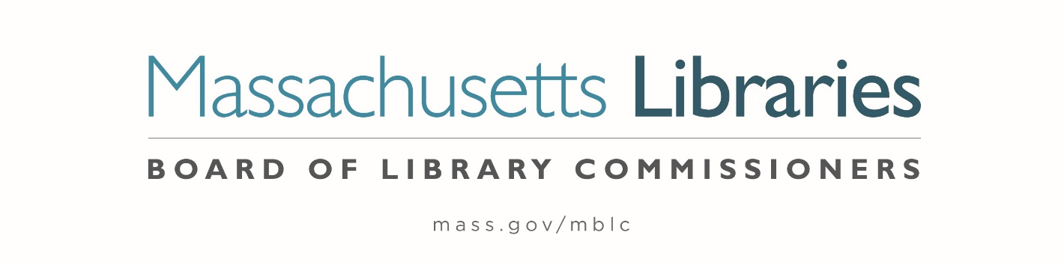

Welcome. Thank you for attending this meeting of the Massachusetts Board of Library Commissioners. Please remember that as part of the meeting agenda there is a time at the end of the meeting for public comment. Should you wish to address the Board during a particular item, please wait to be recognized by the chair.
Note: Agenda may include items not reasonably expected 48 hours before the meeting.
Thursday, June 2, 2022 10:00 A.M.
Massachusetts Library System Offices,
33 Boston Post Road, WEST, Suite 400, Marlborough
Zoom Meeting Information
https://us02web.zoom.us/j/84770590379?pwd=H-s4wZg-Fo3V-HiMXx6vqSKlxJK0uy.1
Meeting ID: 847 7059 0379/ Passcode: 690757
Dial in number: (646) 558-8656/ Meeting ID: 847 7059 0379

Agenda- Regular Monthly Meeting
- Call to order

- Welcome

Speaker: Sarah Sogigian, Executive Director

- Roll Call of Commissioners

Speaker: Mary Ann Cluggish, Chair

- Approval of Minutes- May 5, 2022 Minutes (ACTION)

Speaker: Mary Ann Cluggish, Chair

- Chair’s Report


Speaker: Mary Ann Cluggish, Chair
Posted: Friday, May 27, 2022 at 1:00 P.M.
:00 P.M.

- Commissioner Reports

Speaker: Mary Ann Cluggish, Chair

- Director’s Report

Speaker: James M. Lonergan, Director

- Legislative Report

Speaker: Mary Rose Quinn, Head of State Programs/ Government Liaison

- Consideration of a FY2023 Grant Round for 7000-9506, Library Technology and Resource Sharing, including Telecommunications for Resource Sharing, Resource Sharing Program, Network Infrastructure, and Small Libraries in Networks (ACTION)

Speaker: Paul Kissman, Library Information Systems Specialist

- Consideration of a FY2023 Grant Round for 7000-9506, LEA eContent grants (ACTION)

Speaker: Kate Butler, Electronic Services Specialist

- Update on FY2023 Database Procurement Activities

Speaker: Kate Butler, Electronic Services Specialist

- Consideration of appointments to the State Aid Advisory Committee (ACTION)

Speaker: Mary Rose Quinn, Head of State Programs/ Government Liaison

- Report from Massachusetts Library System (MLS)

Speaker: Sarah Sogigan, Executive Director
Massachusetts Library System (MLS)

- Report from Library for the Commonwealth (LFC)

Speaker: Angela Veizaga, Director of Strategic Partnerships
Boston Public Library (BPL)

- Libraries and COVID-19 Discussion

Speakers: James Lonergan, Director
Rob Favini, Head of Library Advisory and Development

- Public Comment

- Old Business

- Adjournment Mary Ann Cluggish, Chair

To review the Massachusetts Board of Library Commissioners current bylaws
(Organizations and Functions of the Board of Library Commissioners)
Visit https://mblc.state.ma.us/about-us/commissioners/index.php

