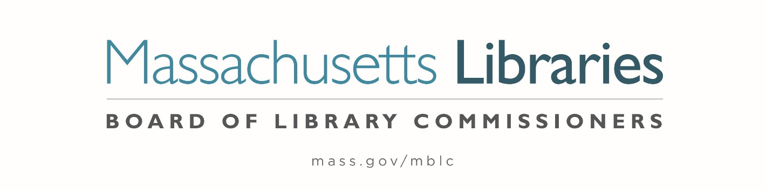

Welcome. Thank you for attending this meeting of the Massachusetts Board of Library Commissioners. Please remember that as part of the meeting agenda there is a time at the end of the meeting for public comment. Should you wish to address the Board during a particular item, please wait to be recognized by the chair.
Note: Agenda may include items not reasonably expected 48 hours before the meeting.
Thursday, July 8, 2021 10:00 A.M.
Zoom Meeting Information

https://us02web.zoom.us/j/85337551389?pwd=ZFNBa1BlRlc1V3FrN1FzOVBjK0EzZz09

Meeting ID: 853 3755 1389 ∙ Passcode: 233731

Dial in number: (646) 558-8656/ Meeting ID: 853 3755 1389

Agenda- Regular Monthly Meeting
- Call to Order- Roll Call of Commissioners
10:00- 10:02 A.M.
Speaker: Mary Ann Cluggish, Chair

- Approval of Minutes- June 3, 2021 Minutes (ACTION)
10:03 - 10:08 A.M.
Speaker: Mary Ann Cluggish, Chair

- Chair’s Report
10:09- 10:14 A.M.
Speaker: Mary Ann Cluggish, Chair

- Commissioner Reports
10:15- 10:25 A.M.
Speaker: Mary Ann Cluggish, Chair

- Director’s Report
10:26- 10:36 A.M.

Speaker: James M. Lonergan, Director
Posted: Wednesday, June 30, 2021 at 5:00 P.M.

- Legislative Report
10:37- 10:42 A.M.

Speaker: Mary Rose Quinn, Head of State Programs/ Government Liaison

- Consideration of approval of the FY2022 Library Services and Technology Act (LSTA) Grant Awards
10:43- 10:58 A.M.
- Access for All (ACTION)
- Archives Arrangement and Description (ACTION)
- At the Table (ACTION)
- Citizenship Corners & Expanded English Language Services (ACTION)
- Civic Hub (ACTION)
- Dig In (ACTION)
- Go Local (ACTION)
- Managing Fine and Decorative Arts (ACTION)
- Mind in the Making (ACTION)
- Open (ACTION)
- Pathways to Success (ACTION)
- Protecting Priority Collections (ACTION)
- Strength in Families (ACTION)

Speaker: Rob Favini, Head of Library Advisory and Development

- Consideration of approval of Board Policy on Budget Revisions (ACTION)
10:59- 11:04 A.M.

Speaker: James Lonergan, Director

- Massachusetts Public Library Construction Program Grant Award
11:05- 11:15 A.M.
- Consideration of approval of provisional grant award under the Massachusetts Public Library Construction Program (ACTION)
- Consideration of approval of a Library Green Incentive award under the Massachusetts Public Library Construction program (ACTION)

Speaker: Lauren Stara, Library Building Specialist

- Report from Massachusetts Library System (MLS)
11:16- 11:21 A.M.
Speaker: Sarah Sogigian, Executive Director
Massachusetts Library System (MLS)

- Report from the Library for the Commonwealth (LFC)
11:22- 11:26 A.M.
Speaker: Catherine Halpin, Collaborative Library Services Coordinator
Boston Public Library (BPL)

- Libraries and COVID-19 Discussion
11:27- 11:32 A.M.
Speakers: James Lonergan, Director
Rob Favini, Head of Library Advisory and Development

- Public Comment 11:33- 11:38 A.M.

- Old Business

- Election of Officers for FY2022 (ACTION) 11:39- 11:44 A.M.

Speaker: N. Janeen Resnick

- Adjournment Mary Ann Cluggish, Chair

To review the Massachusetts Board of Library Commissioners current bylaws
(Organizations and Functions of the Board of Library Commissioners)
Visit https://mblc.state.ma.us/about-us/commissioners/index.php

