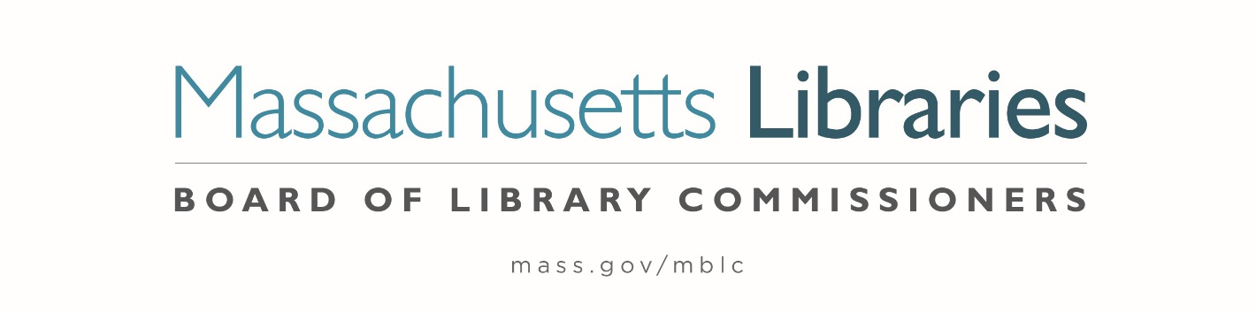

Welcome. Thank you for attending this meeting of the Massachusetts Board of Library Commissioners. Please remember that as part of the meeting agenda there is a time at the end of the meeting for public comment. Should you wish to address the Board during a particular item, please wait to be recognized by the chair.
Note: Agenda may include items not reasonably expected 48 hours before the meeting.
Thursday, December 2, 2021 10:00 A.M.
Zoom Meeting Information
https://us02web.zoom.us/j/89908294141?pwd=R3lBMkxTdDhLa3YrdXlMYm0wTWpzdz09
Meeting ID: 899 0829 4141/ Passcode: 380140
Dial in number: (646) 558-8656/ Meeting ID: 899 0829 4141

Agenda- Regular Monthly Meeting
- Call to Order- Roll Call of Commissioners

Speaker: Mary Ann Cluggish, Chair

- Approval of Minutes- November 4, 2021 Minutes (ACTION)

Speaker: Mary Ann Cluggish, Chair

- Chair’s Report

Speaker: Mary Ann Cluggish, Chair

- Commissioner Reports

Speaker: Mary Ann Cluggish, Chair

- Director’s Report


Speaker: James M. Lonergan, Director
Posted: Friday, November 26, 2021 at 4:00 P.M.
:00 P.M.

- Legislative Report

Speakers: Mary Rose Quinn, Head of State Programs/ Government Liaison

- Consideration of approval of the municipalities meeting the requirements for the FY2022 State Aid to Public Libraries based on eligibility established in FY2022 for the Municipal Appropriation Requirement and in FY2021 for the minimum standards (ACTION)

Speaker: Liz Babbitt, State Aid Specialist

- Creation of/appointments to the Statewide Databases Advisory Committee (ACTION)

Speaker: Kate Butler, Electronic Services Specialist

- Consideration of MBLC Bylaws Revisions (ACTION)

Speakers: Mary Ann Cluggish, Chair
James Lonergan, Director

- Presentation and discussion of the FY2023 Plan of Service and Program and Budget for the Massachusetts Library System and Monthly Report

Speaker: Sarah Sogigian, Executive Director
Massachusetts Library System (MLS)

- Libraries and COVID-19 Discussion

Speakers: James Lonergan, Director
Rob Favini, Head of Library Advisory and Development

- Public Comment

- Old Business

- Adjournment Mary Ann Cluggish, Chair

To review the Massachusetts Board of Library Commissioners current bylaws
(Organizations and Functions of the Board of Library Commissioners)
Visit https://mblc.state.ma.us/about-us/commissioners/index.php

