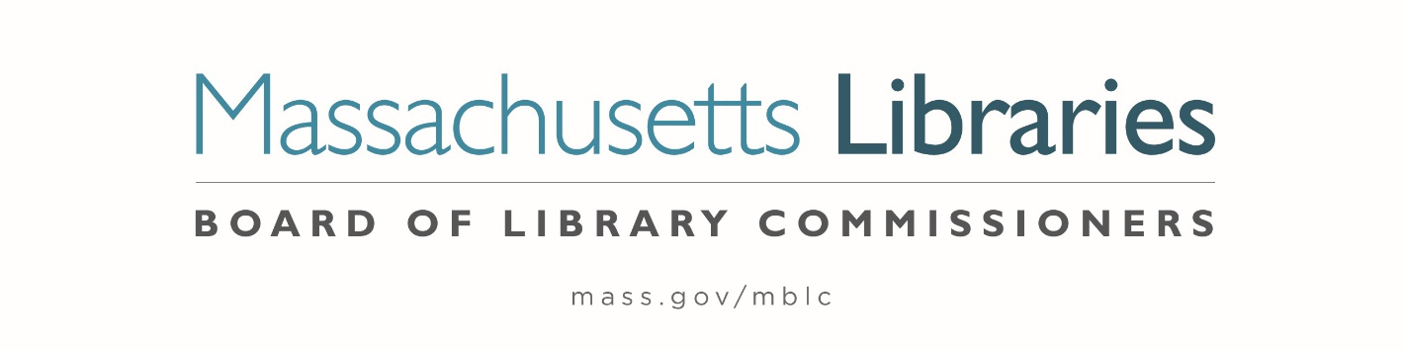

Welcome. Thank you for attending this meeting of the Massachusetts Board of Library Commissioners. Please remember that as part of the meeting agenda there is a time at the end of the meeting for public comment. Should you wish to address the Board during a particular item, please wait to be recognized by the chair.
Note: Agenda may include items not reasonably expected 48 hours before the meeting.
Thursday, August 5, 2021 10:00 A.M.
Zoom Meeting Information

https://us02web.zoom.us/j/85446419255?pwd=ci81amNCcVNsdW9KZGRHQy85MXNsZz09

Meeting ID: 854 4641 9255 ∙ Passcode: 892194

Dial in number: (646) 558-8656/ Meeting ID: 854 4641 9255

Agenda- Regular Monthly Meeting
- Call to Order- Roll Call of Commissioners
10:00- 10:02 A.M.
Speaker: Mary Ann Cluggish, Chair

- Approval of Minutes- July 8, 2021 Minutes (ACTION)
10:03 - 10:08 A.M.
Speaker: Mary Ann Cluggish, Chair

- Chair’s Report
10:09- 10:14 A.M.
Speaker: Mary Ann Cluggish, Chair

- Commissioner Reports
10:15- 10:25 A.M.
Speaker: Mary Ann Cluggish, Chair

- Director’s Report
10:26- 10:36 A.M.

Speaker: James M. Lonergan, Director
Posted: Friday, July 30, 2021 at 12:00 P.M.

- Report from Perkins Library
10:37- 10:47 A.M.

Speaker: Kim Charlson, Library Director, Perkins Library

- Legislative Report
10:48- 10:53 A.M.

Speakers: Mary Rose Quinn, Head of State Programs/ Government Liaison

- Preliminary discussion of the FY2023 Legislative Agenda
10:54- 11:04 A.M.

Speakers: James Lonergan, Director
Mary Rose Quinn, Head of State Programs/ Government Liaison

- Report from Massachusetts Library System (MLS)
11:05- 11:10 A.M.
Speaker: Sarah Sogigian, Executive Director
Massachusetts Library System (MLS)

- Report from the Library for the Commonwealth (LFC)
11:11- 11:16 A.M.
Speaker: Catherine Halpin, Collaborative Library Services Coordinator
Boston Public Library (BPL)

- Libraries and COVID-19 Discussion
11:17- 11:22 A.M.
Speakers: James Lonergan, Director
Rob Favini, Head of Library Advisory and Development

- Public Comment 11:23- 11:28 A.M.

- Old Business

- Adjournment Mary Ann Cluggish, Chair

To review the Massachusetts Board of Library Commissioners current bylaws
(Organizations and Functions of the Board of Library Commissioners)
Visit https://mblc.state.ma.us/about-us/commissioners/index.php

