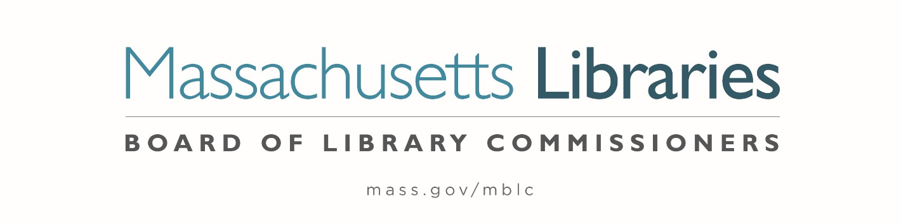

Welcome. Thank you for attending this meeting of the Massachusetts Board of Library Commissioners. Please remember that as part of the meeting agenda there is a time at the end of the meeting for public comment. Should you wish to address the Board during a particular item, please wait to be recognized by the chair.
Note: Agenda may include items not reasonably expected 48 hours before the meeting.
Thursday, April 7, 2022 1:00 P.M.
Zoom Meeting Information
https://us02web.zoom.us/j/86587234472?pwd=ZHJuaTR1NFd0UUVBYXpVK1RFZXJBQT09
Meeting ID: 865 8723 4472/ Passcode: 254138
Dial in number: (646) 558-8656/ Meeting ID: 865 8723 4472

Agenda- Regular Monthly Meeting
- Call to Order- Roll Call of Commissioners

Speaker: Mary Ann Cluggish, Chair

- Approval of Minutes- March 3, 2022 Minutes (ACTION)

Speaker: Mary Ann Cluggish, Chair

- Chair’s Report

Speaker: Mary Ann Cluggish, Chair

- Commissioner Reports

Speaker: Mary Ann Cluggish, Chair

- Director’s Report


Speaker: James M. Lonergan, Director
Posted: Thursday, March 31, 2022 at 1:00 P.M.
:00 P.M.

- Legislative Report

Speaker: Mary Rose Quinn, Head of State Programs/ Government Liaison

- Overview/ summary of the Massachusetts Public Library Construction Program (MPLCP)

Speaker: Lauren Stara, Library Building Specialist

- Consideration of approval for the Small Library Pilot Project (ACTION)

Speaker: Lauren Stara, Library Building Consultant

- Consideration of an appointment to the Public Relations Committee (ACTION)

Speaker: Celeste Bruno, Communications Director

- Presentation of the FY2023 Plan of Service and Program and Budget for the Massachusetts Center for the Book

Speakers: Sharon Shaloo, Executive Director
Massachusetts Center for the Book
Krista McLeod, Director, Nevins Memorial Library, Methuen
Board Member, Massachusetts Center for the Book

- Report from Massachusetts Library System (MLS)

Speaker: Sarah Sogigan, Executive Director
Massachusetts Library System (MLS)

- Report from Library for the Commonwealth (LFC)

Speaker: Angela Veizaga, Director of Strategic Partnerships
Boston Public Library (BPL)

- Libraries and COVID-19 Discussion

Speakers: James Lonergan, Director
Rob Favini, Head of Library Advisory and Development

- Public Comment

- Old Business

- Adjournment Mary Ann Cluggish, Chair

To review the Massachusetts Board of Library Commissioners current bylaws
(Organizations and Functions of the Board of Library Commissioners)
Visit https://mblc.state.ma.us/about-us/commissioners/index.php

