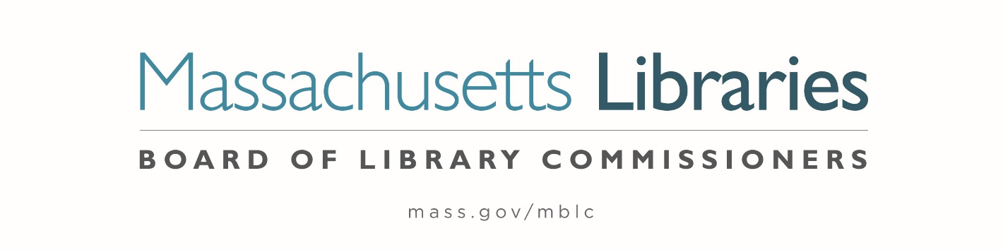

Welcome. Thank you for attending this meeting of the Massachusetts Board of Library Commissioners. Please remember that as part of the meeting agenda there is a time at the end of the meeting for public comment. Should you wish to address the Board during a particular item, please wait to be recognized by the chair.
Note: Agenda may include items not reasonably expected 48 hours before the meeting.
Zoom Meeting
https://zoom.us/j/98166684343?pwd=NklqN0pYTnBVYy83MEtHN2l0YzIzZz09
Meeting ID: 947 6347 2449∙ Password: 175718
Dial in number: (646) 558-8656
Thursday, September 3, 2020 10:00 A.M.
Agenda- Regular Monthly Meeting
- Call to Order

- Welcome

- Approval of Minutes- Regular Monthly Meeting August 6, 2020 (ACTION)

Speaker: Mary Ann Cluggish, Chair

- Chair’s Report

Speaker: Mary Ann Cluggish, Chair

- Commissioner Reports

Speaker: Mary Ann Cluggish, Chair

- Director’s Report

Speaker: James M. Lonergan, Director

Posted: Thursday, August 27, 2020 at 4:00 P.M.
- Legislative Report

Speaker: Mary Rose Quinn, Head of State Programs/ Government Liaison

- Discussion/ review of policies for the FY2023 State Aid to Public Libraries Program

Speaker: Liz Babbitt, State Aid Specialist

- MBLC Strategic Planning Update

Speaker: James M. Lonergan, Director
Abby Straus, Consultant, Maverick & Boutique

- Update from the Massachusetts School Library Association (MSLA)

Speaker: Greg Pronevitz, Consultant

- Report from the Massachusetts Library System

Speaker: Sarah Sogigian, Executive Director
Massachusetts Library System (MLS)

- Report from Library for the Commonwealth

Speaker: Catherine Halpin, Collaborative Library Services Coordinator
Boston Public Library (BPL)

- Libraries and COVID-19 Discussion

Speakers: Mary Ann Cluggish, Chair
James Lonergan, Director

- Commissioner Activities

- Public Comment

- Old Business

- Adjournment Mary Ann Cluggish, Chair

To review the Massachusetts Board of Library Commissioners current bylaws
(Organizations and Functions of the Board of Library Commissioners)
visit http://mblc.state.ma.us/mblc/board/MBLC_Bylaws.pdf

